ECDC/WHO Euro TK 8.05.2020
neuer Surveillancereport soll heute online gehen, manche Länder haben doppelt Fälle (aggregiert und case-based), Belgien, Estland, ...Deutschland nicht
Case definition only on case definition, most other issues are taken out
should be published at the end of next week, comments, if this is feasible by Tuesday next week
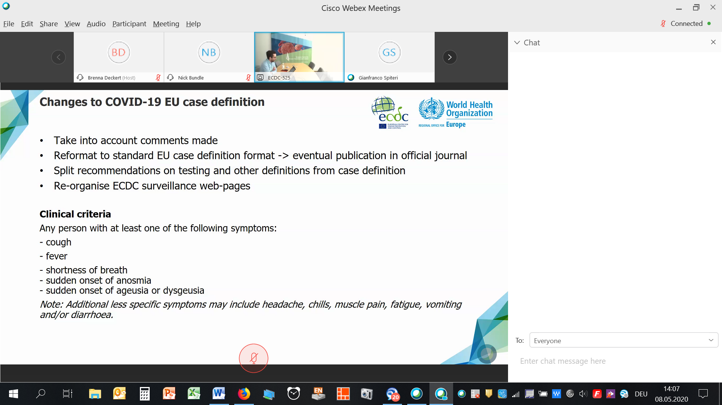
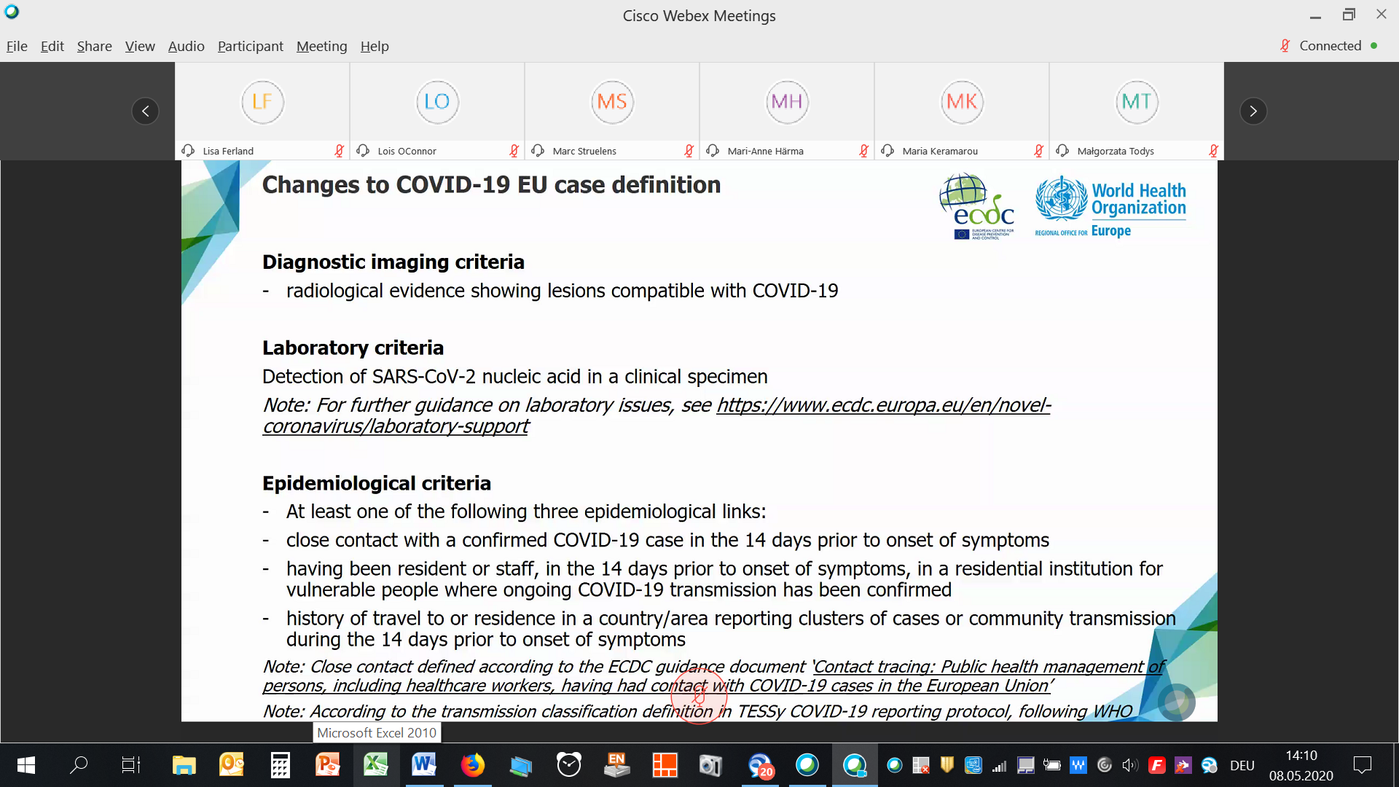

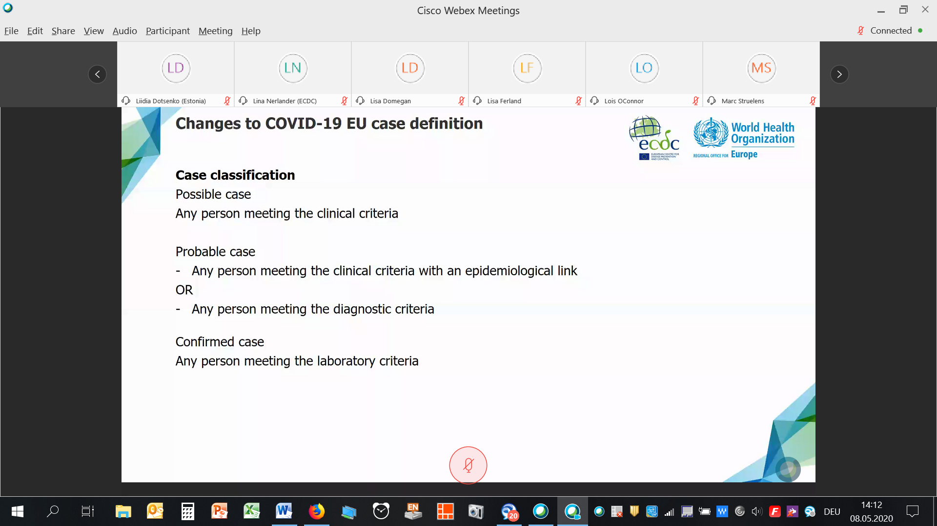
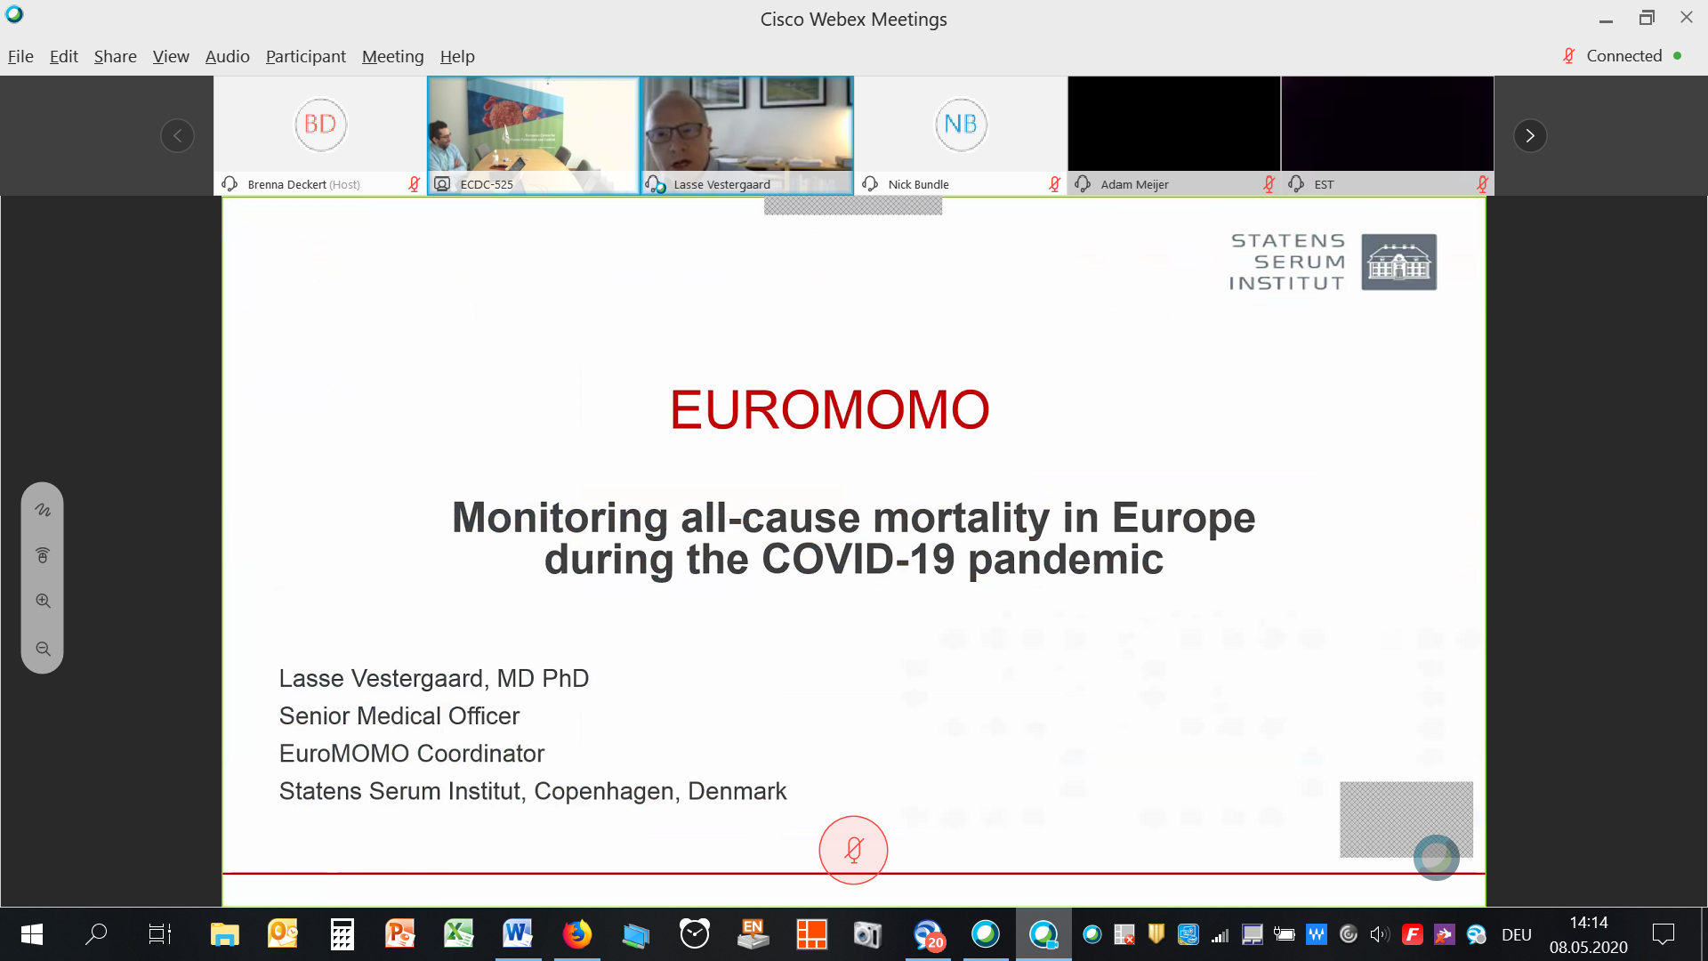
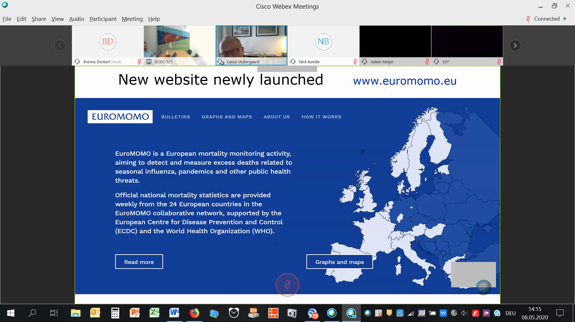
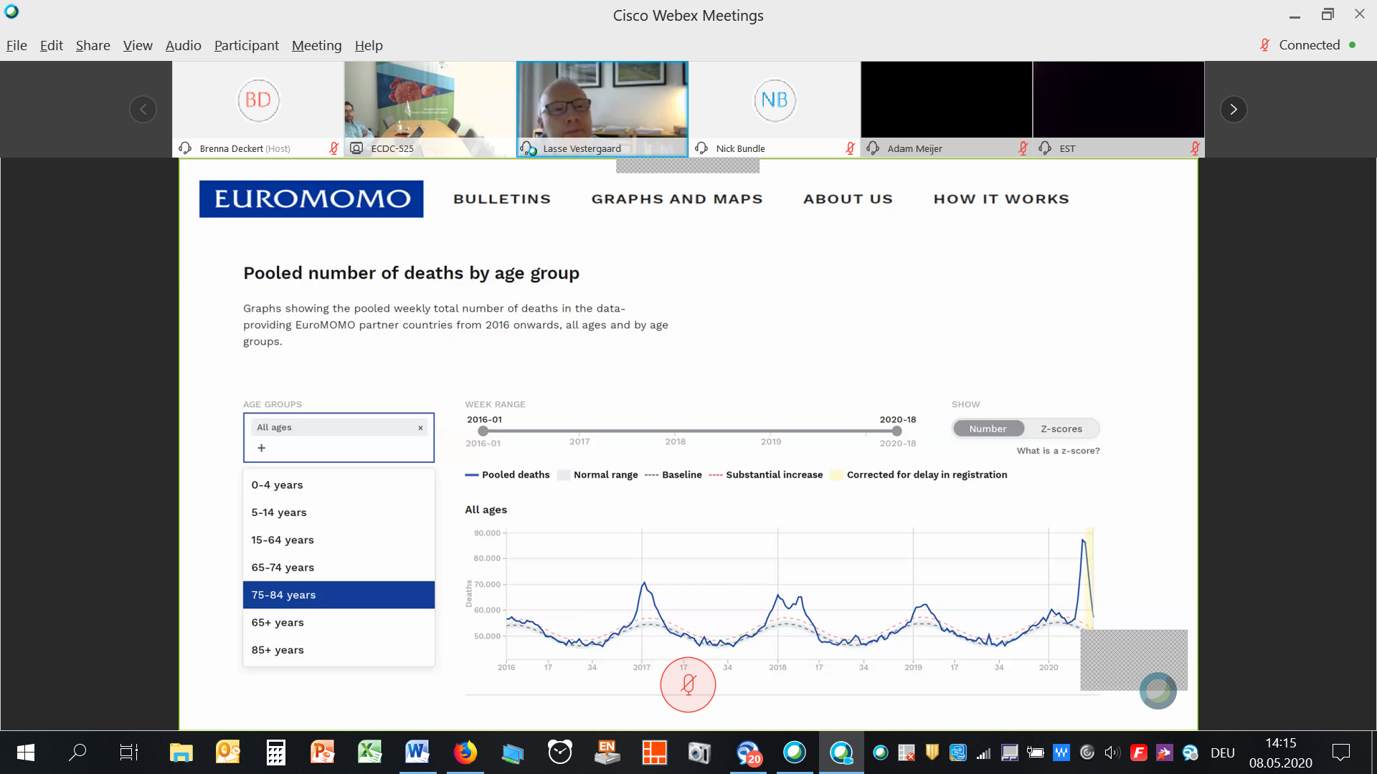
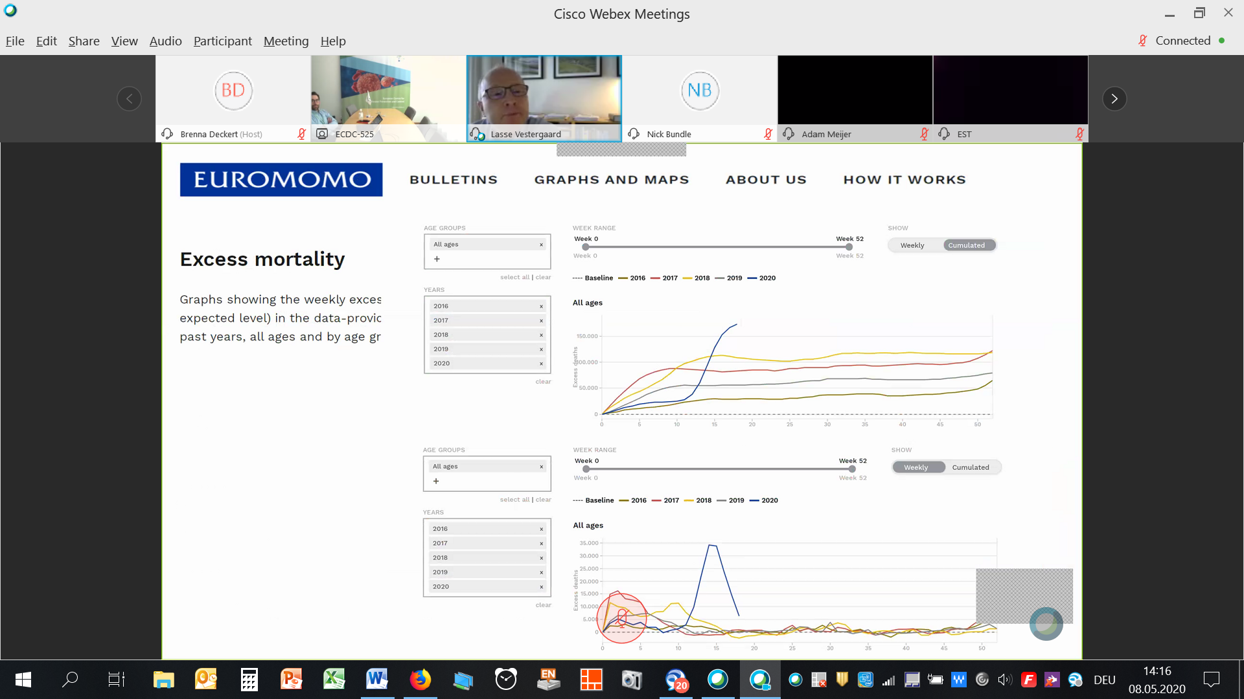
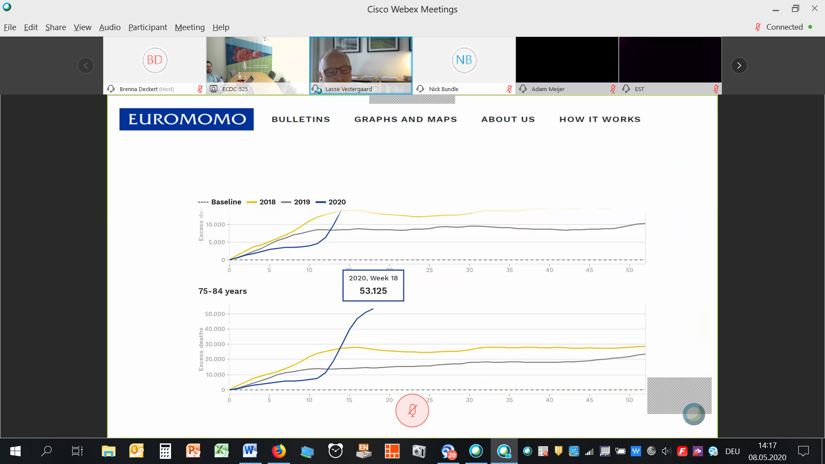
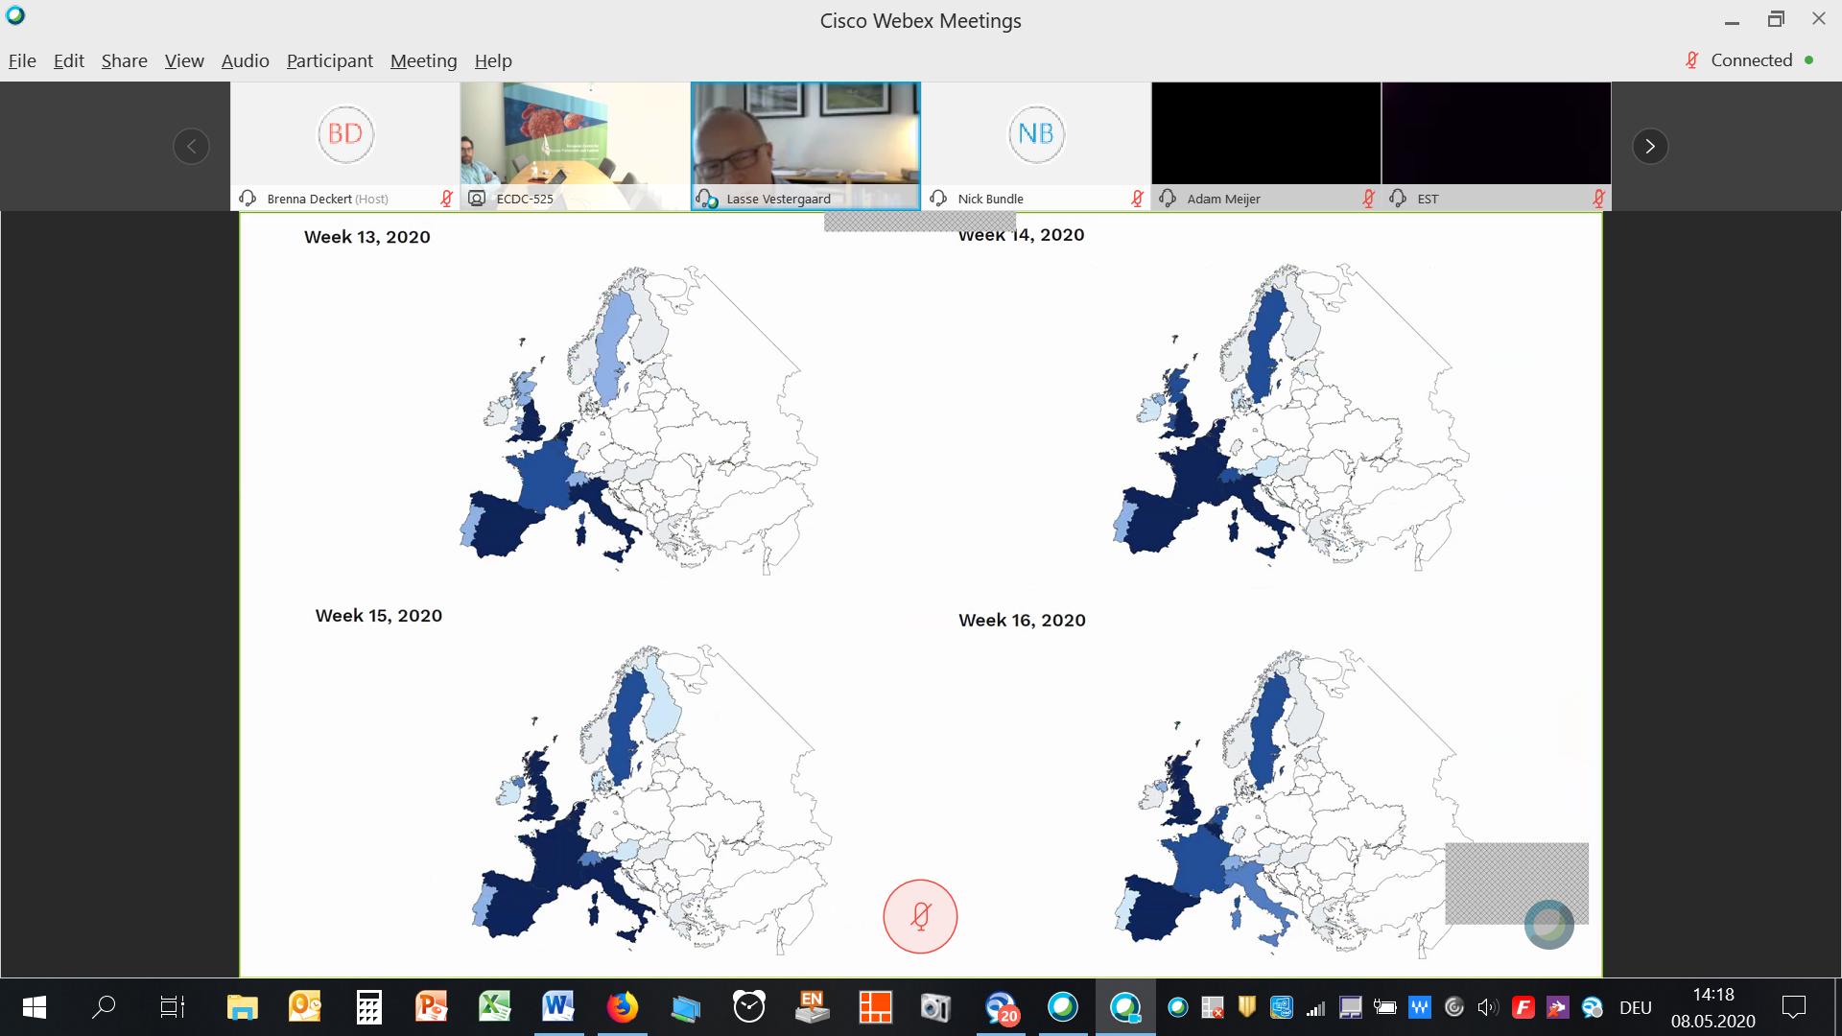
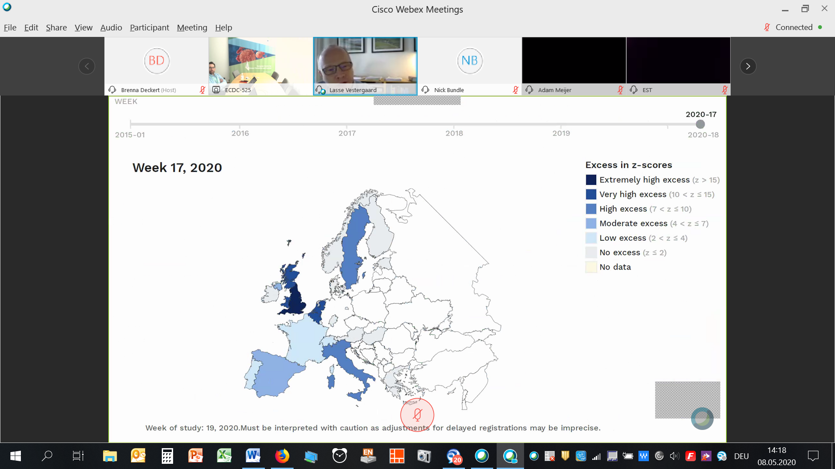
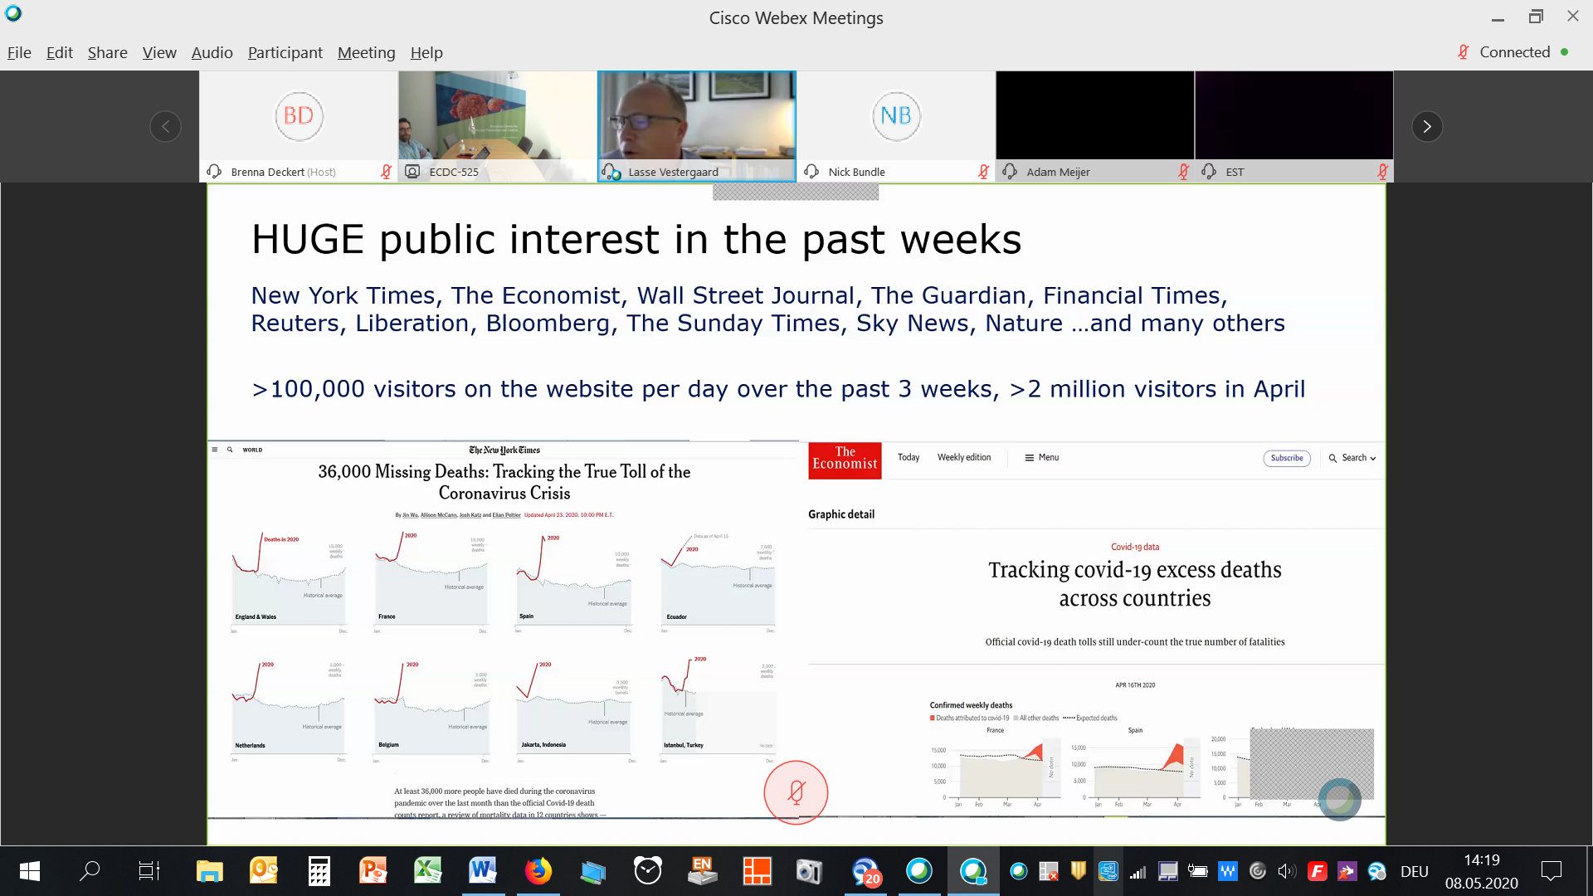
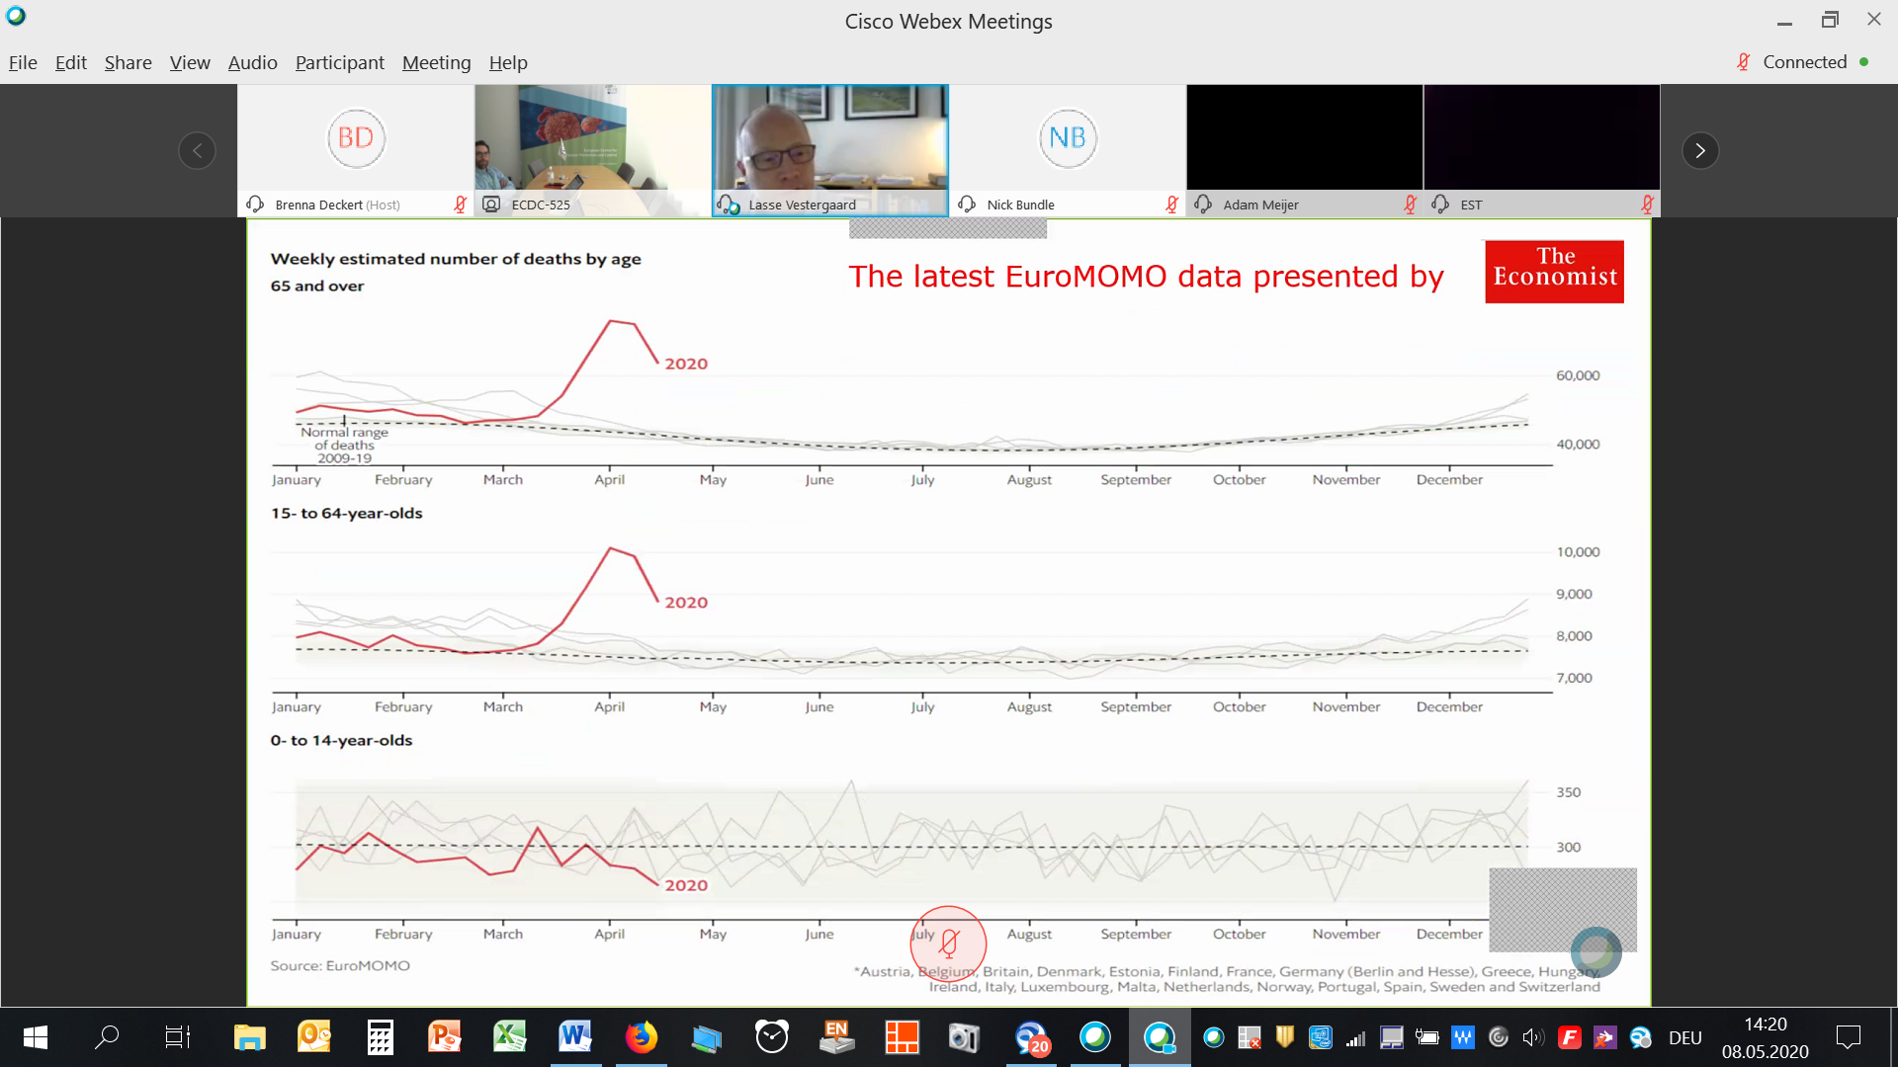
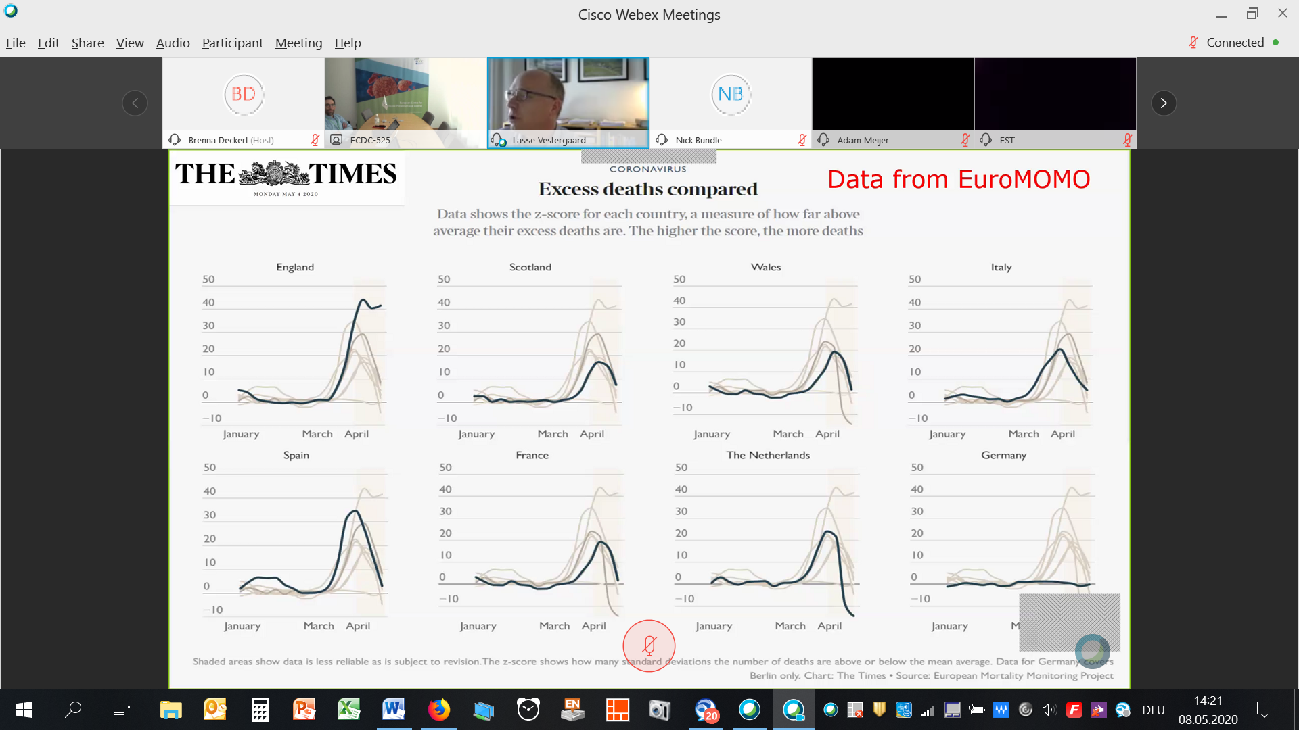
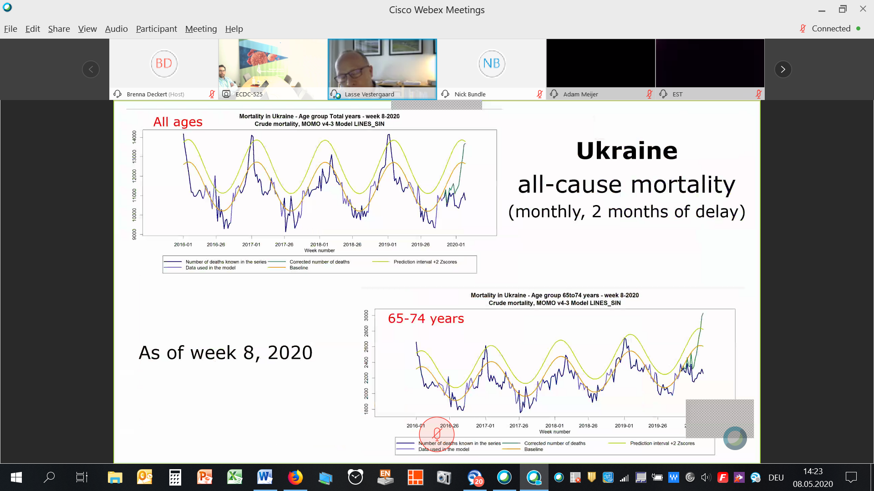
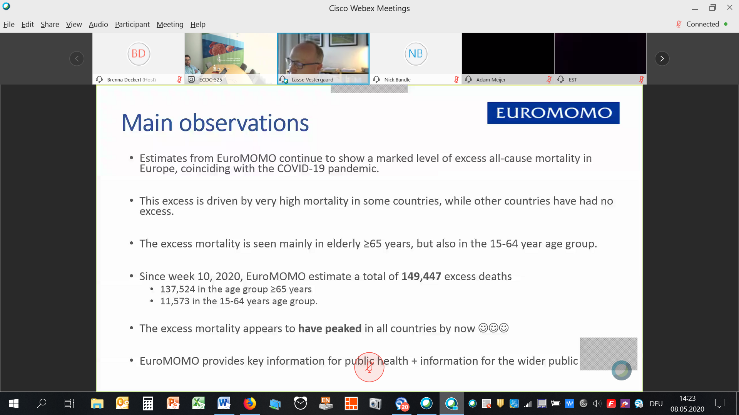
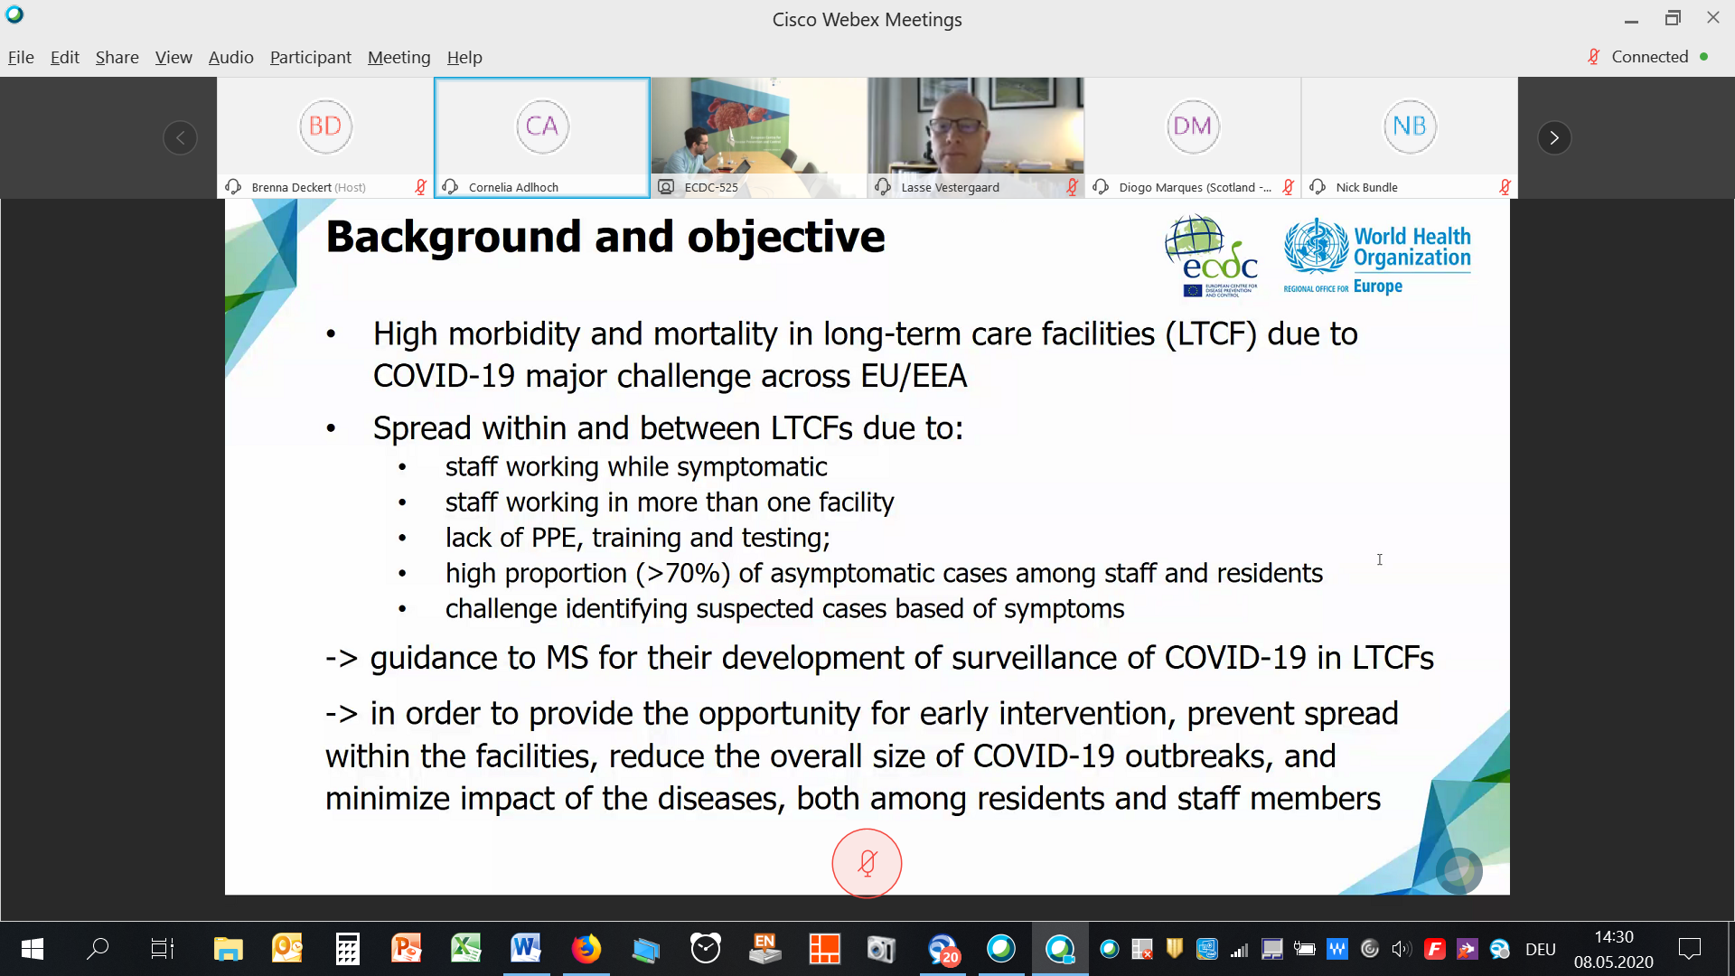
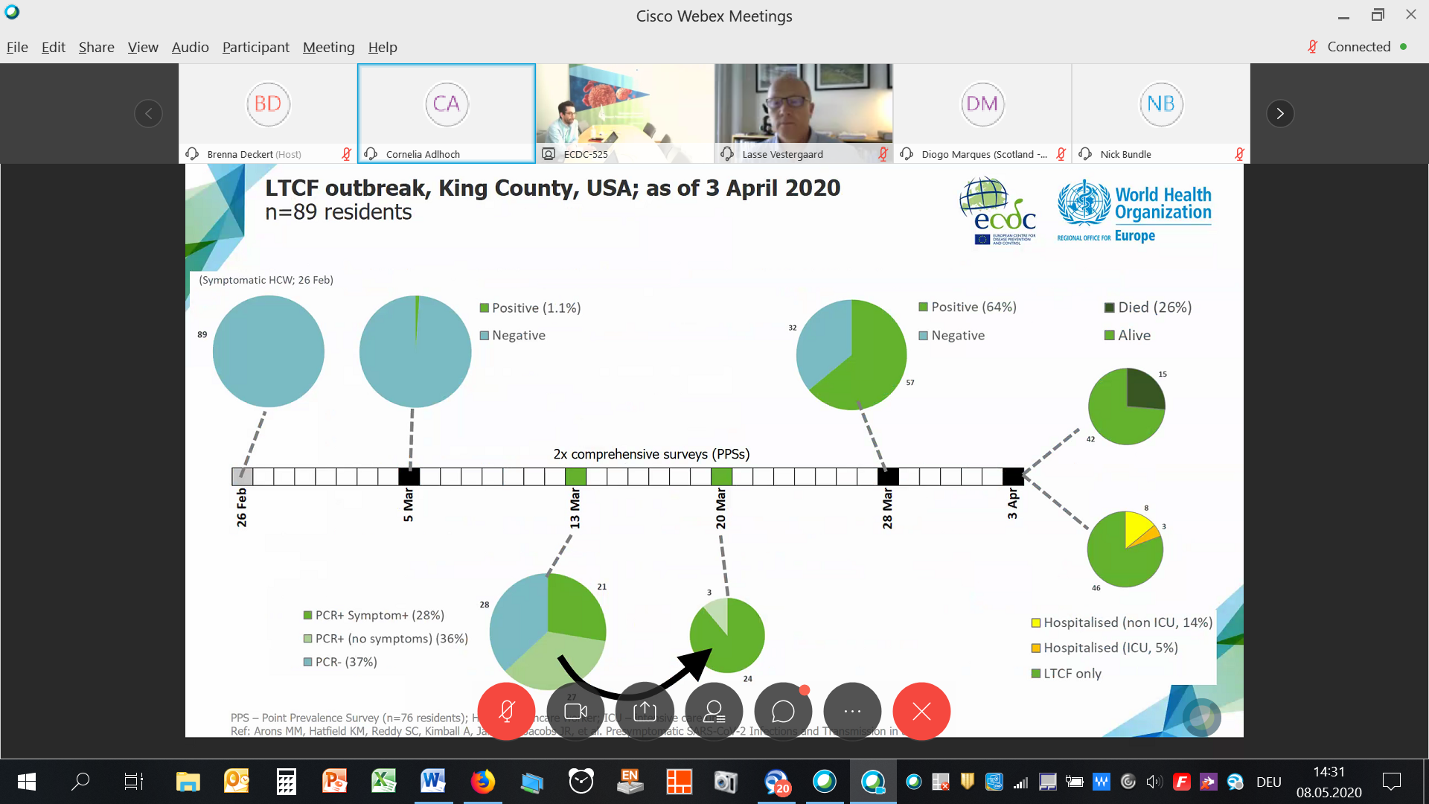
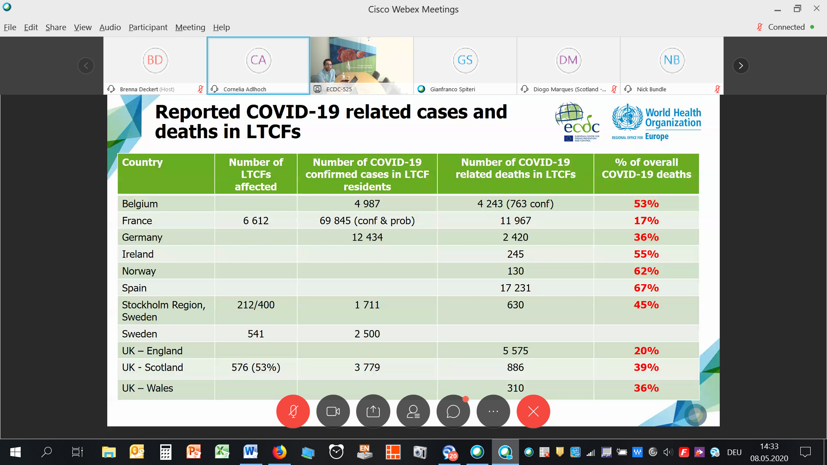
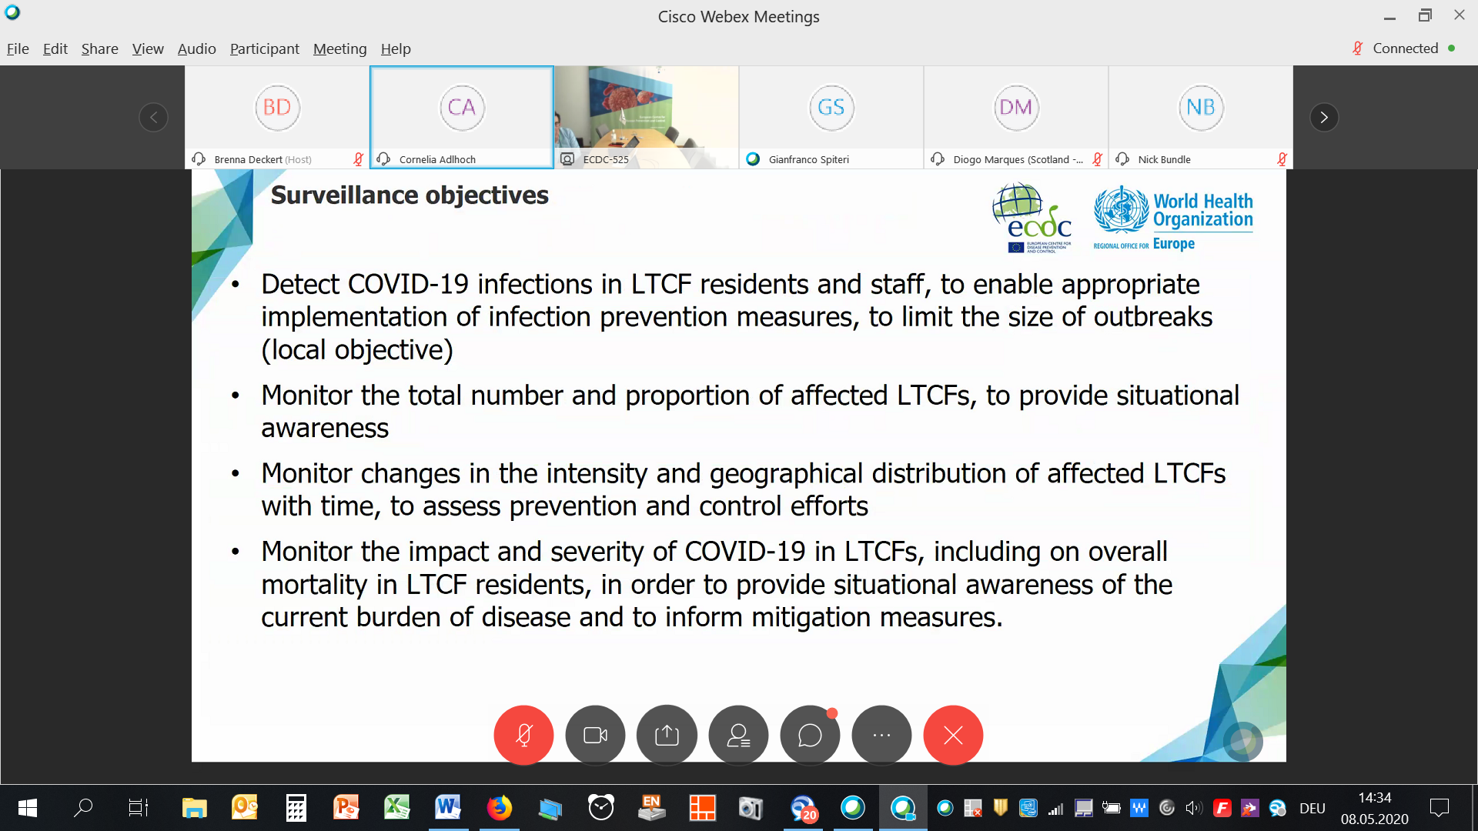
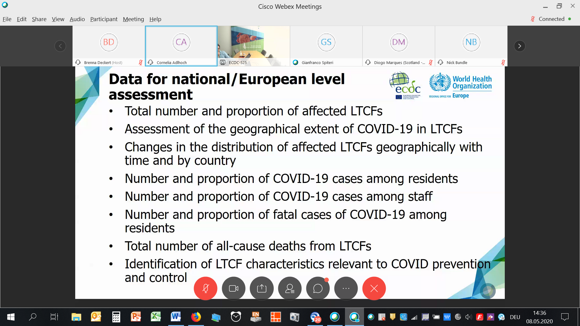
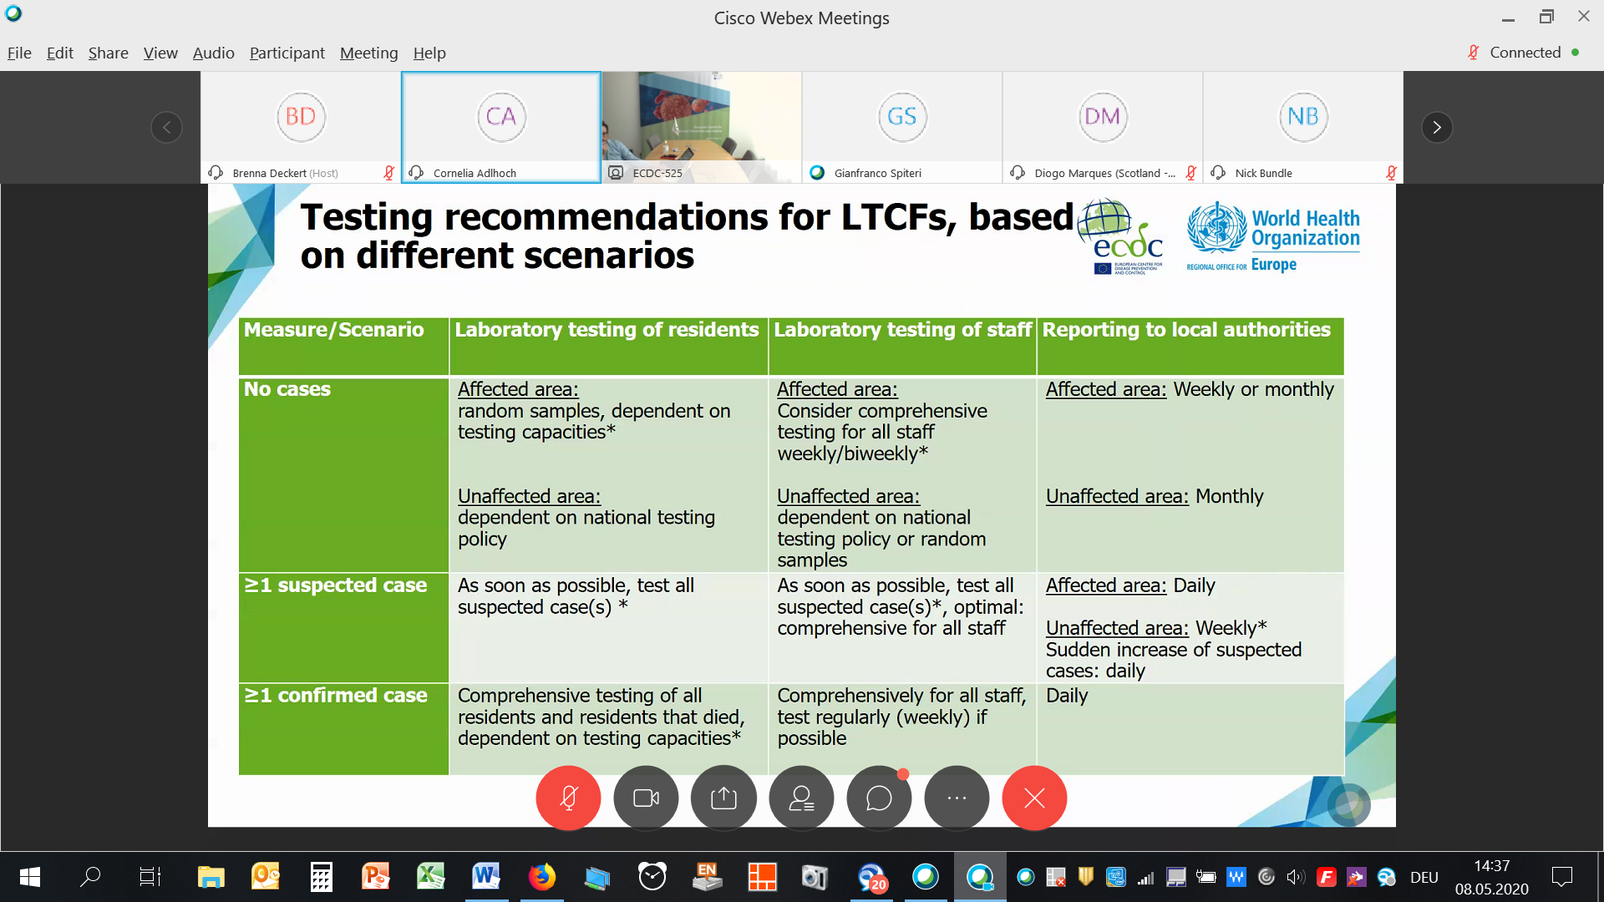
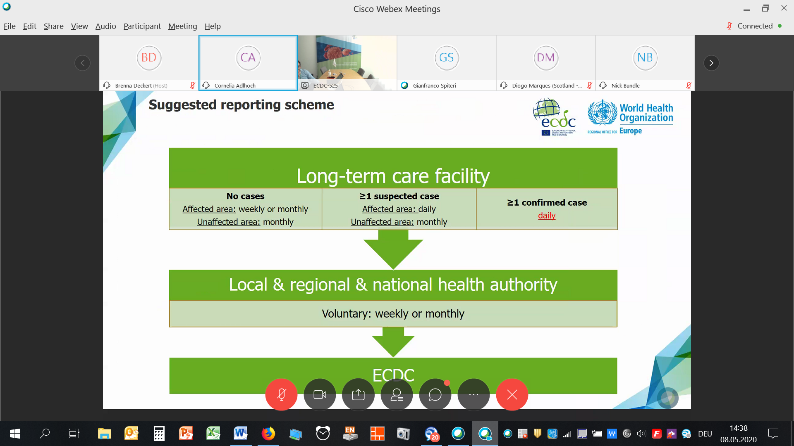

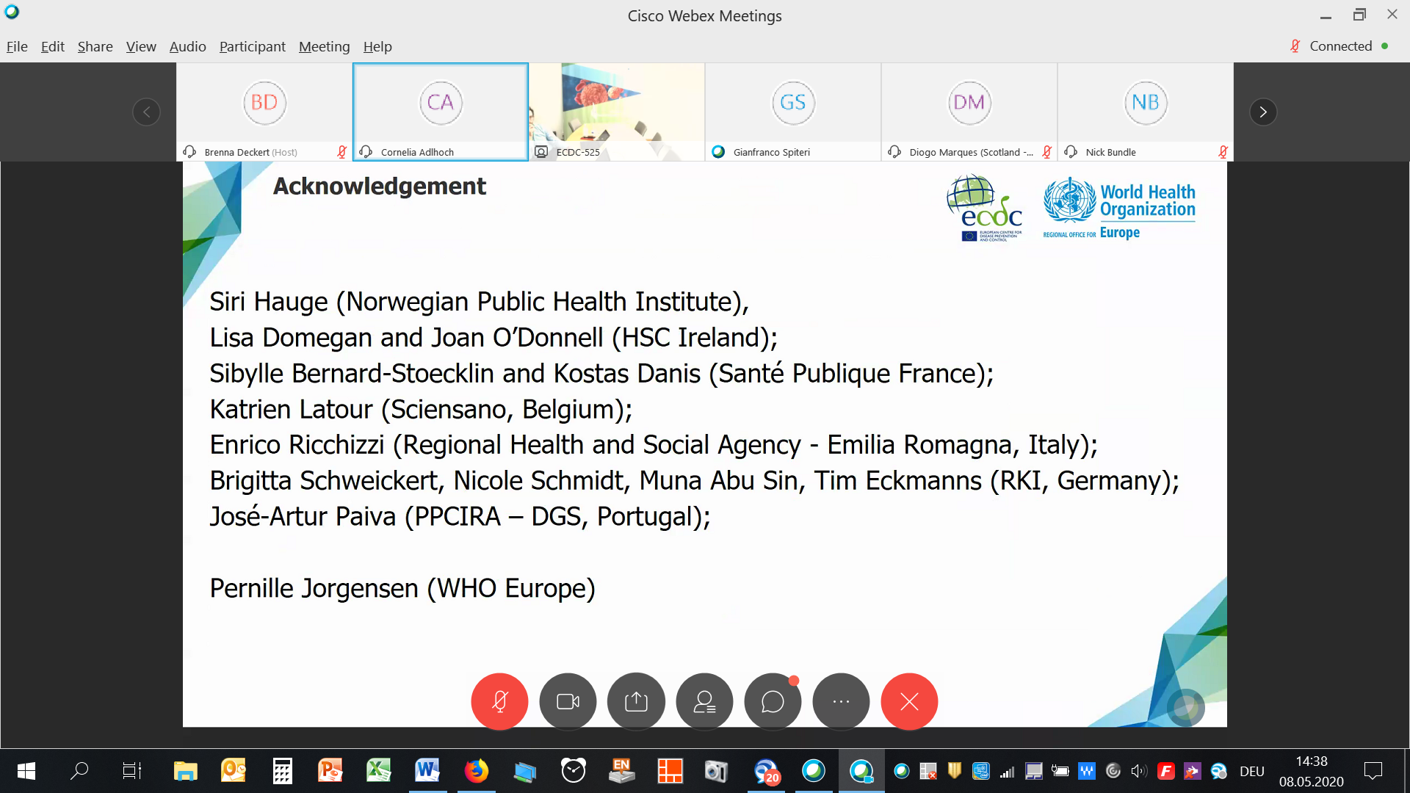
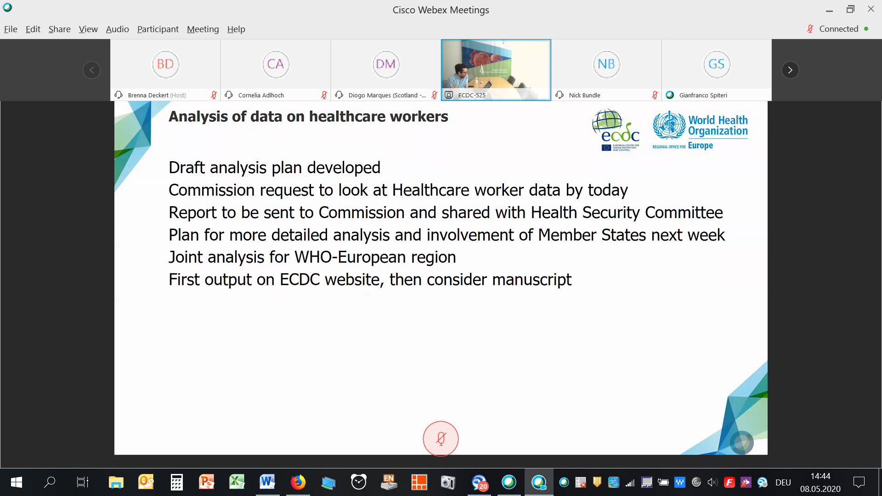
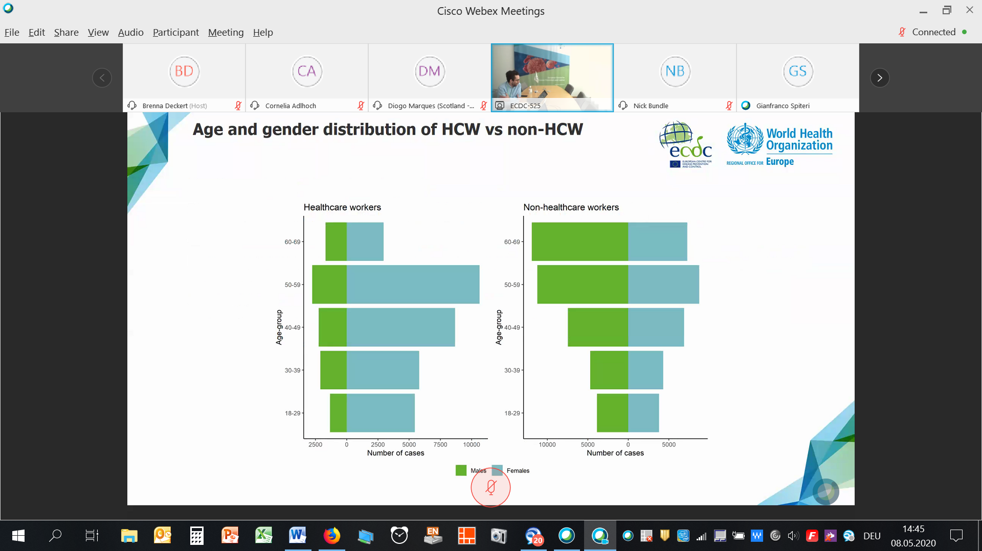
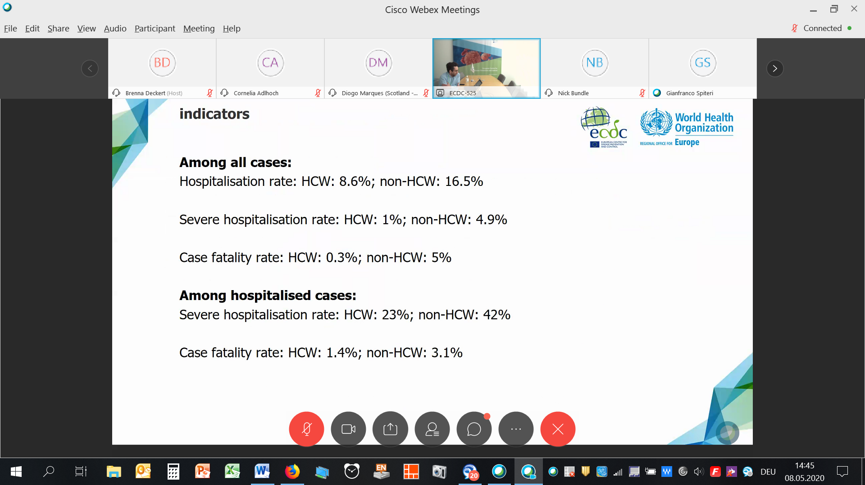
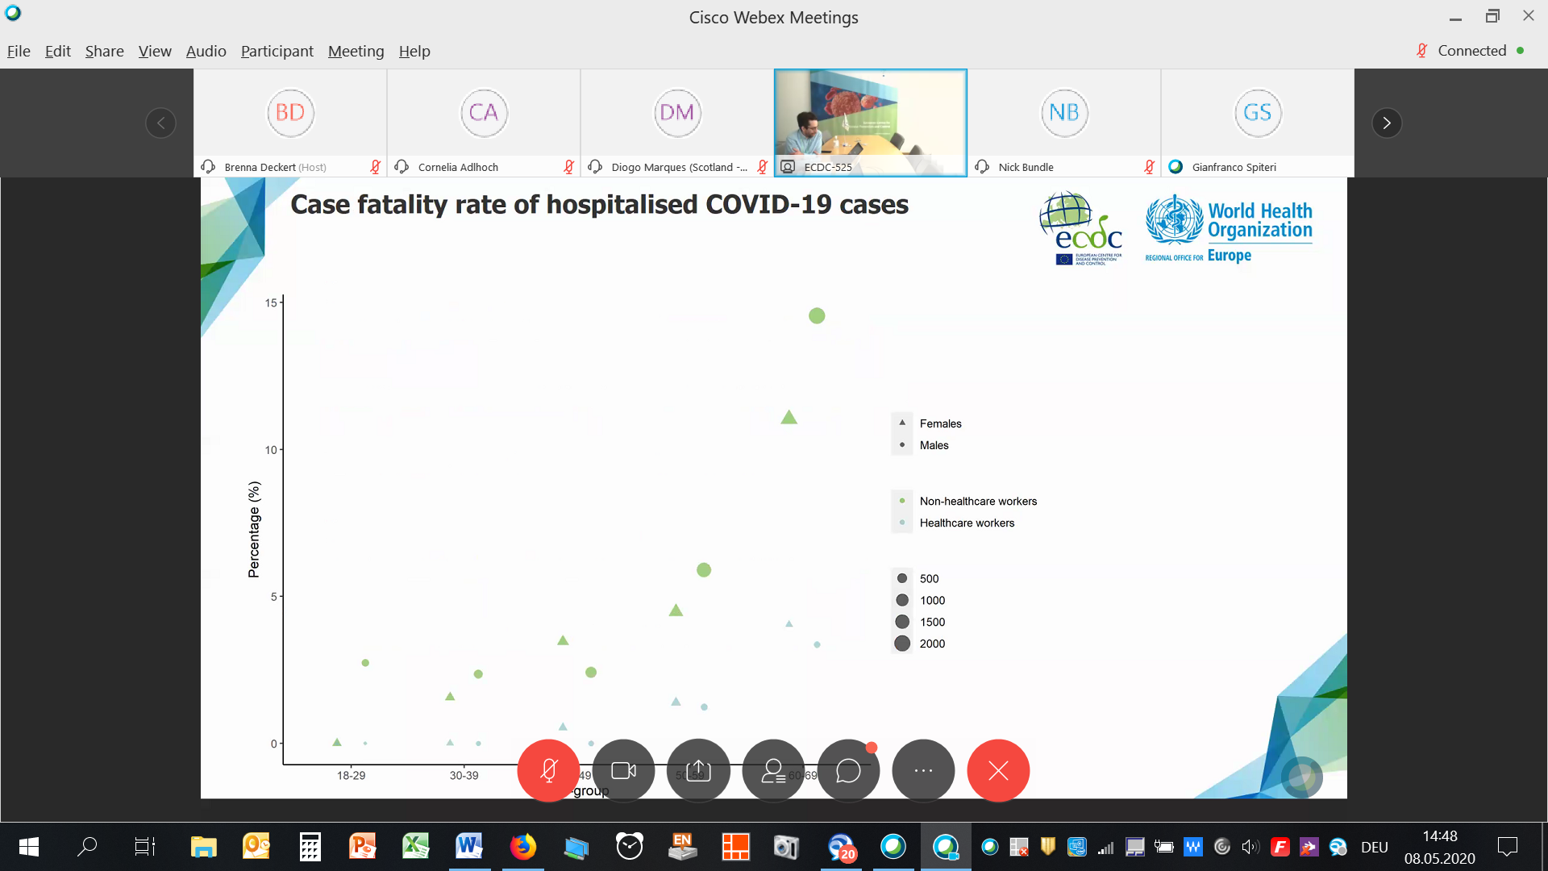
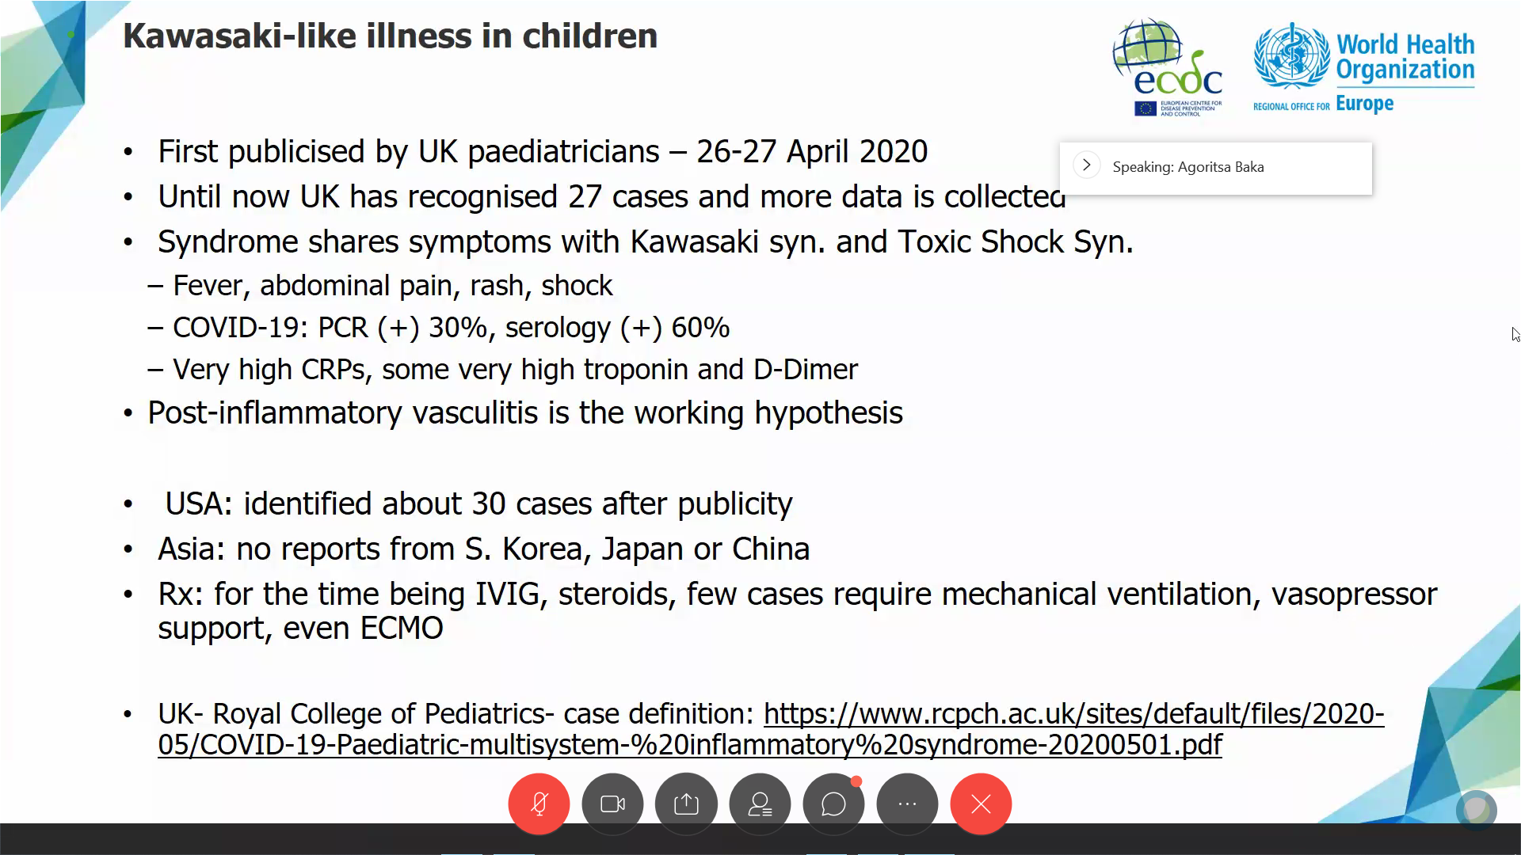
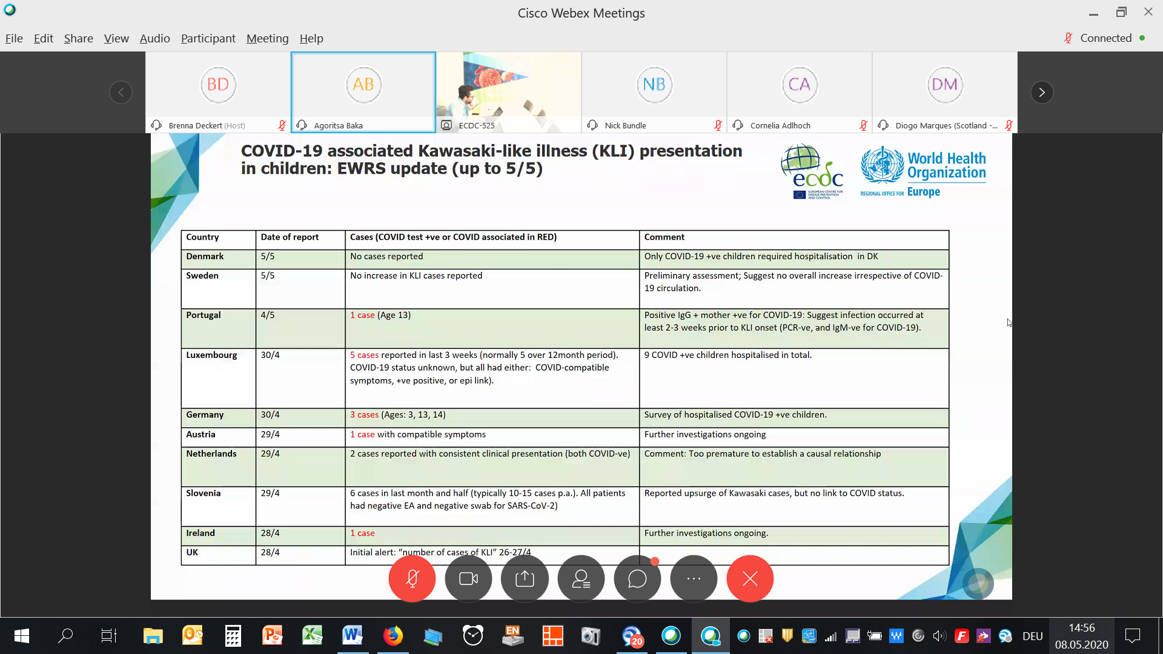
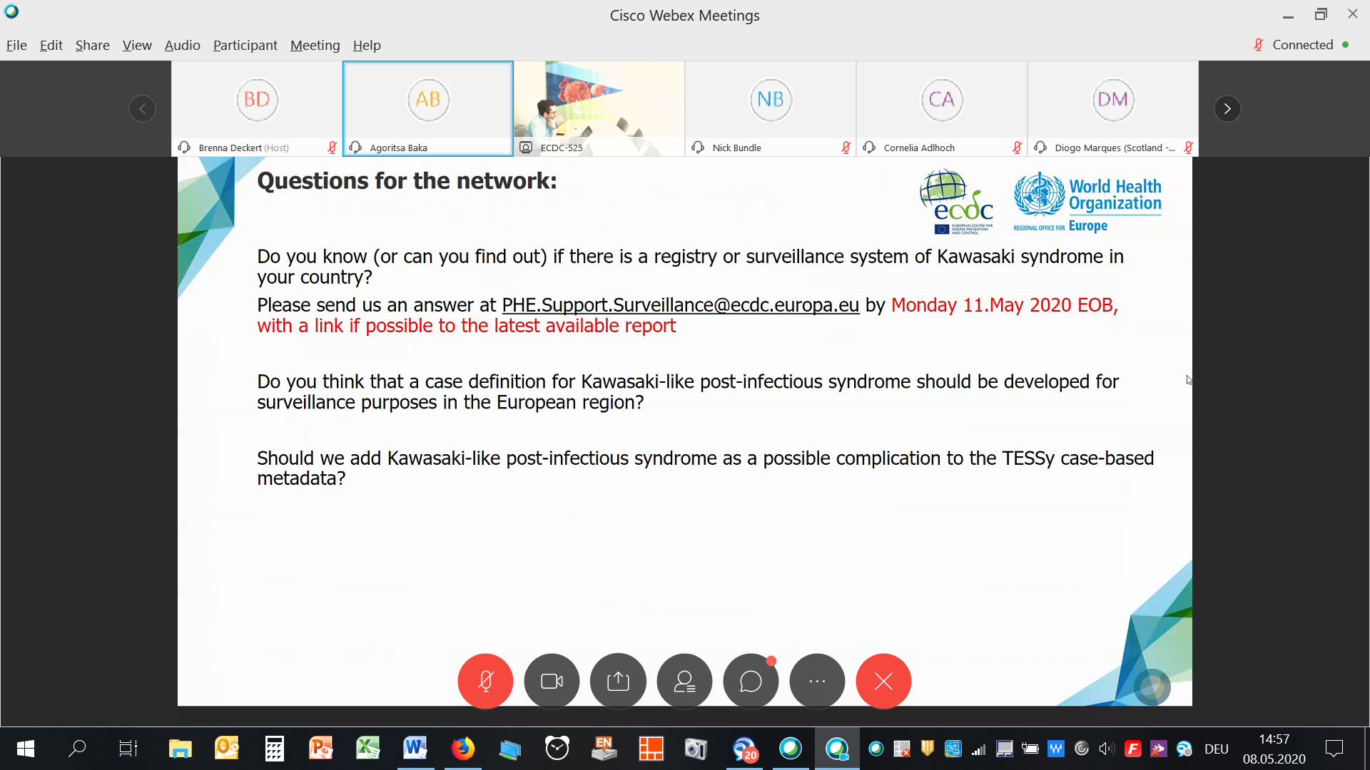
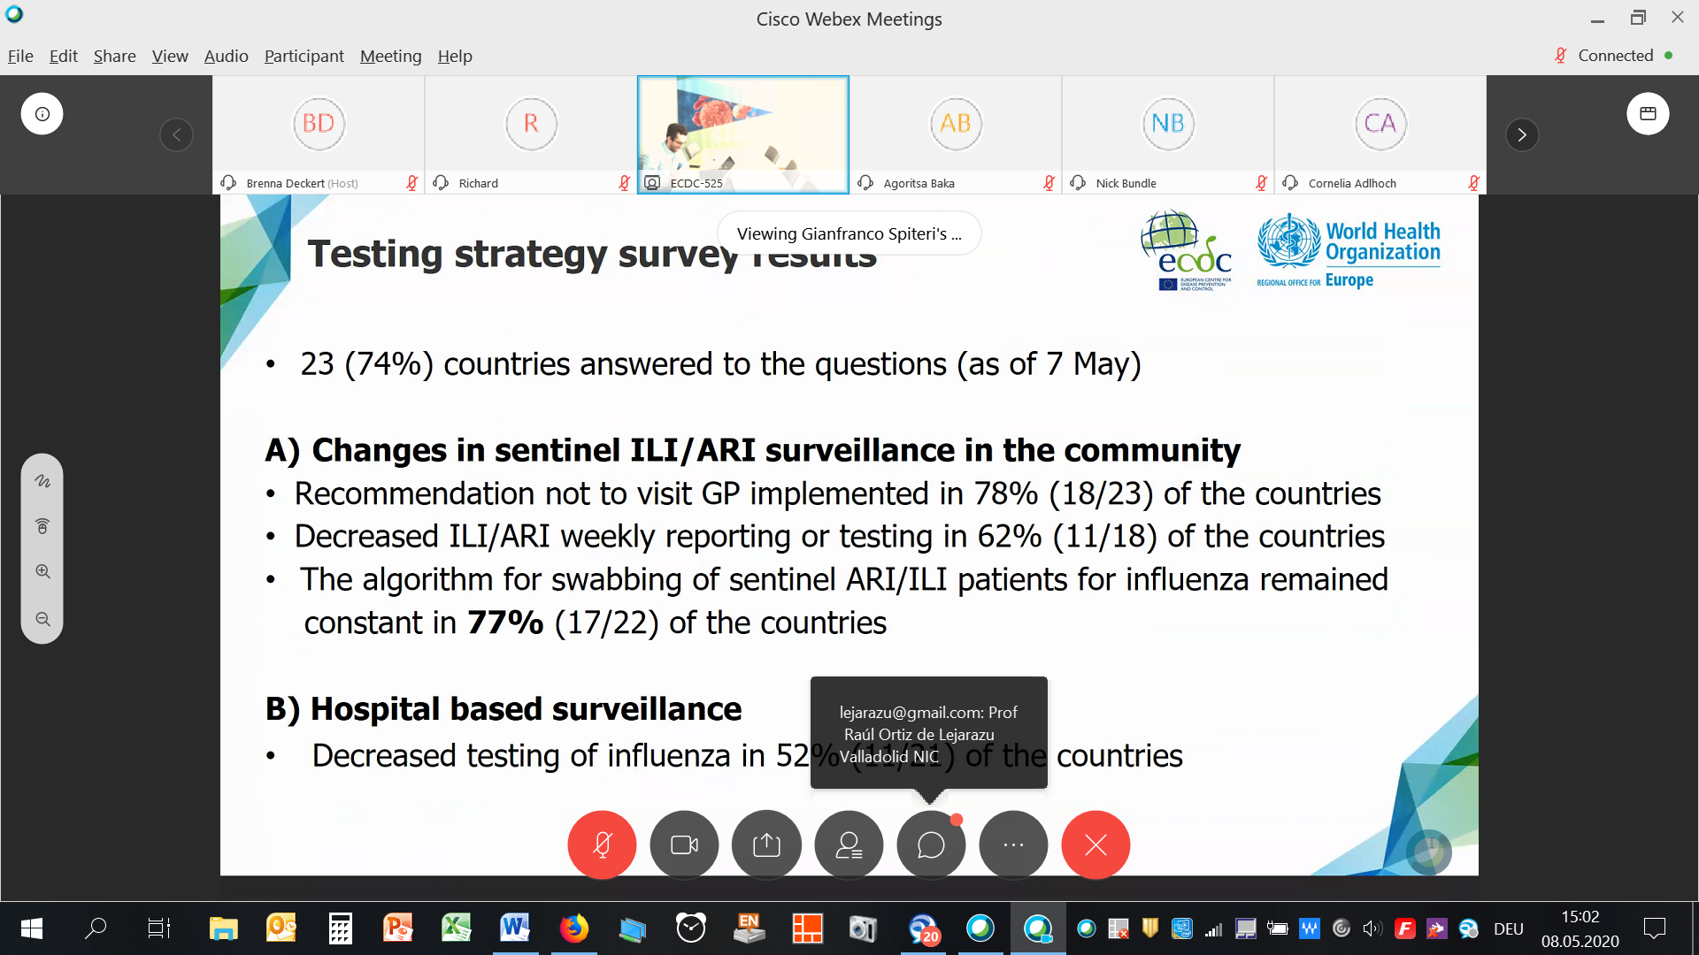
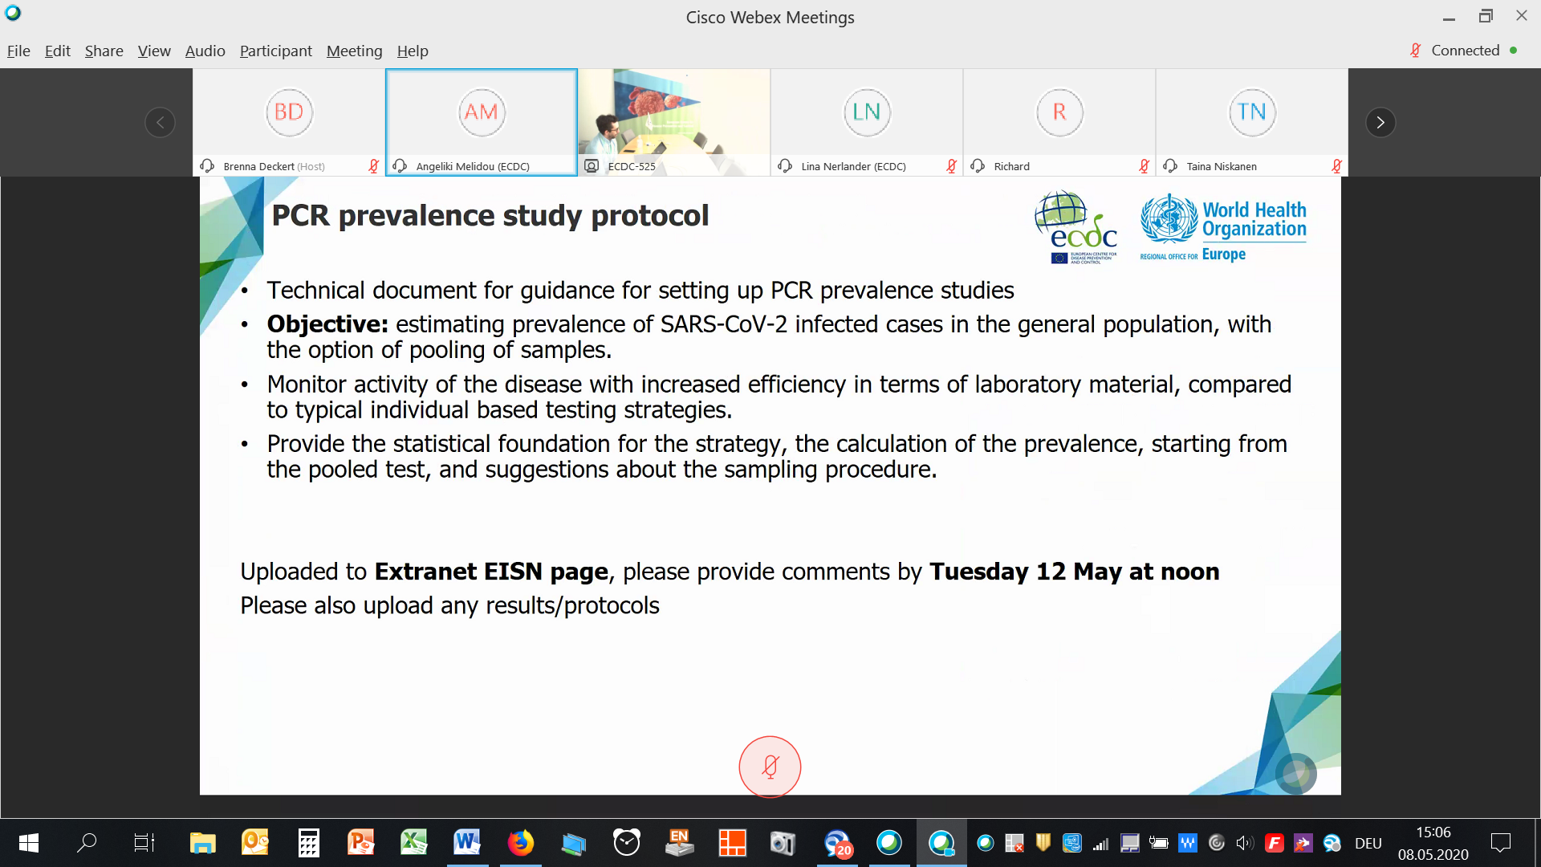
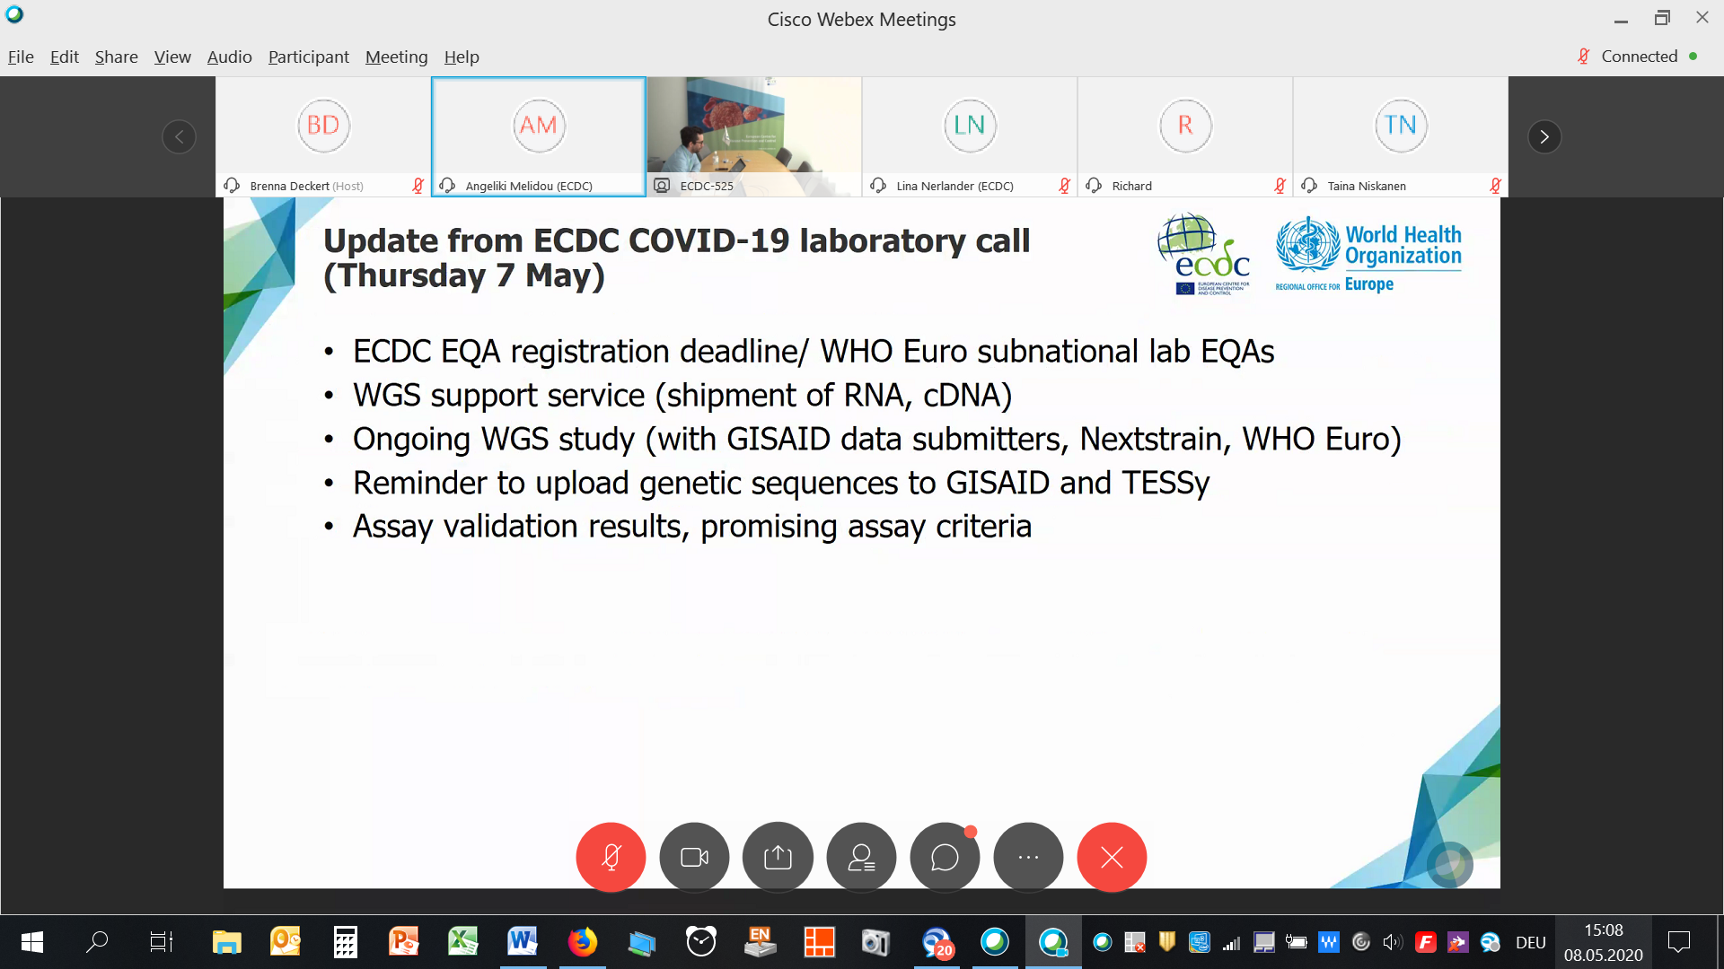
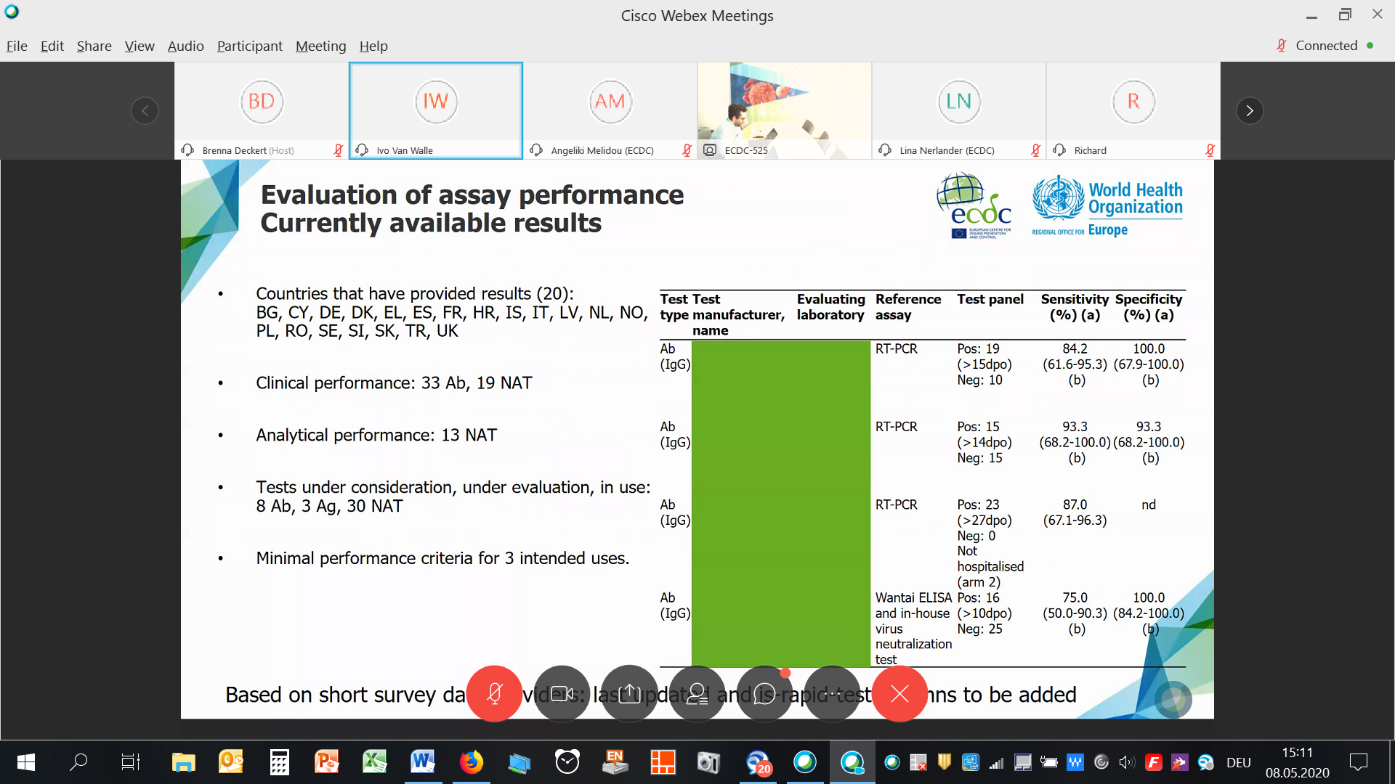

Kopie vom Chat:
from Gianfranco Spiteri to everyone:
Please feel free to comment/ask questions in the chat!
from Diogo Marques (Scotland - PHS) to everyone:
Publicly available data on COVID deaths in Scotland (both lab confirmed and as in death certificates): https://www.nrscotland.gov.uk/covid19stats
from Sibylle Bernard-Stoecklin SpF to everyone:
Thank you Diogo, very interesting!
from Cornelia Adlhoch to everyone:
Thanks a lot, how frequently doyou update? weekly which day?
from Diogo Marques (Scotland - PHS) to everyone:
Thank you Sibylle. Connie, data is updated weekly now :) both report and open data, it is really interesting. I cannot take credit as this is done by a "sister" organisation in Scotland but we work really closely with them.
from Diogo Marques (Scotland - PHS) to everyone:
As part of enhanced surveillance I'm also interested in ascertaining how much COVID-19 there is in deaths that do NOT have COVID in their death certificate to 1) ascertain underreporting and 2) validate/monitor death certification over time (we know that in begining doctors were reluctant to put COVID19 in death certificates due to implicates for funeral directors (PPE) and funerals).
from Diogo Marques (Scotland - PHS) to everyone:
If any country is planning similar surveillance it would be really interesting to collaborate/share protocols.
from Sibylle Bernard-Stoecklin SpF to everyone:
We will try to estimate the deaths attributable to COVID-19 in the near future at Santé publique France (no protocol yet), so happy to collaborate !
from Diogo Marques (Scotland - PHS) to everyone:
Thank you Sibylle, thats great :)
from Hanna Nohynek to everyone:
the Brighton collaboration group might also help developing the case definition since once could think that after COVID vaccination this is something that should be ruled out as possible AEFI
from Sibylle Bernard-Stoecklin SpF to everyone:
In France, we are establishing a surveillance system of Kawasaki syndrome related to COVID-19, with a case definition, together with the pediatricians
from Richard to everyone:
INoPSU I think are involved in developing a common case definition
from lejarazu@gmail.com to everyone:
I think Societies Pediatrics coul help on that
from lejarazu@gmail.com to everyone:
Prof Raúl Ortiz de Lejarazu Valladolid NIC
from Helena Rebelo-de-Andrade to everyone:
HCoV-NL63 infection also were associated with Kawasaki disease in childhood that may result in aneurysms of the coronary arterie
from Hanna Nohynek to everyone:
also worthwhile touching bases with ESPID
from Gianfranco Spiteri to everyone:
Thanks all - we will follow up in the coming days on the Kawasaki syndrome issue and involve you.
from Diogo Marques (Scotland - PHS) to everyone:
Thank you be very welcome. In Scotland we can look into some data linkages between lab confirmed and Kawasaki disease diagnostics but unlikely to pick up anything due to data recording lag.
from Isabelle Thomas to everyone:
Does anyone have any information on the value of saliva testing for COVID PCR?
from Isabelle Thomas to everyone:
and the type of saliva device?
from Cornelia Adlhoch to everyone:
https://www.nejm.org/doi/full/10.1056/NEJMoa2008457?url_ver=Z39.88-2003&rfr_id=ori:rid:crossref.org&rfr_dat=cr_pub%3dpubmed
from Cornelia Adlhoch to everyone:
Have a look at the paper where they link PCR CT values, culture and days of symptom onset
from Isabelle Thomas to everyone:
thank you !
from Richard to everyone:
Paper by Wolfel et al 2020: At this time, replication-competent virus has not been successfully cultured more than 9 days after onset of illness. Estimated likelihood of recovering replication-competent virus approaches zero by 10 days.
from Goranka to everyone:
Is it 9 days cut-off from the symptom onset even if positive RT-PCR even 4-5 weeks atfter symptom onset? I'm aware of recent publication of not being able to cultivate virus in samples taken after 9 days of symptom onset. Thankss, Goranka.

