

Ontaneously c

**COVID-19 in children and the role of school settings in COVID-19 transmission**

**DRAFT TECHNICAL REPORT 31 July 2020**

|  |
| --- |
| Key messages   * A small proportion (<5%) of overall COVID-19 cases reported in the EU/EEA and the UK are among children (persons 18 years and younger). When diagnosed with COVID-19, children are much less likely to be hospitalised or have fatal outcomes as compared to adults. * Children are more likely to have mild or asymptomatic infection, meaning that infection may go undetected or undiagnosed. * When symptomatic, children shed virus in similar quantities as adults. The infectiousness of asymptomatic children is unknown. * While very few significant outbreaks of COVID-19 in schools have been documented, they do occur, and may be difficult to detect due to the relative lack of symptoms in children. * Available evidence indicates a tendency towards lower levels of antibodies among children and adolescents compared to adults. More specialised studies need to be performed with focus on this population to better understand infection as well as antibody dynamics. * No evidence was found to suggest that children are the primary drivers of SARS-CoV-2 transmission in schools, in particular in preschools and primary schools. * Schools are unlikely to be worse propagating environments than occupational or leisure activities with similar densities of people. * Closures of childcare and educational institutions are unlikely to be an effective single control measure for community transmission of COVID-19 and cannot be justified based on protecting the health of children, who develop very mild, if any, disease from COVID-19. * Decisions on control measures in schools and school closures/openings should be made consistently with decisions on other physical distancing and public health response measures within the community. |

Glossary

The school structures within the EU/EEA Member States and UK are heterogeneous, with children entering and moving through educational establishments at different ages [1]. Given this variation, it is not possible to define the age of attendance in EU education establishments with full consistency. Hence for the purpose of this document, the following classification has been used:

|  |  |
| --- | --- |
| **Preschools** | Establishments including childcare, day cares, nurseries and kindergartens for children under < 5 years of age, but may include older children in some EU settings. |
| **Primary schools** | Establishments providing early year compulsory education, which in most EU settings include children 5-11 years of age. |
| **Secondary schools** | Education establishments for children 12-18 years of age. |
| **Schools** | The generic term used to define all educational establishments within the scope of the document, and it can be inferred that this includes all three categories of schools referred to above unless otherwise stated. |
| **Staff** | Includes teachers, administrators and management, school nurses, janitors, cleaning and kitchen personnel and other adults working in the childcare and educational settings. |

Scope of this document

The aim of this document is to provide an overview of the epidemiology and disease characteristics of COVID-19 in children (0-18 years) in EU/EEA countries and the United Kingdom (UK), and an assessment of the role of childcare (preschools; ages 0- <5 years) and educational (primary and secondary schools; ages 5-18 years) settings in COVID-19 transmission.

Target audience

The target audience for this report is public health authorities in EU/EEA countries and the UK.

**Background**

Although fewer than 5% of COVID-19 cases reported in EU/EEA countries and the UK have been persons under 18 years of age, the role of children in SARS-CoV-2 transmission remains unclear, especially in the context of educational settings. Available evidence to-date indicates that children most likely contract COVID-19 in their households or through contact with infected family members, particularly in countries where school closures and strict physical distancing has been implemented [2,3].

Following the declaration of COVID-19 as global pandemic in early March, many EU/EEA countries and the UK began to close schools to limit the spread of the virus despite having limited evidence whether childcare and educational settings play a role in transmitting SARS-CoV-2. These decisions were based on what is known of the impact of pre-emptive early school closures on transmission of pandemic influenza. Over subsequent months, Member States have adjusted policies on schools as the pandemic has progressed.

On 24 March 2020, preschools and primary schools were still open in (25/31) (80%) and 27/31 (87%) of the EU/EEA countries and the UK respectively, while 29 (93%) and 27 (87%) out of 31 EU/EEA countries and the UK had closed secondary schools or higher education respectively.

By 20 April 2020, 80% (25/31) of EU/EEA countries and the UK had implemented full or partial closure of preschools, 94% (29/31) closed primary schools and 100% had closed secondary schools or higher education (31/31).

From mid-May following reduction in the number of COVID-19 cases and/or deaths, EU/EEA countries started to re-open schools at least partially. In the week beginning 18 May (week 21) 19 countries (61%) reported closure of preschools and 24 (77%) reported closure of primary schools; respectively 6 and 5 fewer countries in comparison to the previous month.

From mid-June, EU/EEA countries had removed closure notices in the majority of preschool and primary schools; in the week beginning 15 June (week 25) closures were in place in only 9 (29%) and 14 (45%) of countries respectively, but secondary school closures were retained in 20 countries (65%). Despite policies on school closures or opening, schools in many countries in Europe had started summer holidays at around this time (exact dates vary across and within countries).

As of 29 July 2020, 21 EU/EEA countries and the UK had reopened their primary schools and preschools at least partially, although in many settings, school summer holidays were still ongoing.

Five Member States (Estonia, Finland, Iceland, Latvia and Sweden) never closed preschools and only two never closed primary schools (Iceland and Sweden).

**Figure 1:** Total number of EU/EEA countries & the UK (N=31) that enacted some form of school closures over the lifetime of the pandemic1.

*1Totals are the sum of countries that had any form of school closure or restrictions in place at each specific time point, including those with only partial closures in place.*

Approaches to school closures have not been binary in most Member States. Various policy approaches have been deployed that can be termed as ‘partial closure’ particularly during the recent phases of the pandemic when many countries were reducing societal interventions and reopening schools. ‘Partial’ measures taken include restricting class sizes, opening schools only for specific age/year groups, organising lessons with staggering timetables or alternating student cohorts between remote and in-school teaching [4].

ECDC has been collecting detailed information on childcare and educational setting closures in each individual country over time, by preschool, primary and secondary school (**Annex 1**). This includes partial closures (which in this context means any approach other than complete closure throughout the country).

A number of other non-pharmaceutical interventions (NPI) have been used as measures to reduce the risk of SARS-CoV-2 transmission in school settings when these have been open with the aim to decrease the number of people in the school building, and/or to decrease the probability of infectious cases participating to school activities. These include basic advice to maximise physical distancing (supported by partial school closures in many cases), and encouragement/regulations for sick students, teachers and staff to stay home. Some countries in which schools had been closed also prepared detailed plans and guidance for their re-opening, Belgium and the United Kingdom being two such examples. A summary of NPI approaches used, including specific examples of actions taken by individual Member States, is presented in **Annex 2**.

Many national and international organisations have published guidance related to the organisation of schools to address risks from COVID-19, including WHO and several EU/EEA Member states and the UK. Examples are listed in **Annex 3**.

The effect of school closures on the transmission of SARS-CoV-2 in the EU/EEA and the UK is largely unknown, but the effect of school closures on children’s health and well-being has been well-documented and researched over the years after influenza pandemics and after school closures during summer months.

Impact of school closures on the health and well-being of children

A diversity of negative impacts of school closures on children’s wellbeing, learning opportunities and safety have been identified by multiple organisations [4-6]. These range from learning interruptions, exacerbation of disparities and mental health issues, to increasing risk for domestic violence. The negative impacts affect in particular children from vulnerable and marginalised population groups.

A report from the European Network of Ombudspersons for Children (ENOC) and UNICEF [6] indicates that children living in precarious conditions, and/or from ethnic minorities have faced more difficulties with distance learning both because of digital poverty and because of difficulties in parents being able to assist in the learning process.

The United Nations Educational, Scientific and Cultural Organisation (UNESCO) [7] highlights that when schools close, children and youth are deprived of opportunities for growth and development. These disadvantages are disproportionate for under-privileged learners who tend to have fewer educational opportunities beyond school. Furthermore, economic circumstances can put at risk the return to school for those children and youth that are pressured to work and generate income for financially distressed families.

Other health aspects, both physical and mental, also need consideration. For many students living in poverty, schools are not only a place for learning, but also for eating healthily, therefore researchers warn that school closures will exacerbate food insecurity [7]. Research have highlighted that the active social life children aged 2- 10 years have at school, helps them to learn from peers and has positive impacts on personality traits and sense of identity, while disruptions of close peer relationships have been associated with depression, guilt, and anger in children [8]. Furthermore, school and extracurricular activities are among the activities that provide structure, meaning and a daily rhythm for children and youth. For those suffering from anxiety and depression, the loss of such activities can worsen symptoms and further cement social withdrawal and hopelessness [10].

The report from The European Network of Ombudspersons (ENOC) and the United Nations International Children's Fund (UNICEF) also highlights other consequences of school closures [6]. Children with disabilities may be particularly affected as they can feel more isolated when schools and special services are closed and they have limited possibilities for digital communication. In addition, more time spent online increases the risk for children of cyber-bullying.

ECDC Guidance on the provision of support for medically and socially vulnerable populations [11]highlights that children are at increased risk of domestic violence during periods of school closures associated with health emergencies. The guidance indicates that, with schools closed, children lose a safety-net that can detect and report child abuse, as well as an external social network and the support for coping with abuse at home.

Methodological approach

This technical report provides an overview of the epidemiology and disease characteristics of COVID-19 among children, and an assessment of the role of childcare and educational settings in COVID-19 transmission.

**To address the epidemiology and disease characteristics of COVID-19 in children**, a summary of evidence was produced based on analysis of data from two different sources:

1. Case-based epidemiological data from the European Surveillance System (TESSy);
2. Data from the scientific literature that focuses on disease characteristics of COVID-19 with a focus on the population aged 18 years or younger. Searches were conducted to collect and to provide an overview of the latest available evidence on COVID-19 disease background in children, covering the following aspects: symptoms, severity, complications, viral shedding, infection, transmission, immune response and immunity.

**To address the role of schools in driving community transmission** information was gathered from literature searches and a survey with follow-up calls.

1. Literature searches

These were performed using the daily literature searches conducted by ECDC to collect the latest available publications on COVID-19. The ECDC COVID-19 EndNote reference library contains more than 40000 records and is updated and maintained by the ECDC Library. The EndNote library is updated daily with results of a saved search designed to retrieve all new publications related to COVD-19 in PubMed, which is complemented with monitoring of journal websites, COVID-19 specific publishers’ portals for new publications and preprint portals for upcoming publications.

A more detailed description of the search is described in **Annex 4**. Articles were screened for relevance to the school settings specifically and were included or excluded based on the criteria described in Annex 2. Additional articles were considered for relevance if they were published while the review was ongoing so that the latest evidence could be included. The search was performed on 30 June 2020 and in total, 59 articles were retrieved.

1. Survey and follow-up calls

A two-question survey was distributed by email to the 31 ECDC Operational Contact Points for Influenza and COVID-19, as well as the countries’ National Focal Points (NFPs) for Influenza, NFP for Surveillance, NFPs for Preparedness and Response and the National Coordinators. The questions were:

1. Have there been any outbreaks of COVID-19 in educational settings in your country?
   1. If yes, have you undertaken any investigations in relation to these outbreaks?
2. Do you have any indications of transmission from children to adults in educational settings or in general (e.g. from household studies or contact tracing)?

Follow-up phone calls allowing further clarifications and informal discussions of a country’s experience were held with a subset of the responding countries.

Results

Epidemiology and disease characteristics of COVID-19 in children

As of 26 July 2020, children made up a very small proportion of the 744 448 cases reported to TESSy as case-based data in the EU/EEA and in the UK; 31 380 (4%) were children aged under 18 years. Of these, 7 044 (24% of children) were below five years of age, 9 645 (32%) between five and 11 years and 13 020 (44%) between 12 and 18 years.

The age distribution observed in the EU/EEA and the UK reflects testing policies and case definitions, which usually include the presence of symptoms. It is possible that the small proportion of cases reported among children reflects a lower risk of children developing COVID-19 symptoms or the fact that children are generally not prioritised for testing as they commonly experience milder symptoms, and as there might be lower tolerability/acceptance to test children given the invasiveness of nasopharyngeal swabbing.

Pooled and country-specific TESSy data are available in an online report series, published weekly on the ECDC website: [https://covid19-surveillance-report.ecdc.europa.eu/](https://covid19-surveillance-report.ecdc.europa.eu/#5_risk_groups_most_affected).

*Common signs and symptoms in children*

COVID-19, like SARS and MERS, is observed less frequently in children, who tend to present milder symptoms and have a better overall outcome than adults [11-15]. The most commonly reported symptoms in children are fever and cough [12,13,16]. Other symptoms include gastrointestinal symptoms, sore throat/pharyngitis, shortness of breath, myalgia, rhinorrhoea/nasal congestion and headache with varying prevalence among different studies [12,13,16,17].

In a cohort of 582 paediatric cases of SARS-CoV-2 infection from 21 European countries, signs and symptoms at presentation at the healthcare institution included fever (pyrexia) (65%), upper respiratory tract infection (54%), headache (28%), lower respiratory tract infection (25%) and gastrointestinal symptoms (22%) [18]. Correspondingly, studies from Italy [2,3,20,21], Germany [20], UK [23], Turkey [21] and Sweden [25] described similar symptoms and reported fever and cough as the most commonly observed symptoms. Gastrointestinal symptoms were more prevalent in children with severe COVID-19, compared to those with mild disease [26].

Asymptomatic infection in children has been described in several large case series from China, which reported 4% to 28% asymptomatic paediatric cases in cases tested based on symptoms, signs or contact tracing [23,24]. A recent systematic review presenting data on 2 914 paediatric patients with COVID-19 from China, Spain, Iran, the Republic of Korea and the United States identified 14.9% asymptomatic cases in children [14]. Others have reported 18% asymptomatic cases in a meta-analysis of 551 laboratory-confirmed cases in children [29] and 16% asymptomatic cases among a European cohort of 582 children [18]. Similar observations were made for infants and neonates, of whom 16% were asymptomatic in a review of 160 infants with confirmed COVID-19 [17].

One explanation for why children might have milder symptoms of COVID-19 than adults is that children have a much more effective innate immune response than adults or elderly people. The observation of virus transmission by asymptomatic cases is strengthening the scientific evidence that the highly effective innate immune response against viruses, such as in children, provides a sufficient suppression of virus replication to prevent the development of COVID-19 specific symptoms [30].

Another explanation for milder symptoms in children is the possibility of cross-immunity against SARS-CoV-2 developed by the previous seasonal coronavirus infection. There is conflicting evidence about cross-immunity from prior seasonal coronavirus infection and anti-SARS-CoV-2 antibody levels [27,28] and [28,29]. Children seem to be better protected from COVID-19, because they have a well-functioning or rapidly responding immune system that also does not tend to overreact to the present human coronaviruses.

*Severity and complications*

Among children reported by EU/EEA countries and the UK to TESSy, the proportion of cases hospitalised were lowest in the age-groups 5-11 years and 12-18 years (3% and 4% respectively) and highest among 0-4 year olds (10%). Among adults, the proportion of hospitalised cases increased with age and was highest among 70-79 and 80-89 year olds (39% and 35% respectively) (Figure 2a). Deaths among cases under 18 years of age were extremely uncommon; only six out of a total of 19 654 (0.03%) deaths reported in TESSy were among children (among countries reporting complete data on outcome). This corresponds to a crude case-fatality of 0.03% among those aged under 19 years, compared to 5.8% among those aged 18 years and above, driven largely by deaths in cases aged 60 years and above, where case-fatality rates increase to 36% among those aged 90 years or above (Figure 2b). In weekly monitoring of all-cause deaths in 24 participating European countries or regions, mortality among 0-14 year old children has not exceeded background rates in stark contrast to the significant excess mortality among the older adult age groups [34].

Figure 2a. **Proportion of hospitalised COVID-19 cases by age-group, TESSy, EU/EEA and UK, 26 July 2020**

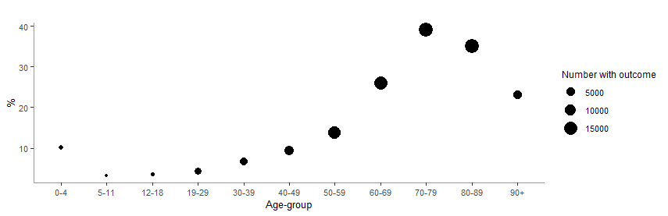

Figure 2b. **Crude case fatality rate by age-group among all notified COVID-19 cases, TESSy, EU/EEA and UK, 26 July 2020**

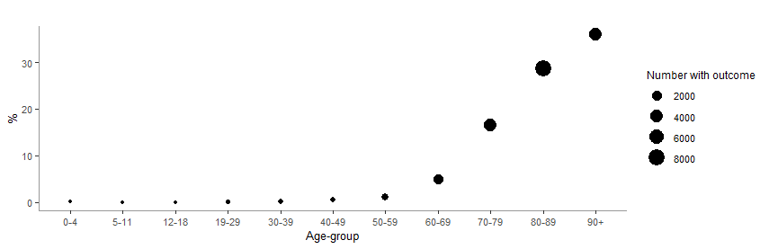

Severe or critical illness has been reported among 2.5% to 5% of paediatric cases from China [23,31], and more recently, 4% of cases were reportedly as severe or critical in a systematic review [36] and meta-analysis [13] of 4 857 and 2 855 children, respectively. Infants and neonates were described as more vulnerable to severe COVID‐19 compared to other paediatric groups in recent literature reviews [13,16,33], although a low mortality rate (0.006%) with favourable outcomes in most cases was reported for this group [16,18].

Pre-existing medical conditions have been suggested as a risk factor for severe disease and ICU admission in children and adolescents [17,18].

Several countries affected by the COVID-19 pandemic reported cases of children who were hospitalised in intensive care units due to a rare paediatric inflammatory multisystem syndrome (PIMS) or multisystem inflammatory syndrome in children (MIS-C) [34-36], characterised a systemic disease involving persistent [fever](https://en.wikipedia.org/wiki/Fever), [inflammation](https://en.wikipedia.org/wiki/Inflammation) and organ dysfunction following exposure to SARS-CoV-2 [37-39]. For further information on PIMS in SARS-CoV-2 patients please refer to the ECDC rapid risk assessment [44]. Paediatric patients have also been reported with cardiovascular involvement [41-44], namely myocarditis, as well as with renal dysfunction [45,46].

Viral shedding of SARS-CoV-2 among children

The detection of viral RNA by PCR does not directly indicate infectivity. Nevertheless, the detection of viral RNA and the measure of viral load are potentially useful markers for infectiousness as well as for assessing disease severity and prognosis. Overall for COVID-19 patients, SARS-CoV-2 viral RNA has been detected in most bodily fluids including blood [47-49], saliva [47,48], nasopharyngeal specimens [50], urine [55], and in stool [52,53]. Based on the limited case data, children may display a shorter *duration* of viral shedding of SARS-CoV-2 through the upper respiratory tract than adults. In contrast, children show prolonged viral shedding via the gastrointestinal route after clearing the virus from the respiratory tract [58].

There does not appear to be a significant difference in viral RNA load between symptomatic children and symptomatic adults, indicating that children would shed viral RNA (whether viable or not) in a similar pattern as adults [59]. This does not however give indication of whether children transmit the infection to an equal extent given that exact load of viable virus is unknown, and as it will depend on from what specimen virus is identified (e.g. upper respiratory tract versus gastrointestinal).Children develop neutralizing antibodies after SARS-CoV-2 infection [33].

*Seroprevalence of COVID-19 antibodies among children*

Seroprevalence studies aim to determine the proportion of population groups that have detectable antibodies against SARS-CoV-2, which inform how many people that have been infected with the virus. A number of seroprevalence studies have taken place in EU/EEA region, while others are still on going. Table 1 summarises preliminary results found in literature searches or countries’ official websites. All studies were conducted after the peak of 1st wave in various time points, with regards to national response measures (before, during or after lockdown).

Table 1: **Descriptions and results of sero-epidemiological studies including children in EU/EEA Member States and Switzerland from public sources, as of 24 July 2020.**

|  |  |  |  |  |  |  |  |  |
| --- | --- | --- | --- | --- | --- | --- | --- | --- |
| Country | Number (n) | Type of study | Age group | Time of sampling (in 2020) | Timing | Laboratory method | Proportion of positive samples (%) | |
| Seroprevalence studies designed for children and adolescent population | | | | | | | |
| France  (Paris area)* [60] | 605 children | Prospective cross sectional multi-centre ambulatory paediatric clinics | 0-15 years | 14 April-12 May | After peak of 1st wave - during lockdown | Biosynex COVID-19 BSS test IgG/IgM | 10.7 | |
| Germany  (Baden-Württemberg)* [61] | 2 466 children | Cross sectional multi-center | 1-10 years | 22 April-15 May | After peak of 1st wave- during lockdown | Euroimmun IgG  Elecsys Anti-SARS-CoV-2 | 0.8 | |
| France  (Oise)* [62] | 242 students | Retrospective closed cohort in high school | 14-17 years | 30 March-4 April | After school outbreak -during lockdown | Multiple assays | 10.2 | |
| Germany (Saxony)* [63] | 1 538 students | Cross sectional in 13 Schools of the region | 14-17 years | 25 May-30 June | After peak of 1st wave - after lockdown | Diasorin LIAISON, CMIA and Abbott | 0.7 | |
| General population seroprevalence studies | | | | | | | |
| Spain [60] | 6 527 children | Nationwide population based household  random sampling – 2 collections | Household  Focus: 0-19 years | 27 April – 11 May | After peak of 1st wave – during lock down | POC (Orient Gene Biotech COVID-19 IgG/IgM) & Immunoassay (Abbott Laboratories) | 3.4- 3.8 | |
| Spain  (Barcelona) [65] | Overall sampling 311 individuals | Random age stratified population (asymptomatic children) | 0-14 &  15-29 years | 21 April - 24 April | After peak of 1st wave -During lock down | Rapid lateral flow immunoassay IgG/IgM | 0 & 10 | |
| Switzerland (Geneva) [66] | 214 children | Repeated population based household sampling | 5-19 years | 3 weekly samplings in April | After peak of 1st wave | Euroimmun IgG | 6.1 | |
| Belgium [67] | NA | Prospective cross sectional, residual samples | 0-20 years | 30 March -end April | During lockdown | Euroimmun IgG | 5 | |
|  |  |  |  |  |  |  |  | |
| Germany (Gangelt) [68] | 405 households | Random sample household study | 5-14 years &  15-34 years | 30 March -7 April | After peak of 1st wave - before lockdown | Euroimmun IgG | 9.1 &15.4 | |
| Germany (Neustadt-am-Rennsteig) [69] | 58 children | Population-based cohort – household sampling | Children-adolescents | 12-22 May | After peak of 1st wave -after lockdown | Combination of ELISA and CLIA/CMIA tests | 1.7 | |
| Netherlands [70] | Overall sampling 2 096 individuals | Random sample household study | 0-19 years | 31 March -13 April | During lockdown | NA | 1-2% | |
| Sweden  (multiple regions) [71] | 1 600 children | Residual sera from non-COVID-19 patients in primary care | 0-19 years | weeks 18-21 | No lockdown | Bead-based multiplex serology assay | 4.5-7.5 | |

Two studies, conducted by France and Germany [56-59], had a special focus on children (0-10 years) and two on adolescents (14-17 years) in school settings. Both studies in France found a prevalence of SARS-CoV-2 antibodies around 10% whereas in Germany the results were <1% among the young population.

A number of SARS-CoV-2 seroprevalence studies in the general population have been conducted. The methodology used in these studies was mainly a random household sampling, while others used convenience samples (e.g. residual sera). When extrapolating seroprevalence results for the young age group (0-18 years), the actual denominators for this population were not always shown in detail, or included very small sample sizes. This creates a limitation for the current synthesis and interpretation.

As described above, the seroprevalence results in the general population within the EU/EEA region vary from 0-10%. Although the sampling time frames differ among the countries performing the studies (in relation to local lockdowns) the extent of mitigation measures deployed does not seem to affect significantly the level or seroprevalence in the young population. Results from Sweden, which did not close schools or enforce mandatory lockdown measures, show a presence of 4.5-7.5% of SARS-CoV-2 antibodies among the young population over a period of 4 weeks, which is comparable to seropositivity among the adults.

In general, the majority of the countries report slightly lower seroprevalence found in children compared to young adult groups (20-55 years), however these differences are small and uncertain. Low level of antibodies found in children’s’ blood can be an indication that children are less susceptible to infection than adults, and therefore play a less significant role in the spread of the virus [70]. In a population seroprevalence study in Geneva [66], they estimated that in young children aged 5–9 years the risk of being seropositive was lower (RR 0.32 (CI 0.11–0.63) than in those aged 20–49 years.

In the study from Paris, with a relatively large number of children included (>600), they combined RT-PCR SARS-CoV-2 and serology results to assess the spread of SARS-CoV-2 infection (i.e. the study captures both people with ongoing viral infection and those with antibodies from past exposure to the virus). Less than 2% were positive for RT-PCR for SARS-CoV-2, while seropositivity was much higher (10.7%). No significant difference was seen in the proportion of positive RT-PCR or serology results between asymptomatic and paucisymptomatic children. However, asymptomatic children with no history of symptoms during the preceding weeks accounted for two thirds of children with positive serology results (28/41), which supports the hypothesis that asymptomatic infections are more frequent in the young in comparison to older age groups.

In summary, cross-sectional epidemiological studies show a tendency towards lower levels of antibodies among children and adolescents compared to adults. The study done in Sweden did not show a difference between those under 19 years of age and working age adults. More specialised studies need to be performed with focus on this population to better understand infection as well as antibody dynamics.

Evidence relating to the role of childcare and educational settings in COVID-19 transmission

Evidence related to the role of childcare and educational setting in COVID-19 transmission between children and adults relies on detection of potential cases or clusters followed by extensive contact tracing and follow-up to determine if any close contacts develop symptoms and test positive for SARS-CoV-2 within the 14-day incubation period. Evidence is provided in the following sections from Member State reports to a country survey, as well as through the scientific literature.

*Overview of outbreaks and transmission in childcare and educational settings: experiences from Member States*

Out of 31 EU/EEA and UK countries, 15 countries[1] replied to the survey. To gather more detailed information and clarification on their replies, five countries[2] were invited for a follow-up phone call lasting between 15 and 35 minutes.

Of the 15 countries responding to the survey, six countries specifically reported having identified COVID-19 outbreaks in school settings and nine countries reported not having identified any outbreaks. Of the nine countries not having observed outbreaks in educational facilities, four countries specified not having seen any cases at all and the remaining five reported that individual cases in pupils and/or adults had been identified, but with no evidence of secondary transmission. The former may partly be linked to the fact that their schools were closed early in the pandemic.

Of the six countries reporting that clusters had been identified in educational settings, all expressed that these were limited in number; only involving a few secondary cases. At most, one country reported a cluster of more than 10 cases (13 confirmed, 4 students and 9 staff), however this event was seen as an exception rather than the norm.

Ten countries replied that they did not have strong indications of children-to-adults transmission, whether in schools (all 10 countries) or in other settings (six of these 10 countries). One country reported knowledge of a single event in which one child transmitted the infection to both parents. The remaining four countries explained that they could not specifically reply to the question.

The above findings were expanded on by the five countries with whom follow-up calls were held. Only one of the five countries described being aware of one to two events in which secondary transmission had been identified in the school setting.

Several of the countries with whom follow-up calls were held expressed that their schools had, at some point during the peak of their outbreaks, been closed as a mitigation measure, and recognised this in itself could be an explanation as to why school outbreaks did not occur. However, these countries further highlighted that, up until their schools were closed (and if their schools re-opened before the summer break), outbreaks in schools were still not observed or identified.

Two of the five countries further explained that there were challenges in adequate capacity for contact tracing and outbreak investigation at some point during their epidemic peak and, thus, perhaps not all outbreaks were identified and/or traced. Even taking this into account, they did not consider that many school outbreaks would have been missed since their national surveillance systems would have been sensitive enough to have picked up any signals indicating that children and schools were substantially affected.

In summary, clusters in educational facilities were identified in several of the 15 reporting countries, however those that occurred were limited in number and size, and were rather exceptional events. Several countries specifically expressed that they had no indication that school settings played a significant role in the transmission of COVID-19. Secondary transmission in schools, from either child-to-child or child-to-adult, was perceived to be rare. Countries where schools had re-opened by the time of the survey stated they did not see an increase in cases in these settings. Responses from the countries suggest that, so far, schools have not been a major outbreak environment for COVID-19 in the EU/EEA and UK.

Overview of outbreaks and transmission in childcare and educational settings: Evidence from the literature

The overall limitation of surveillance and contact tracing studies is that surveillance is often symptom-based, thereby often omitting possible asymptomatic cases in children. To supplement surveillance and outbreak study data provided by countries, ECDC performed a literature review (see Methods) to assess the evidence for SARS-CoV-2 transmission between different actors in the school setting and the evidence for school closures on overall COVID-19 transmission (Figure 3).

What is the evidence for transmission between children within the school setting?

Available evidence appears to suggest that transmission among children in schools is less efficient for SARS-CoV-2 than for other respiratory viruses such as influenza [68]. However, this evidence is mainly derived from school outbreaks which tend to rely on detecting symptomatic cases only and will thus underestimate the number of infected and asymptomatic, and potentially infectious, children in these outbreaks.

In France, a carefully documented study identified an infected child (age 9) who had interactions with a large number of contacts in three different schools and did not transmit the disease, as evidenced by the large number of negative results of tested symptomatic and asymptomatic contacts [69].

In Ireland, transmission within schools was investigated prior to school closures and no evidence of secondary transmission within the school setting was found. Among the 924 child contacts and 101 adult contacts of the six cases (3 children, 3 adults) in the school setting, there were no confirmed cases identified during the 14-day follow-up period [70]. It is important to note that this study did not consider asymptomatic infections.

In Australia, a contact tracing study in 15 primary- and high schools, where 9 student COVID-19 cases were detected, found one secondary positive case in a primary school student (among 735 child close contacts who were followed up) [75].

In Singapore, two preschools and one secondary school identified child index cases and tested close contacts. In a case where a preschool child was the index case (mean age 4.9 years), 34 preschool student contacts developed potential COVID-19 symptoms during the incubation period, however all 34 symptomatic cases tested negative for SARS-CoV-2. In a case where the index child was in secondary school (mean age 12.8 years), a total of 8 out of 77 students developed symptoms and were screened for SARS-CoV-2 during the incubation period. All 8 symptomatic student contacts from the school tested negative [72,73].

In summary, in children where COVID-19 was detected and contacts followed-up, only one child contact in the school setting was detected as SARS-CoV-2 positive during the follow-up period. The conclusion from these investigations is that children are not the primary drivers of SARS-CoV-2 transmission to other children in the school setting.

What is the evidence for transmission from children (student) to adults (teacher/staff) within the school setting?

One hundred and one adult contacts in the school setting of three SARS-CoV-2 positive children resulted in no additional case in an Irish study [70]. It is important to note that this study did not consider asymptomatic infections.

In Australia, a contact tracing study in 15 primary and high schools where 9 student COVID-19 cases were detected found no evidence of any transmission to 128 adult close contacts in the school setting [75].

In the Netherlands, as of June 2020, there have been no reports of possible COVID-19 clusters linked to schools or reports of employees infected by children [70].

In summary, where COVID-19 in children was detected and contacts followed-up, no adult contacts in the school setting have been detected as SARS-CoV-2 positive during the follow-up period. The conclusion from these investigations is that children are not the primary drivers of SARS-CoV-2 transmission to adults in the school setting.

What is the evidence for transmission from adults (teacher/staff) to children (students) within the school setting?

There is very little documented evidence of potential transmission from adults to children within the school setting. In Ireland, three adult cases had a total of 102 child contacts that did not result in detection of any secondary child cases although, only symptomatic individuals were referred for follow-up testing [70]. The outbreak in a high school in Israel did not specify the age of the index cases, making identification of adult to student transmission within the school setting impossible without further information [77].

In Australia, a contact tracing study in 15 primary and high schools where 9 staff member COVID-19 cases were detected, found one secondary positive case in a secondary school student (among 735 child close contacts who were followed up) [75].

However, there is ample evidence that if a child is infected by an adult, it is likely to be in the household setting. In an Italian cohort, contact with an infected person outside of the family was rarely reported and 67% of children had at least one parent who tested positive for SARS-CoV-2 infection [2,3]. It is also important to note that interactions between children and adults differ from the school setting and the household setting.

In summary, while there is evidence of transmission from adults to children in household settings, there is little evidence of this occurring within the school setting.

What is the evidence for transmission between adults (teacher/staff) within the school setting?

There is limited evidence within the peer-reviewed literature documenting transmission between adults within the school setting. In Sweden, where schools for children younger than 16 years remained open, the Public Health Authority analysed occupational groups within the school and found that teachers were at no higher risk for COVID-19 than the general public. Relative risks for preschool teachers (0.7), compulsory school (1.1), senior high school teacher (0.7), recreation staff (0.8), student assistants (1.1), other educators (1.0), and childcare providers (1.0) [78]. Swedish schools recommended that everyone with mild symptoms remain home, practice physical distancing, cancel mass gatherings within the school setting, and practice hand hygiene while in the school setting. See Box 1 for more information on the Swedish approach.

A study documenting an apparent school outbreak of 50 people in Chile describes an index case, a teacher, participating in multiple parent conferences about 5 days prior to the peak of the outbreak [79]. However, the designation of the index case is based on testing based on symptoms and might therefore have missed asymptomatic children. Serology results 8-10 weeks after the outbreak suggest comparable levels of infections among children and adults of the school, but these infections might have happened also outside of the school setting, as the school in question was closed down rapidly after the index case was detected.

The conclusion from these investigations is that adults are not at higher risk of SARS-CoV-2 within the school setting compared to the risk in the community or household.

What is the evidence for effect of school openings on transmission to the community/household?

Denmark reopened childcare and primary education on 15 April, with moderately high overall notification rates at national level, and did not report any increase in the reproductive number [80], and did not detect important school outbreaks. Similarly, the Netherlands did not see a sudden increase in their reproductive number or detect significant outbreaks, when primary schools and childcare facilities opened on 11 May, with moderately high notification rates at national level [70].

Since the beginning of the pandemic, 41% of Ireland’s 576 cases in children were linked with outbreaks in private family homes, followed by outbreaks in workplaces in workplaces (n=25; 18.1%), travel related outbreaks (n=19; 13.7%), outbreaks in residential institutions (n=12; 8.7%), extended family (n=11; 8.0%) and in the community (n=8; 5.8%). None of the COVID-19 cases have been linked to outbreaks in places or education or childcare facilities (personal communication Ireland).

Following reopening of schools and relaxing of physical distancing measures in Israel, the country has experienced a resurgence of cases nationwide [77] and some public health officials in Israel consider transmission in schools, especially in secondary schools to be driving the transmission. The outbreak in a high school in Israel did not specify the age of the index cases, making identification of adult to student transmission within the school setting impossible without further information.

Iceland also kept both day cares and primary schools open throughout the spring term and the rates of SARS-CoV-2 in children <15 years remained low compared to rates in the older age groups [81]. Likewise, in Sweden, the 14-day incidence for children <15 years has remained lower than all of the other age groups even when Sweden expanded their testing policy to include mild cases (see Box 1 for further details) [82].

In summary, there is limited evidence showing schools driving transmission within the community, however there is indicating that community transmission is imported into or reflected in the school setting. Given that all countries have implemented additional non-pharmaceutical interventions in addition to school closures, it is difficult to understand the true impact of school closure and opening on transmission of SARS-CoV-2 within the community from the school setting itself.

**BOX 1 – SWEDEN – Keeping preschools and primary schools open**

Throughout the pandemic, Sweden’s decision to keep preschools and primary schools open for children younger than 16 years gained worldwide attention when most other countries decided to close all in-person schooling. The country reports that the overall incidence continues to decrease, with an incidence of 22 per 100 000 inhabitants for week 29, and that regional differences in incidence and severity of cases continue to exist [83].

In contrast to other EU/EEA Member States, Sweden actively kept preschool and primary schools (0-15 years of age) open during the school spring term with the condition that other measures are introduced to reduce the risk of spread of infection. Authorities explained that the decision was based on assessing the epidemiological situation, the available evidence on children and school settings’ role in community transmission, and the need to consider the additional health impacts of school closures on children [84]. High schools (ages 16-19 years of age) were closed and distance learning was provided as it was considered that older age groups are more independent and could manage distance learning. Furthermore, the consideration that high schools commonly cover a wider geographical area, and thus, there was a higher perceived risk involved in transportation to and from school.

In a recent report, Sweden presents that children are affected to a lesser extent than other age groups; as of the 28th May 0-9 year olds represented 0.5% of all cases and the age group 10-19 years represented 1.2% of all cases (total number of cases as of 28th May was 35 719 cases). Furthermore their data show that children represent a minor proportion of all intensive care COVID-19 cases; individual cases in the 0-9 year age group and 0.3% of all ICU cases in the age group 10-19) [84].

Sweden’s weekly epidemiological report published on 24 July 2020 [83] and in ECDC’s weekly country overview [82] shows, in Figure A, an increase in positive cases in the 0-19 age group in weeks 24-27 as testing capacity expanded to include mild cases. Throughout the entire pandemic, the incidence in children 0-19 years has remained lower than all other age groups and the number of severe cases for the 0-19 age group never mirrored the trends of the older age groups. Repeated serosurveys analysing residual sera from non-COVID-19 primary care patient samples in 9 counties of Sweden over weeks 18-21 do not show a significant difference in seropositivity rates among 0-19 year old children and working age adults [71].

**Figure A. 14-day age-specific COVID-19 case notification rate**

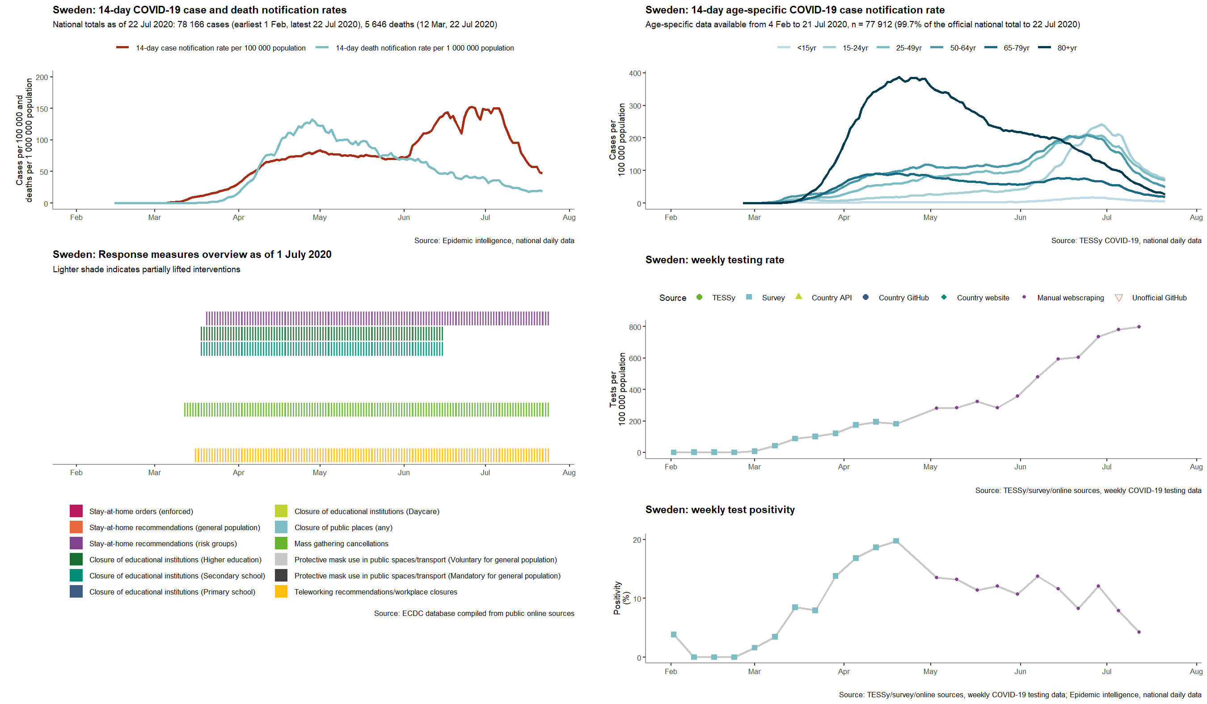

On the 29th May, 2020, Swedish authorities updated their recommendations on schools and COVID-19, presenting and taking into consideration the latest epidemiological situation, updated review of the scientific evidence on COVID-19, children and educational settings, as well as an updated review of the scientific evidence on the impact of school closures on health in the children [84]. The following considerations were summarised [84]:

* Children and youth represent a small proportion of the overall number of COVID-19 cases in the country
* Most children are infected by adults and children often have mild symptoms, if any
* Children are considered to transmit the disease to a lesser extent than adults
* Schools have not been seen to be a significant driver of (community) transmission
* Teachers and staff were not identified to have an increased risk, compared to other occupations, for contracting COVID-19 disease [78]
* The closure of schools has other negative effects on children and youth

As of the 15th June, 2020, Sweden recommends that all educational facilities remain open, and that these settings must continue to implement and abide by the national recommendations for preventing and decreasing the transmission of COVID-19 [84].

Discussion

An analysis of laboratory-confirmed COVID-19 cases from EU/EEA and UK in TESSy suggests that a very small proportion of reported cases (<5%) are in children and that the disease in children appears to be mild. This analysis is supported by similar results from surveillance in China, USA and Japan.

The results from surveillance analyses may be biased due to the fact that children develop less symptoms than adults and most surveillance systems are, or have been, focused on confirming symptomatic cases. Therefore, it is possible that a significant proportion of children are infected and infectious while asymptomatic. Random sample population surveys with PCR in Stockholm, Sweden and the UK do not show any significant differences in rates of PCR positivity between adults and children during ongoing community circulation [85,86]. In contrast, however, wide-spread population testing in Vo, Italy, and Iceland suggest that with active screening by PCR during ongoing outbreaks, very few children (asymptomatic or symptomatic) are detected.

Several studies suggest significant cross-reactivity against SARS-CoV-2 antibodies against seasonal human coronaviruses. This could potentially explain the lower levels of symptomatic infections in children.

When infected and symptomatic, children appear to be able to shed the virus in similar quantities to adults consistent with infectious potential. Less is known about infectiousness of asymptomatic or presymptomatic children. The results from cross-sectional serology and school outbreak studies together with the low number of symptomatic and laboratory-confirmed children reported through surveillance and outbreak studies are consistent with the majority of SARS-CoV-2 infected children being asymptomatic. Therefore, for children to have a significant potential for onward transmission, one needs to assume important asymptomatic or presymptomatic transmission.

South Korea has permissive testing recommendations for contacts identified in their contact tracing, thereby also identifying more secondary cases among children than in other settings. The secondary attack rate among contacts identified by tracing an index case of 0-9 years of age were the lowest among all age groups and highest among contacts of 10-19 years old index cases indicating transmission potential in both children and adolescents, and possibly more effective transmission in adolescents than in adults. These results, consistent with unpublished data from EU/EEA and UK contact tracing efforts, support the transmission potential of children, at least, in adolescents.

Serological studies indicate that significant numbers of children do get infected, when exposure opportunities exist and that seropositivity among children and adolescents can be at most at similar levels to working-age adults. Interpreting age-group differences in seropositivity is hampered by the small number of children included in many studies. Meaningful comparisons between seropositivity reported in different locations is difficult due to differences in the characteristics of the laboratory methodology used and timing of the studies in relation to the outbreak and response measures.

The relative contribution of contacts, fomite, droplet and aerosol transmission of SARS-CoV-2 is unknown also in children. In addition, children present more often with gastrointestinal symptoms and diarrhoea complicating case identification.

There are multiple potential ways of transmitting COVID-19 within the settings of childcare and education, either between children, between staff or between staff and children, all of which could potentially contribute to community spread of the infection.

In several studies in children where COVID-19 was detected and school contacts followed-up, only one child contact in Australia was detected as SARS-CoV-2 positive during the follow-up period. The conclusion from these investigations is that children are not the primary drivers of SARS-CoV-2 transmission to other children in the school setting.

Where COVID-19 in children was detected and contacts followed-up, no adult contacts in the school setting have been detected as SARS-CoV-2 positive during the follow-up period. The conclusion from these investigations is that children are not the primary drivers of SARS-CoV-2 transmission to adults in the school setting.

While there is evidence of transmission from adults to children in household settings, there is little evidence of this occurring within the school setting. Available evidence also indicates that adults working the school setting are not at higher risk of SARS-CoV-2 as compared to the risk in the community or household.

Six countries of the 15 responding countries reported clusters of COVID-19 in educational facilities, however those that occurred were limited in number and size, and were rather exceptional events. Several countries specifically expressed that they had no indication that school settings played a significant role in the transmission of COVID-19. Secondary transmission in schools, from either child-to-child or child-to-adult, was perceived to be rare. Countries where schools had re-opened by the time of the survey stated they did not see an increase in cases in these settings. Responses from the countries suggest that, so far, schools have not been a major outbreak environment for COVID-19 in the EU/EEA and UK.

Reports from EU/EEA countries and the UK were in line with data from the literature, where there are limited case reports of outbreaks of COVID-19 in schools, perhaps reflecting that such outbreaks occured relatively infrequently to date. Available study results are also somewhat inconsistent; contact tracing of index cases of outbreaks in Australia [75], France [69] and Ireland [70] identified very few positive cases among exposure individuals, while a recent report from Israel [77], where schools reopened simultaneously with the lifting of many other physical distancing measures, suggests that up to 32% of cohort contacts in a high school setting were virus positive.

Interpretation of results is challenging as the route of exposure is usually undefined in these outbreak settings; where there is concurrent community transmission there is potential that school children may have been infected outside the school. Authorities in Sweden, where preschool and primary schools remained open, did not report any outbreaks among children during the spring of 2020, and reported seropositivity among children similar to adults. Assessing the impact of school closures on transmission of COVID-19 from national data is complicated by the fact that decisions on school closures were rarely done in isolation, and multiple physical distancing measures were introduced and subsequently lifted simultaneously.

Taken together, there is limited evidence from EU/EEA countries and the literature showing schools driving transmission within the community. However there are indications that community transmission is imported into or reflected in the school setting. Given that all countries have implemented additional non-pharmaceutical interventions in addition to school closures, and that they have sometimes relaxed these when re-opening schools, it is difficult to understand the true impact of school closure and opening on transmission of SARS-CoV-2 within the community from the school setting itself. Schools being integral part of the communities they serve, results from outbreak studies in schools are difficult to disentangle from concurrent community outbreaks.

As highlighted in the Swedish context and by a review of work carried out in vulnerable groups in the EU/EEA, there may be reasons beyond COVID-19 prevention, which may be of importance to policy makers when considering whether to close or open schools. These include physical and mental health concerns, educational attainment, and ability of caregivers to carry out employment activities.

Based on available evidence, it is important that non-pharmaceutical measures in the community, such as physical distancing, cancellation of mass gatherings, hand hygiene and staying home if symptomatic, remain integral to preventing schools from becoming a setting for accelerating onward transmission. If these measures are in place in the community, and if infection control policies including hand hygiene and stay at home for students and staff with symptoms, schools themselves the likelihood of COVID-19 transmission in the school setting is not higher than the likelihood in the community at-large.

European public health authorities responding to our survey on school outbreaks reported very few clusters or outbreaks in schools, however the majority of countries experienced peak transmission waves during schools’ closures, so exposure opportunities have been limited. From the literature, there are limited case reports of outbreaks in schools, which perhaps reflect that such outbreaks occur relatively infrequently to date. Available study results are also somewhat inconsistent; contact tracing of index cases of outbreaks in Australia [75], France [73], and Ireland [74] identified very few positive cases among exposure individuals, while a recent report from Israel [77] suggests that up to 32% of cohort contacts in a high school setting were virus positive.

**Figure 3. Schematic of known transmission routes between children and adults within the childcare and educational settings and between the community/household.**

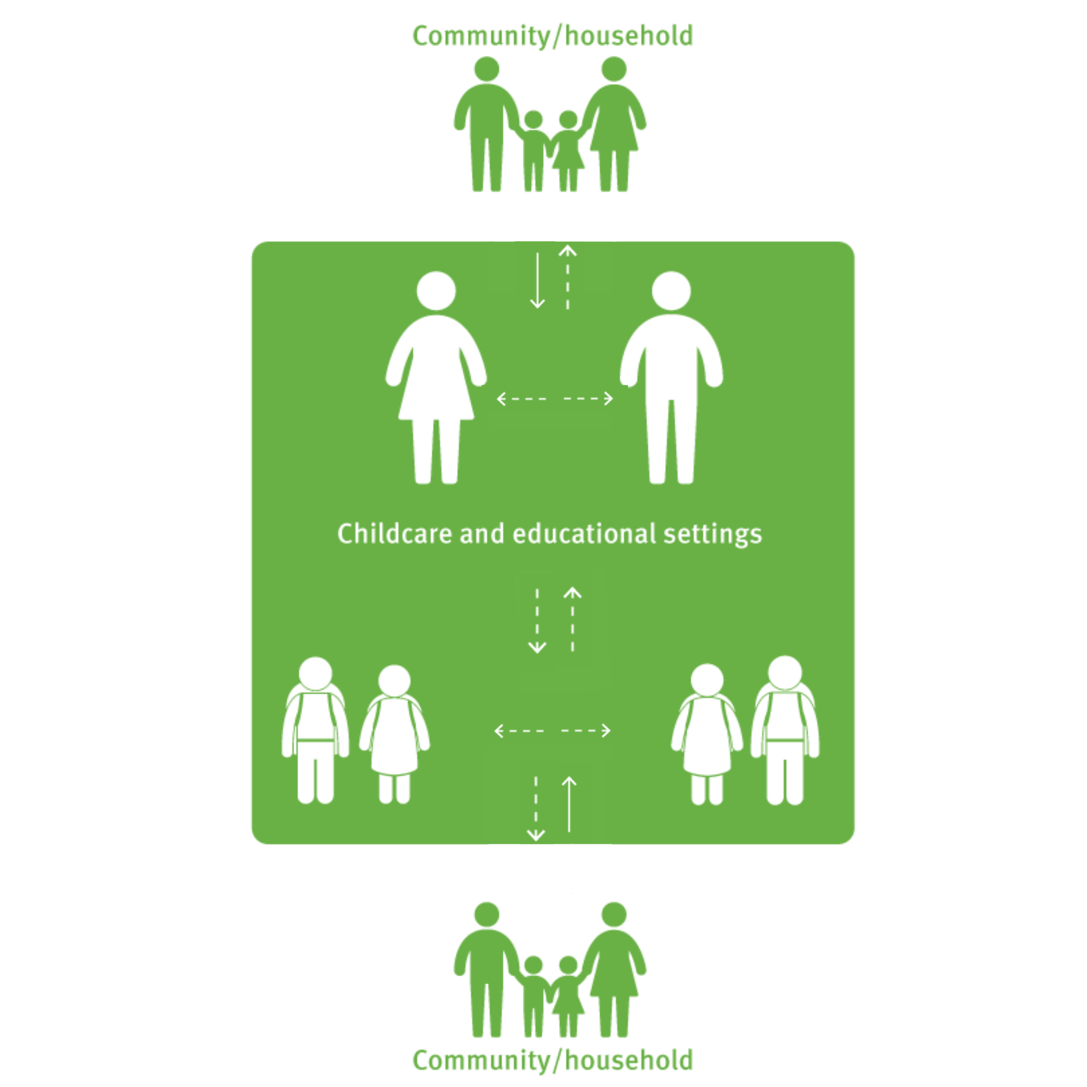

*Note: solid arrows represent routes of transmission where there is strong evidence for transmission, dashed lines represent routes of transmission where there is variable or mixed evidence between individuals within the childcare and educational settings and to the community/household outside of the educational settings.*

Limitations

This technical report is undertaken based on information and data available to ECDC at the time of publication.

* There is still limited epidemiological and clinical information on COVID-19 in children (e.g. efficiency of different modes of transmission, proportion of mild and asymptomatic cases, transmission during incubation and recovery period, effectiveness of treatment regimes, risk factors for severe illness other than age and effective preventive measures).
* Most case-based surveillance systems in the EU/EEA countries does not collect information that would allow public health to identify outbreaks or clusters in specific schools without the notification from the school itself.
* The majority of seroprevalence results among children and adolescent population presented here, were extracted from general population based studies, with a variety of sampling methodology used. Very often, denominators were not mentioned for this population, or were of very small numbers, making comparison and interpretation of results difficult.
* Results from serological studies are often not adjusted for test characteristics.
* Information on testing strategies in educational settings was not available.
* Many countries are not testing asymptomatic cases so detecting transmission among mild or asymptomatic children and teachers is difficult to identify and understand.
* It remains difficult to parse out all potential routes of transmission within the school settings as some activities have been limited like school sporting events, mixed mass gatherings of students and adults such as school concerts, performances, and graduations, etc., The potential impact of allowing those events to take place within the school setting is still unknown.
* Interpretation of outcomes of school outbreak reports in the midst of ongoing community transmission is difficult.

Research needs

The role of children in COVID-19 transmission is yet be fully elucidated and there is need to determine the extent to which children are; a) susceptible to SARS-CoV-2 virus across different age groups, and b) capable of transmitting infection to others when asymptomatic or symptomatic.

In terms of susceptibility, ongoing large scale surveillance and seroprevalence studies will further inform what proportion of children are infected in comparison to adults. Hence it is important that children are represented in sampling frames in these studies. Interpretation of surveillance would also benefit from improved understanding of the underlying immune response and antibody dynamics in children, including the ability of children to elicit a detectable immune response following both asymptomatic and symptomatic infection.

It is known that children are able to transmit infection to others, but the transmission dynamics and primary routes of transmission remain unclear. Evidence suggests that asymptomatic infection may be more prevalent in children in comparison to adults, but further confirmatory research is needed, together with work to understand both the underlying biological mechanisms of this differential response to infection, and how that impacts the COVID-19 epidemiology. Improved understanding of pre-symptomatic and asymptomatic infection will determine the extent to which children play a role in onward transmission of SARS-CoV-2 to their peers and to adults in both school and community settings.

Specifically in school settings, risk mitigation may benefit from operational research to understand and optimise approaches; this includes assessment of efficacy and compliance of IPC measures in school setting across age groups, such as physical distancing measures, mask wearing etc. There would also be benefit in conducting formal assessments on the relative efficiency of high level school-specific measures, such as restrictions in class sizes and access. Modelling work is likely to provide valuable information on these issues in addition to broader societal impacts from COVID-based adjustment to school attendance, such as social mixing among children and changes to social interactions as a whole. At EU level, a review of specific measures used, and sharing of practises to inform approaches in the Member States, may be of benefit.

Conclusions

As countries performed their own risk assessments on whether schools should re-open after the summer break, this technical report provides a) the epidemiological situation and disease characteristics relating to COVID-19 among children (0-18 years) in EU/EEA countries and the United Kingdom (UK), and b) the evidence of the role of childcare (nurseries) and educational (preschool, primary and secondary schools) settings in COVID-19 transmission and of the secondary transmission of COVID-19 within childcare and other educational settings.

School outbreaks are not a prominent feature in the COVID-19 pandemic, at least partially due to the fact that the majority for children do not develop symptoms, when infected with SARS-CoV-2. No evidence was found to suggest that children are the primary drivers of SARS-CoV-2 transmission in schools, in particular in preschools and primary schools. The only EU/EEA countries (Sweden and Iceland) that kept preschools or primary schools open during their epidemic did not report larger numbers of cases among children, however the overall outbreak was severe and prolonged in Sweden. EU/EEA countries that opened some parts of their schools before the summer breaks have not experienced school outbreaks or major resurgences in contrast to Israel, which is experiencing an important second wave in July 2020 and has reported school outbreaks.

Closures of childcare and educational institutions are unlikely to be an effective single control measure for community transmission of COVID-19 and cannot be justified based on protecting the health of children, who develop very mild, if any disease from COVID-19. Therefore, any decisions on school closures should be done for the purpose of mitigating the impact of community epidemics and will need to be made in the context of all other community mitigation measures. ECDC has commissioned a systematic literature review to review the evidence on role of school closures in community transmission to complement the current report. Special consideration needs to be given to educational institutions serving children with severe pre-existing medical vulnerabilities and to approaches to students and staff with severe medical vulnerabilities.

Targeted measures in schools to increase physical distancing, improve ventilation and cleaning, hand washing facilities and provision of personal protection, are likely to mitigate the possible transmission of COVID-19 in schools and will be helpful to mitigate the impact of other respiratory infections during the upcoming autumn and winter season, thereby reducing pressures on schools and healthcare.

Reactive school closures following community outbreaks, and cases or outbreaks in schools are unlikely to be timely enough to have a significant impact on the dynamics of the local epidemic, but may need to be made due to absenteeism or staff or parental concerns. Preparedness plans for such closures, done in collaboration between school and public health authorities will help rational decision making and communication of such decisions. ECDC guidance on contact management and testing in schools provides targeted testing recommendations for contact tracing (ref).

In conclusion, this review of evidence has shown that children do get infected and when symptomatic, shed virus in similar quantities to adults. The infectiousness of asymptomatic children is unknown. While very few significant outbreaks of COVID-19 have been documented they do occur, and may be difficult to detect due to the relative lack of symptoms in children. Thus schools are unlikely to be worse propagating environments than occupational or leisure activities with similar densities of people. Therefore, decisions on measures in schools and school closures and openings should be made consistently with decisions on other physical distancing measures.

Contributing experts

ECDC experts (in alphabetical order): Cornelia Adlhoch, Barbara Albiger, Agorista Baka, Orlando Cenciarelli, Scott Chiossi, Helena de Carvalho Gomes, Erika Duffell, Lisa Ferland, Lea Franconeri, Tjede Funk, Joana Gomes Dias, Maria Keramarou, Katrin Leitmeyer, Howard Needham, Lina Nerlander, Sabrina Nothdurfter, Aurea Oradini Alacreu, Anastasia Pharris, Pasi Penttinen, Andreea Salajan, Gianfranco Spiteri, Emma Wiltshire, Andrea Würz.

External experts: OSHA, WHO Regional Office for Europe

All external experts have submitted declarations of interest, and a review of these declarations did not reveal any conflicts of interest.

Acknowledgements

ECDC gratefully acknowledges National Focal Points in Cyprus, Denmark, Finland, France, Ireland, Italy, Latvia, Lithuania, Luxembourg, Malta, Netherlands, Romania, Spain, Sweden, United Kingdom who responded to the country-based data collection survey.

References

1. European Commission/EACEA/Eurydice. The Structure of the European Education Systems 2018/19: Schematic Diagrams [Internet]. Luxembourg: Publications Office of the European Union; 2018. Available from: <https://eacea.ec.europa.eu/national-policies/eurydice/sites/eurydice/files/the_structure_of_the_european_education_systems_2018_19.pdf>.

2. Parri N, Lenge M, Buonsenso D. Children with Covid-19 in Pediatric Emergency Departments in Italy. The New England journal of medicine. 2020 Jul 9;383(2):187-90.

3. Garazzino S, Montagnani C, Donà D, Meini A, Felici E, Vergine G, et al. Multicentre Italian study of SARS-CoV-2 infection in children and adolescents, preliminary data as at 10 April 2020. Euro surveillance : bulletin Europeen sur les maladies transmissibles = European communicable disease bulletin. 2020 May;25(18).

4. World Health Organization (WHO). Considerations for school-related health measures in the context of COVID-19 [Internet]. Geneva: WHO; 2020 [updated 10 May 202014 July 2020]. Available from: <https://www.who.int/publications/i/item/considerations-for-school-related-public-health-measures-in-the-context-of-covid-19>.

5. European Network of Ombudspersons for Children (ENOC) and United Nations International Children's Fund (UNICEF). Ombudspersons and Commissioners for Children’s Challenges and Responses to Covid-19 [Internet]. 2020 [22 July 2020]. Available from: <http://enoc.eu/wp-content/uploads/2020/06/ENOC-UNICEFF-COVID-19-survey-updated-synthesis-report-FV.pdf>.

6. United Nations Educational SaCOU. Adverse consequences of school closures

[22 July 2020]. Available from: <https://en.unesco.org/covid19/educationresponse/consequences>.

7. Van Lancker W, Parolin Z. COVID-19, school closures, and child poverty: a social crisis in the making. The Lancet Public health. 2020 May;5(5):e243-e4.

8. Fantini MP, Reno C, Biserni GB, Savoia E, Lanari M. COVID-19 and the re-opening of schools: a policy maker's dilemma. Italian journal of pediatrics. 2020 Jun 9;46(1):79.

9. Courtney D, Watson P, Battaglia M, Mulsant BH, Szatmari P. COVID-19 Impacts on Child and Youth Anxiety and Depression: Challenges and Opportunities. Canadian journal of psychiatry Revue canadienne de psychiatrie. 2020 Jun 22:706743720935646.

10. European Centre for Disease Prevention and Control (ECDC). Guidance on the provision of support for medically and socially vulnerable populations in EU/EEA countries and the United Kingdom during the COVID-19 pandemic [Internet]. ECDC; 2020 [22 July 2020]. Available from: <https://www.ecdc.europa.eu/sites/default/files/documents/Medically-and-socially-vulnerable-populations-COVID-19.pdf>.

11. European Centre for Disease Prevention and Control (ECDC). COVID-19 Surveillance Report, Week 27 [Internet]. ECDC; 2020 [21 July 2020]. Available from: <http://covid19-surveillance-report.ecdc.europa.eu>.

12. Mantovani A, Rinaldi E, Zusi C, Beatrice G, Saccomani MD, Dalbeni A. Coronavirus disease 2019 (COVID-19) in children and/or adolescents: a meta-analysis. Pediatric Research. 2020:1-6.

13. Patel NA. Pediatric COVID-19: Systematic review of the literature. American journal of otolaryngology. 2020 Jun 6;41(5):102573.

14. Castagnoli R, Votto M, Licari A, Brambilla I, Bruno R, Perlini S, et al. Severe Acute Respiratory Syndrome Coronavirus 2 (SARS-CoV-2) Infection in Children and Adolescents: A Systematic Review. JAMA pediatrics. 2020 Apr 22.

15. Ludvigsson JF. Systematic review of COVID-19 in children shows milder cases and a better prognosis than adults. Acta paediatrica (Oslo, Norway : 1992). 2020 Jun;109(6):1088-95.

16. Raba AA, Abobaker A, Elgenaidi IS, Daoud A. Novel Coronavirus Infection (COVID‐19) in Children Younger Than One Year: A Systematic Review of Symptoms, Management and Outcomes. Acta Paediatrica. 2020.

17. Rajapakse N, Dixit D. Human and novel coronavirus infections in children: a review. Paediatrics and international child health. 2020 Jun 25:1-20.

18. Götzinger F, Santiago-García B, Noguera-Julián A, Lanaspa M, Lancella L, Calò Carducci FI, et al. COVID-19 in children and adolescents in Europe: a multinational, multicentre cohort study. The Lancet Child & adolescent health. 2020 Jun 25.

19. Kanthimathinathan HK, Dhesi A, Hartshorn S, Ali SH, Kirk J, Nagakumar P, et al. COVID-19: A UK Children's Hospital Experience. Hospital pediatrics. 2020 Jun 9.

20. Armann JP, Diffloth N, Simon A, Doenhardt M, Hufnagel M, Trotter A, et al. Hospital Admission in Children and Adolescents With COVID-19. Deutsches Arzteblatt international. 2020 May 22;117(21):373-4.

21. Korkmaz MF, Türe E, Dorum BA, Kılıç ZB. The Epidemiological and Clinical Characteristics of 81 Children with COVID-19 in a Pandemic Hospital in Turkey: an Observational Cohort Study. Journal of Korean medical science. 2020 Jun 29;35(25):e236.

22. Rokkas T. Gastrointestinal involvement in COVID-19: a systematic review and meta-analysis. Annals of gastroenterology. 2020 Jul-Aug;33(4):355-65.

23. Dong Y, Mo X, Hu Y, Qi X, Jiang F, Jiang Z, et al. Epidemiology of COVID-19 Among Children in China. Pediatrics. 2020 Jun;145(6).

24. Streng A, Hartmann K, Armann J, Berner R, Liese JG. [COVID-19 in hospitalized children and adolescents]. Monatsschrift Kinderheilkunde : Organ der Deutschen Gesellschaft fur Kinderheilkunde. 2020 Apr 21:1-12.

25. Zhang L, Peres TG, Silva MVF, Camargos P. What we know so far about Coronavirus Disease 2019 in children: A meta-analysis of 551 laboratory-confirmed cases. Pediatric pulmonology. 2020 Aug;55(8):2115-27.

26. Nghochuzie NN, Olwal CO, Udoakang AJ, Amenga-Etego LN, Amambua-Ngwa A. Pausing the Fight Against Malaria to Combat the COVID-19 Pandemic in Africa: Is the Future of Malaria Bleak? Frontiers in microbiology. 2020;11:1476.

27. Devulapalli CS. COVID-19 is milder in children possibly due to cross-immunity. Acta paediatrica (Oslo, Norway : 1992). 2020 Jun 10.

28. Ng K, Faulkner N, Cornish G, Rosa A, Earl C, Wrobel A, et al. Pre-existing and de novo humoral immunity to SARS-CoV-2 in humans. BioRxiv. 2020.

29. Sermet-Gaudelus I, Temmam S, Huon C, Behillil S, Gajdos V, Bigot T, et al. Prior infection by seasonal coronaviruses does not prevent SARS-CoV-2 infection and associated Multisystem Inflammatory Syndrome in children. medRxiv. 2020.

30. EuroMOMO

Statens Serum Institut (SSI). EuroMOMO [Internet]. EuroMOMO and SSI; 2020 [cited 26 July 2020]. Available from: <https://www.euromomo.eu/>.

31. World Health Organization (WHO). Report of the WHO-China Joint Mission on Coronavirus Disease 2019 (COVID-19) [Internet]. Geneva2020 [21 July 2020]. Available from: <https://www.who.int/docs/default-source/coronaviruse/who-china-joint-mission-on-covid-19-final-report.pdf>.

32. Meena J, Yadav J, Saini L, Yadav A, Kumar J. Clinical Features and Outcome of SARS-CoV-2 Infection in Children: A Systematic Review and Meta-analysis. Indian pediatrics. 2020 Jun 24.

33. Yu Y, Chen P. Coronavirus Disease 2019 (COVID-19) in Neonates and Children From China: A Review. Frontiers in pediatrics. 2020;8:287.

34. Centers for Disease Control and Prevention (CDC). Emergency preparedness and response: health alert network [21 July 2020]. Available from: <https://emergency.cdc.gov/han/2020/han00432.asp>

35. Royal College of Paediatrics and Child Health. Guidance: pediatric multisystem inflammatory syndrome temporally associated with COVID-19 [21 July 2020]. Available from: <https://www.rcpch.ac.uk/resources/guidance-paediatric-multisystem-inflammatory-syndrome-temporally-associated-covid-19>.

36. World Health Organization (WHO). Multisystem inflammatory syndrome in children and adolescents with COVID-19 [Internet]. 2020 [21 July 2020]. Available from: <https://www.who.int/publications/i/item/multisystem-inflammatory-syndrome-in-children-and-adolescents-with-covid-19>.

37. Riphagen S, Gomez X, Gonzalez-Martinez C, Wilkinson N, Theocharis P. Hyperinflammatory shock in children during COVID-19 pandemic. Lancet (London, England). 2020 May 23;395(10237):1607-8.

38. Rowley AH. Understanding SARS-CoV-2-related multisystem inflammatory syndrome in children. Nature reviews Immunology. 2020 Jun 16:1-2.

39. Simpson JM, Newburger JW. Multi-System Inflammatory Syndrome in Children in Association with COVID-19. Circulation. 2020 Jun 11.

40. European Centre for Disease Prevention and Control (ECDC). Paediatric inflammatory multisystem syndrome and SARS-CoV-2 infection in children [Internet]. ECDC; 2020 [21 July 2020]. Available from: <https://www.ecdc.europa.eu/en/publications-data/paediatric-inflammatory-multisystem-syndrome-and-sars-cov-2-rapid-risk-assessment>.

41. Ranabothu S, Onteddu S, Nalleballe K, Dandu V, Veerapaneni K, Veerapandiyan A. Spectrum of COVID-19 in Children. Acta paediatrica (Oslo, Norway : 1992). 2020 Jun 15.

42. Ciuca IM. COVID-19 in Children: An Ample Review. Risk management and healthcare policy. 2020;13:661-9.

43. Del Barba P, Canarutto D, Sala E, Frontino G, Guarneri MP, Camesasca C, et al. COVID-19 cardiac involvement in a 38-day old infant. Pediatric pulmonology. 2020 Aug;55(8):1879-81.

44. Rodriguez-Gonzalez M, Rodríguez-Campoy P, Sánchez-Códez M, Gutiérrez-Rosa I, Castellano-Martinez A, Rodríguez-Benítez A. New onset severe right ventricular failure associated with COVID-19 in a young infant without previous heart disease. Cardiology in the young. 2020 Jun 16:1-4.

45. Stewart DJ, Hartley JC, Johnson M, Marks SD, du Pré P, Stojanovic J. Renal dysfunction in hospitalised children with COVID-19. The Lancet Child & adolescent health. 2020 Jun 15.

46. Deep A, Bansal M, Ricci Z. Acute Kidney Injury and Special Considerations during Renal Replacement Therapy in Children with Coronavirus Disease-19: Perspective from the Critical Care Nephrology Section of the European Society of Paediatric and Neonatal Intensive Care. Blood purification. 2020 Jul 14:1-11.

47. Backer JA, Klinkenberg D, Wallinga J. Incubation period of 2019 novel coronavirus (2019-nCoV) infections among travellers from Wuhan, China, 20-28 January 2020. Euro surveillance : bulletin Europeen sur les maladies transmissibles = European communicable disease bulletin. 2020 Feb;25(5).

48. Lavezzo E, Franchin E, Ciavarella C, Cuomo-Dannenburg G, Barzon L, Del Vecchio C, et al. Suppression of a SARS-CoV-2 outbreak in the Italian municipality of Vo'. Nature. 2020 Jun 30.

49. Chang L, Yan Y, Wang L. Coronavirus Disease 2019: Coronaviruses and Blood Safety. Transfusion medicine reviews. 2020 Apr;34(2):75-80.

50. Lu J, Gu J, Li K, Xu C, Su W, Lai Z, et al. COVID-19 Outbreak Associated with Air Conditioning in Restaurant, Guangzhou, China, 2020. Emerging infectious diseases. 2020 Jul;26(7):1628-31.

51. Peng L, Liu J, Xu W, Luo Q, Chen D, Lei Z, et al. SARS-CoV-2 can be detected in urine, blood, anal swabs, and oropharyngeal swabs specimens. Journal of medical virology. 2020 Apr 24.

52. Cai J, Xu J, Lin D, Yang Z, Xu L, Qu Z, et al. A Case Series of children with 2019 novel coronavirus infection: clinical and epidemiological features. Clinical infectious diseases : an official publication of the Infectious Diseases Society of America. 2020 Feb 28.

53. Cheung KS, Hung IFN, Chan PPY, Lung KC, Tso E, Liu R, et al. Gastrointestinal Manifestations of SARS-CoV-2 Infection and Virus Load in Fecal Samples From a Hong Kong Cohort: Systematic Review and Meta-analysis. Gastroenterology. 2020 Apr 3;159(1):81-95.

54. Xu CLH, Raval M, Schnall JA, Kwong JC, Holmes NE. Duration of Respiratory and Gastrointestinal Viral Shedding in Children With SARS-CoV-2: A Systematic Review and Synthesis of Data. The Pediatric infectious disease journal. 2020 Jun 30.

55. Jones TC, Mühlemann B, Veith T, Biele G, Zuchowski M, Hoffmann J, et al. An analysis of SARS-CoV-2 viral load by patient age. medRxiv. 2020.

56. Cohen R, Jung C, Ouldali N, Sellam A, Batard C, Cahn-Sellem F, et al. Assessment of spread of SARS-CoV-2 by RT-PCR and concomitant serology in children in a region heavily affected by COVID-19 pandemic. medRxiv. 2020.

57. Debatin K-M, Henneke P, Hoffmann GF, Kräusslich H-G, Renk H. Prevalence of COVID-19 in children in Baden-Württemberg - Preliminary study report [21 July 2020]. Available from: <https://www.klinikum.uni-heidelberg.de/fileadmin/pressestelle/Kinderstudie/Prevalence_of_COVID-19_in_BaWu__.pdf>.

58. Fontanet A, Tondeur L, Madec Y, Grant R, Besombes C, Jolly N, et al. Cluster of COVID-19 in northern France: A retrospective closed cohort study. MedRXiv. 2020.

59. Armann JP, Unrath M, Kirsten C, Lueck C, Dalpke A, Berner R. Anti-SARS-CoV-2 IgG antibodies in adolescent students and their teachers in Saxony, Germany (SchoolCoviDD19): very low seropraevalence and transmission rates. medRxiv. 2020:2020.07.16.20155143.

60. Pollán M, Pérez-Gómez B, Pastor-Barriuso R, Oteo J, Hernán MA, Pérez-Olmeda M, et al. Prevalence of SARS-CoV-2 in Spain (ENE-COVID): a nationwide, population-based seroepidemiological study. Lancet (London, England). 2020 Jul 3.

61. Brotons C, Serrano J, Fernandez D, Garcia-Ramos C, Ichazo B, Lemaire J, et al. Seroprevalence against COVID-19 and follow-up of suspected cases in primary health care in Spain. medRxiv. 2020.

62. Stringhini S, Wisniak A, Piumatti G, Azman AS, Lauer SA, Baysson H, et al. Repeated seroprevalence of anti-SARS-CoV-2 IgG antibodies in a population-based sample from Geneva, Switzerland. medRxiv. 2020.

63. Herzog S, De Bie J, Abrams S, Wouters I, Ekinci E, Patteet L, et al. Seroprevalence of IgG antibodies against SARS coronavirus 2 in Belgium: a prospective cross-sectional study of residual samples. medRxiv. 2020.

64. Streeck H, Schulte B, Kuemmerer B, Richter E, Höller T, Fuhrmann C, et al. Infection fatality rate of SARS-CoV-2 infection in a German community with a super-spreading event. medrxiv. 2020.

65. Weis S, Scherag A, Baier M, Kiehntopf M, Kamradt T, Kolanos S, et al. Seroprevalence of SARS-CoV-2 antibodies in an entirely PCR-sampled and quarantined community after a COVID-19 outbreak-the CoNAN study. medRxiv. 2020.

66. Rijksinstituut voor Volksgezondheid en Milieu (RIVM). Children and COVID-19 [Internet]. 2020 [21 July 2020]. Available from: <https://www.rivm.nl/en/novel-coronavirus-covid-19/children-and-covid-19>.

67. Folkhälsomyndigheten. Påvisning av antikroppar efter genomgången covid-19 i blodprov från öppenvården (Delrapport 1) [Internet]. Stockholm: Folkhälsomyndigheten; 2020. Available from: <https://www.folkhalsomyndigheten.se/contentassets/9c5893f84bd049e691562b9eeb0ca280/pavisning-antikroppar-genomgangen-covid-19-blodprov-oppenvarden-delrapport-1.pdf>.

68. Viner RM, Russell SJ, Croker H, Packer J, Ward J, Stansfield C, et al. School closure and management practices during coronavirus outbreaks including COVID-19: a rapid systematic review. The Lancet Child & adolescent health. 2020 May;4(5):397-404.

69. Danis K, Epaulard O, Bénet T, Gaymard A, Campoy S, Bothelo-Nevers E, et al. Cluster of coronavirus disease 2019 (Covid-19) in the French Alps, 2020. Clinical infectious diseases : an official publication of the Infectious Diseases Society of America. 2020 Apr 11.

70. Heavey L, Casey G, Kelly C, Kelly D, McDarby G. No evidence of secondary transmission of COVID-19 from children attending school in Ireland, 2020. Euro surveillance : bulletin Europeen sur les maladies transmissibles = European communicable disease bulletin. 2020 May;25(21).

71. Australian National Centre for Immunisation Research and Surveillance (NCIRS). COVID-19 in schools – the experience in NSW [Internet]. Syndney: NCIRS; 2020. Available from: <http://ncirs.org.au/sites/default/files/2020-04/NCIRS%20NSW%20Schools%20COVID_Summary_FINAL%20public_26%20April%202020.pdf>.

72. Yung CF, Kam KQ, Nadua KD, Chong CY, Tan NWH, Li J, et al. Novel coronavirus 2019 transmission risk in educational settings. Clinical infectious diseases : an official publication of the Infectious Diseases Society of America. 2020 Jun 25.

73. Stein-Zamir C, Abramson N, Shoob H, Libal E, Bitan M, Cardash T, et al. A large COVID-19 outbreak in a high school 10 days after schools’ reopening, Israel, May 2020. Euro Surveill. 2020;25(29):pii=2001352.

74. Folkhälsomyndigheten. Förekomst av covid-19 i olika yrkesgrupper [Internet]. Stockholm: Folkhälsomyndigheten; 2020. Available from: <https://www.folkhalsomyndigheten.se/publicerat-material/publikationsarkiv/f/forekomst-av-covid-19-i-olika-yrkesgrupper/>.

75. Torres JP, Piñera C, De La Maza V, RN, Lagomarcino AJ, Simian D, RN, Torres B, RN, et al. SARS-CoV-2 antibody prevalence in blood in a large school community subject to a Covid-19 outbreak: a cross-sectional study. Clinical Infectious Diseases. 2020.

76. Reuters. Reopening schools in Denmark did not worsen outbreak, data shows [Internet]. Reuterse; 2020 [24 July 2020]. Available from: <https://www.reuters.com/article/us-health-coronavirus-denmark-reopening/reopening-schools-in-denmark-did-not-worsen-outbreak-data-shows-idUSKBN2341N7>.

77. Folkhälsomyndigheten. Veckorapport om covid-19, vecka 29 [Internet]. Stockholm: Folkhälsomyndigheten; 2020. Available from: <https://www.folkhalsomyndigheten.se/globalassets/statistik-uppfoljning/smittsamma-sjukdomar/veckorapporter-covid-19/2020/covid-19-veckorapport-vecka-29-final_updated.pdf>.

78. Folkhälsomyndigheten. Covid-19 hos barn och unga - en kunskapssammanställning [Internet]. Stockholm: Folkhälsomyndigheten; 2020. Available from: <https://www.folkhalsomyndigheten.se/contentassets/03fff9a4b6ba4b36b84f69a5f9486cbf/covid-19-barn-unga-kunskapssammanstallning.pdf>.

79. European Centre for Disease Prevention and Control (ECDC). COVID-19 country overviews [Internet]. ECDC; 2020 [cited 27 July 2020]. Available from: <https://covid19-country-overviews.ecdc.europa.eu/#33_sweden>.

80. Folkhälsomynfigheten. Förekomsten av covid-19 i region Stockhom, 26 mars-3 aprlil 2020 [Internet]. Stockholm: Folkhälsomyndigheten; 2020. Available from: <https://www.folkhalsomyndigheten.se/contentassets/7bd5627f82a84590bc2992784234b88b/forekomsten-covid-19-region-stockholm-26-mars3-april-2020.pdf>.

81. United Kingdom Office for National Statistics. Coronavirus (COVID-19) infections in the community in England [Internet]. 2020 [cited 26 July 2020]. Available from: <https://www.ons.gov.uk/peoplepopulationandcommunity/healthandsocialcare/conditionsanddiseases/datasets/coronaviruscovid19infectionsinthecommunityinengland>.

82. Santé publique, Sécurité de la chaîne alimentaire et Environnement de Belgique,, Centre de crise. Le retour progressif à l’école va pouvoir continuer en Belgique [Internet]. 2020 [cited 24 July 2020]. Available from: <https://www.info-coronavirus.be/fr/news/retour-progessif-a-lecole/>.

83. European Centre for Disease Prevention and Control (ECDC). Using face masks in the community - Reducing COVID-19 transmission from potentially asymptomatic or pre-symptomatic people through the use of face masks [Internet]. ECDC; 2020 [23 July 2020]. Available from: <https://www.ecdc.europa.eu/en/publications-data/using-face-masks-community-reducing-covid-19-transmission#:~:text=The%20use%20of%20face%20masks%20in%20public%20may%20serve%20as,symptoms%20or%20who%20remain%20asymptomatic>.

84. Knibbs LD, Morawska L, Bell SC, Grzybowski P. Room ventilation and the risk of airborne infection transmission in 3 health care settings within a large teaching hospital. American journal of infection control. 2011 Dec;39(10):866-72.

85. Rothe C, Schunk M, Sothmann P, Bretzel G, Froeschl G, Wallrauch C, et al. Transmission of 2019-nCoV Infection from an Asymptomatic Contact in Germany. The New England journal of medicine. 2020 Mar 5;382(10):970-1.

86. World Health Organization (WHO). Natural Ventilation for Infection Control in Health-Care Settings 2009 [23 July 2020]. Available from: <https://apps.who.int/iris/bitstream/handle/10665/44167/9789241547857_eng.pdf?sequence=1>.

87. European Centre for Disease Prevention and Control (ECDC). Heating, ventilation and air-conditioning systems in the context of COVID-19 [Internet]. ECDC; 2020 [23 July 2020]. Available from: <https://www.ecdc.europa.eu/sites/default/files/documents/Ventilation-in-the-context-of-COVID-19.pdf>.

88. van Doremalen N, Bushmaker T, Morris DH, Holbrook MG, Gamble A, Williamson BN, et al. Aerosol and Surface Stability of SARS-CoV-2 as Compared with SARS-CoV-1. The New England journal of medicine. 2020 Apr 16;382(16):1564-7.

89. European Centre for Disease Prevention and Control (ECDC). Disinfection of environments in healthcare and non-healthcare settings potentially contaminated with SARS-CoV-2 [Internet]. ECDC; 2020 [cited 23 July 2020]. Available from: <https://www.ecdc.europa.eu/en/publications-data/disinfection-environments-covid-19>.

90. European Centre for Disease Prevention and Control (ECDC). Considerations for infection prevention and control measures on public transport in the context of COVID-19 [Internet]. ECDC; 2020 [23 July 2020]. Available from: <https://www.ecdc.europa.eu/sites/default/files/documents/COVID-19-public-transport-29-April-2020.pdf>.

Annex 1. School closures at national level reported from public sources and daily confirmed cases of COVID-19 over time in EU/EEA Member States and UK, by preschool, primary and secondary school as of 25 July 2020

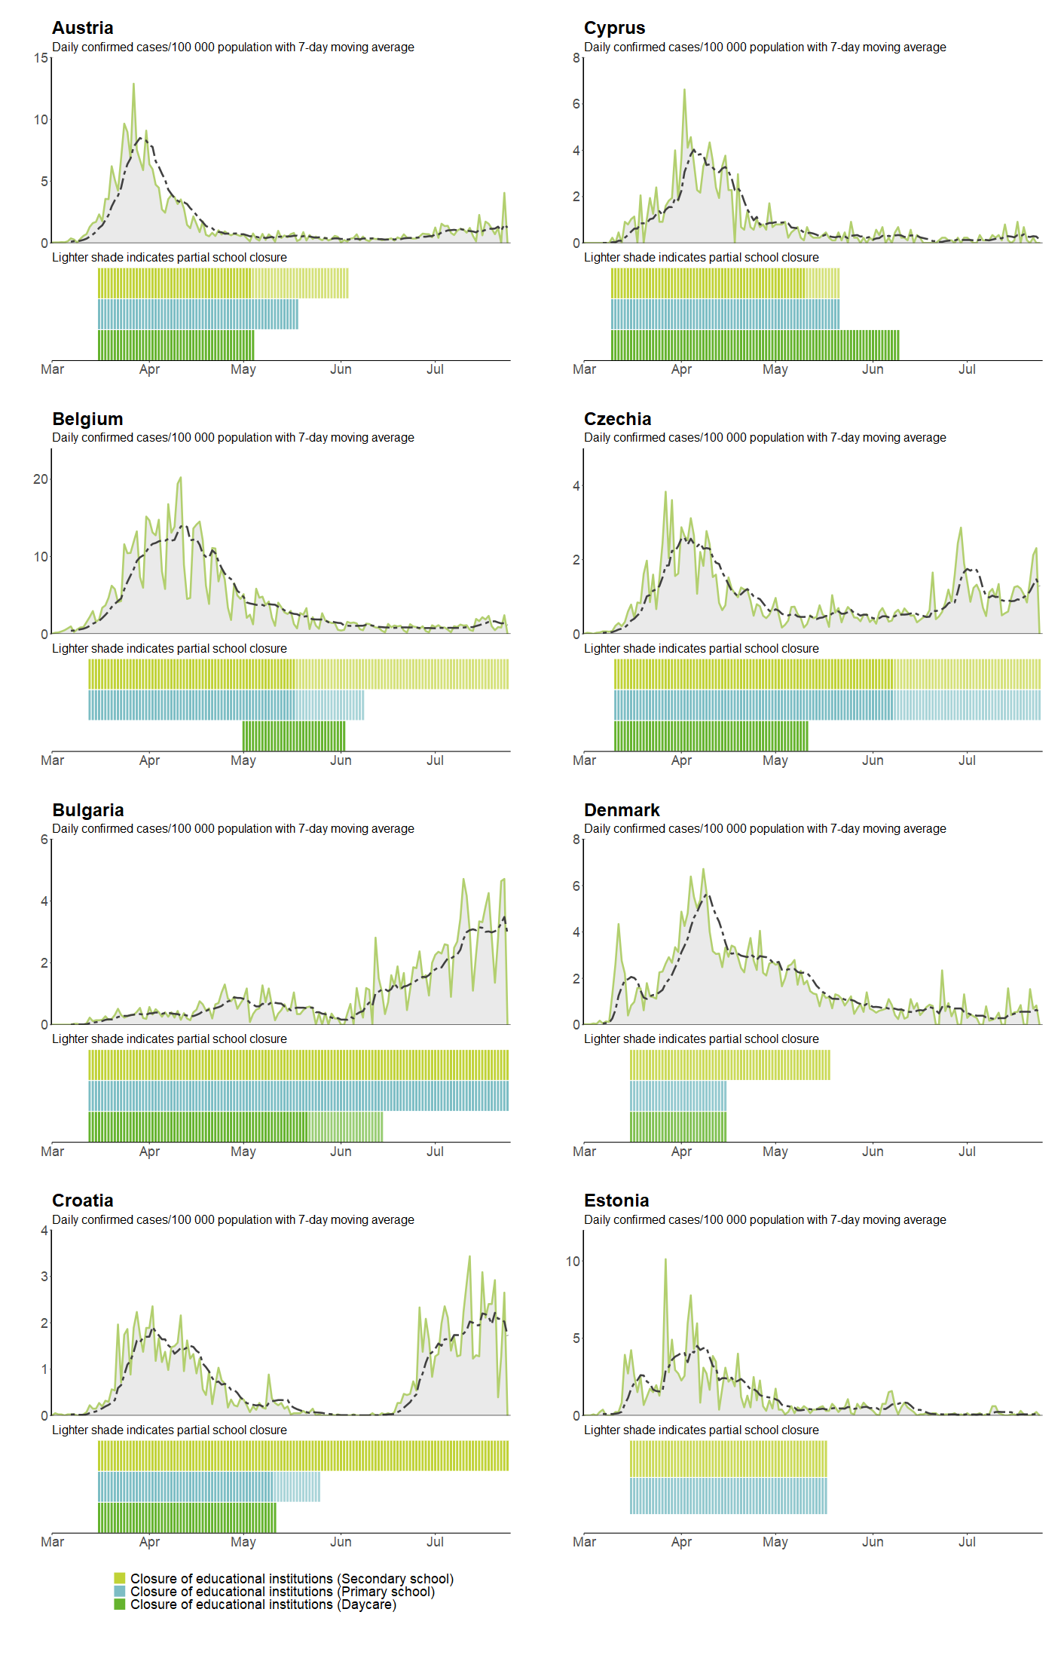

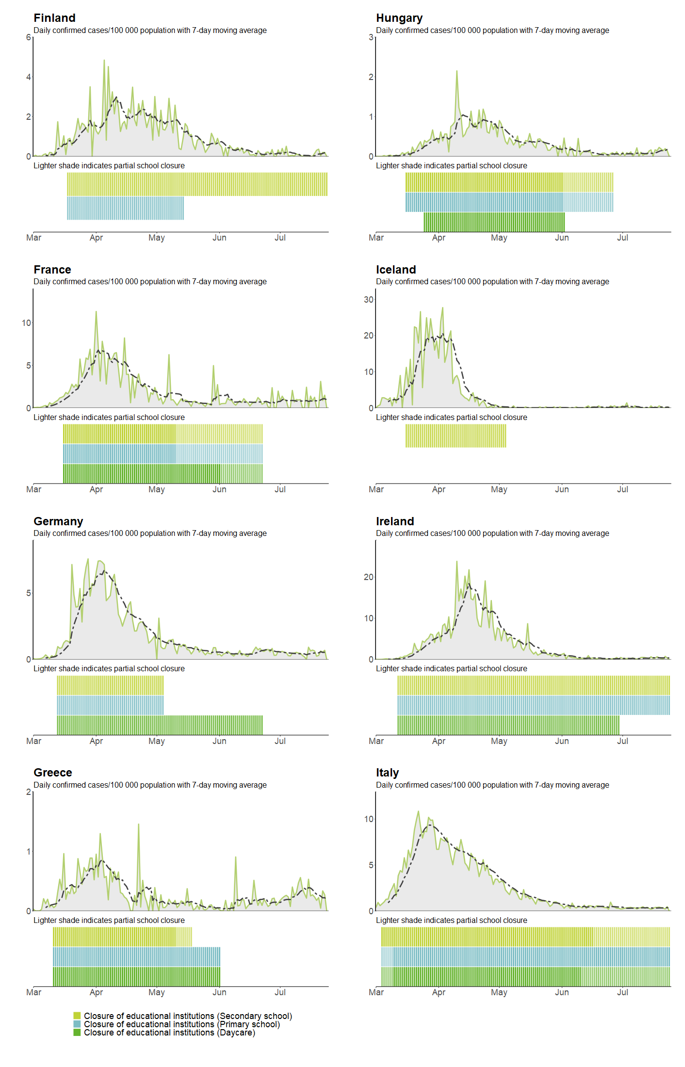

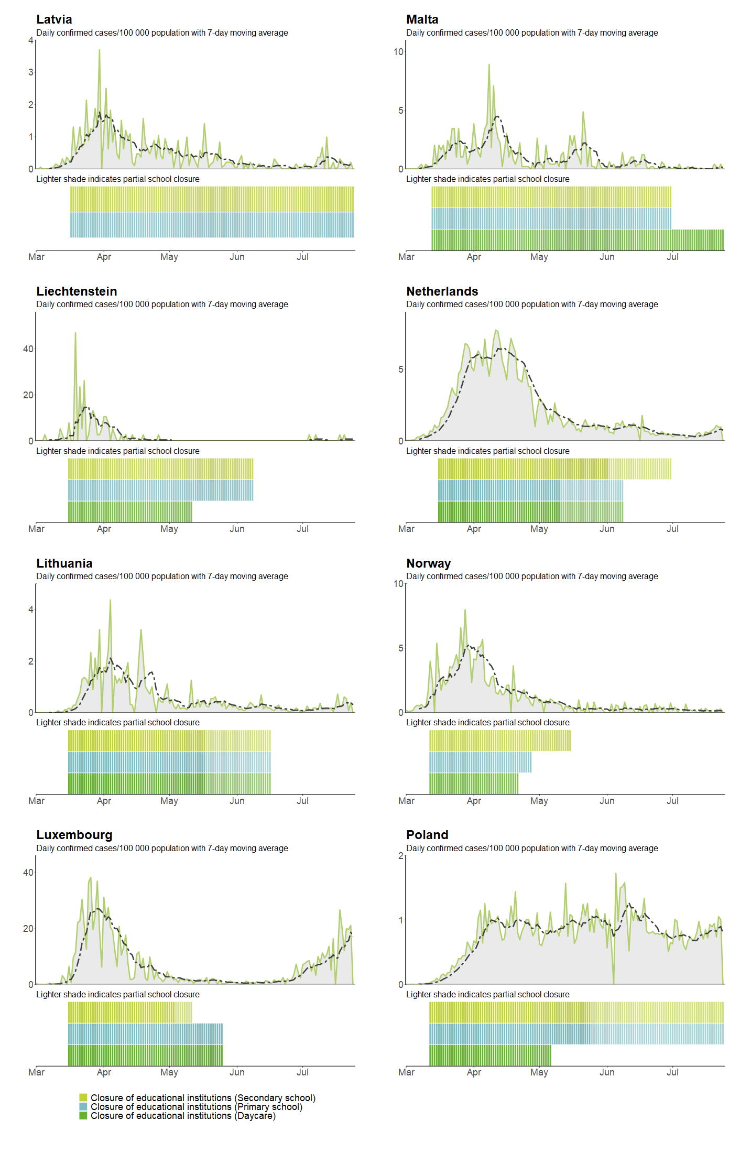

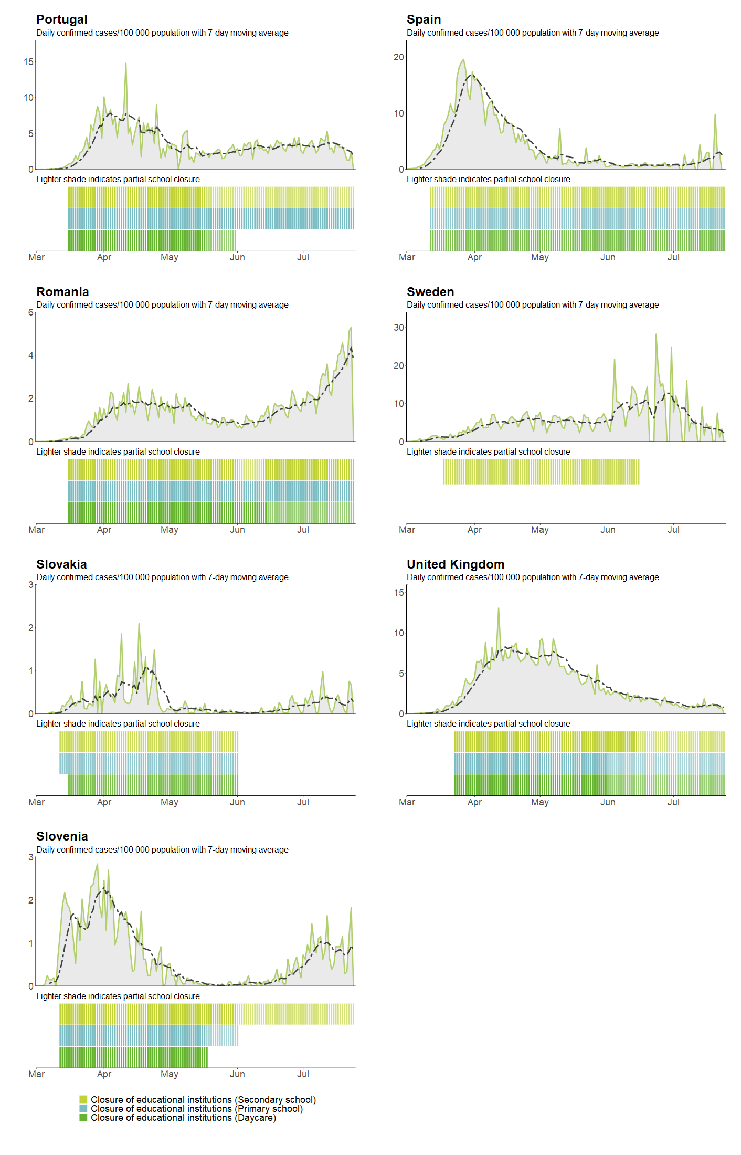

Annex 2. Examples of IPC recommendations currently implemented by Member States in schools remaining open and in the planning for re-opening schools

Appropriate infection prevention and control (IPC) measures in the childcare and educational setting are essential to prevent and control COVID-19 transmission. The introduction of any measure should follow a risk assessment evaluating the capacity of each school to appropriately implement it, taking also into account the different educational settings, the population groups (children, adults, age groups, vulnerable groups among children as well as among the adults) as well as the local epidemiological data. Based on the risks identified, appropriate non-pharmaceutical and personal protective measures can be introduced, with the aim of ensuring children have access to the most optimal and safe educational and social environment.

Non-pharmaceutical and personal protective measures currently represent the main content of public health advice provided internationally, although only indirect data about their efficacy in mitigating the risk of COVID-19 transmission is available.

Physical distancing

Physical distancing is considered the main measure to reduce the risk of COVID-19 transmission. In childcare and educational facilities this measure can definitely be considered and approaches to ensure this be established. They should furthermore be adapted to the specific age group, taking into account the current knowledge of disease transmission in the age group and further the feasibility and appropriateness of the measure for the age group. For example, in Belgium and the Netherlands it is recognised that physical distancing (and the use of masks) is not feasible and/or appropriate to introduce in the younger age groups (< 12 years - childcare settings and primary schools) [70,87].

Clusters and outbreaks or COVID-19 in instances of choir practice and performances or potentially associated with speaking loudly or shouting point towards the need for stricter implementation of physical distancing, avoiding gatherings of children and adolescents and particular activities entailing shouting, such as indoor athletic practices, indoor choir, singing contests or theatre practices. Other measures to facilitate physical distancing of students, depending on local risk assessment and capacities include increasing the distance between student desks, decreasing the number of students per class, stagger class starting times and breaks, as well as lunch time. Eating lunch outdoors, if possible, can also be considered, as well as transparent Plexiglas physical barriers at reception or information points and other fixed sites where staff comes in contact with large numbers of students, e.g. serving at the canteen.

Use of face masks

When physical distancing cannot be maintained, the use of face masks is recommended in the community. In the school setting, the implementation of this measure is challenging, as it is known that children will have a lower tolerance and ability to use the mask properly [88]. A European standard on minimum requirements for community face masks is currently available by the European Committee for Standardization.

A number of countries have introduced the requirement to wear face masks in schools, varying in the recommended age groups. Most commonly the requirement to wear a face mask starts in the >12-year age groups and/or are a requirement for the teachers and other staff (Belgium, Czechia, and the Netherlands). A number of countries have not had any requirements for the use of facemasks, mirroring the general non-requirement of facemasks in the community (Norway, Sweden).

Moreover, when taking care of young children, the use of face masks by the caretakers and teachers can stress the children and make them uncomfortable. For this reason, the use of face masks by teachers when taking care of children in kindergartens, is not advised in Belgium for educational and social reasons. The same recommendation is provided in Czechia. In primary schools, the use of face masks is recommended for teachers and other adults when physical distancing cannot be guaranteed, while it is not recommended for the students. In secondary schools, the use of face masks is recommended for both students and adults.

ECDC has published a guidance on [Using face masks in the community - Reducing COVID-19 transmission from potentially asymptomatic or pre-symptomatic people through the use of face masks](https://www.ecdc.europa.eu/sites/default/files/documents/COVID-19-use-face-masks-community.pdf) [88]. This guidance is available in all the 26 official languages of the EU.

Hand hygiene

SARS-CoV-2 is believed to be transmitted mainly via respiratory droplets and by direct contact. However, indirect contact with contaminated fomites is also believed to play a role in transmission. Therefore, frequent and meticulous hand washing and disinfection plays a key role in mitigating the risk of COVID-19 transmission. Rigorous hand hygiene, especially after contact with frequently touched surfaces, before eating, drinking, and after using the toilet, is a measure that will be essential in all school settings and for both children and staff. In all countries within the EU/EEA and the UK, rigorous hand hygiene is considered an essential measure to be implemented.

Respiratory etiquette

Similar to hand hygiene, respiratory etiquette is an essential measure aimed to reduce the risk of COVID-19 transmission. It includes mainly covering of nose and mouth with a paper tissue when sneezing or coughing to help reduce the spread of potentially infectious droplets. Similarly, the use of textile masks or other face coverings can potentially reduce the spread of droplets. Appropriate standards for the creation of textile masks are currently available in Europe. The used paper tissues should be disposed of immediately, ideally into no-touch bins (hands-free), and hands should be washed/sanitised immediately afterwards. The UK “Guidance for full opening: schools” suggest to ensure good respiratory hygiene by promoting the ‘catch it, bin it, kill it’ approach, in place since the 2009 influenza pandemic. In the Netherlands, children in day care and primary school may attend with cold symptoms as long as they do not have a fever and have had no known contact with a novel coronavirus case [70].

Ventilation

Poor ventilation in indoor spaces is associated with increased transmission of respiratory infections, particularly if confined [84]. Transmission of COVID-19 has been associated with closed spaces, including some from pre-symptomatic cases [50,85,86]. It is therefore important that proper ventilation – preferably with fresh air (i.e. by opening windows and doors) – is practiced, whenever possible, in all the school areas visited by children and adults (e.g. classrooms, corridors, canteen, etc.).

heating, ventilation, and air conditioning (HVAC) systems may have a complementary role in decreasing transmission in indoor spaces by increasing the rate of air exchange, decreasing recirculation of air and increasing the use of outdoor air when well maintained. It is important that HVAC systems are properly maintained as they provide a key role in reducing potential transmission of SARS-CoV-2 within buildings. In the Belgian and the UK guidelines, ventilation is considered as a key measure to be implemented.

ECDC has published a guidance on [Heating, ventilation and air-conditioning systems in the context of COVID-19](https://www.ecdc.europa.eu/sites/default/files/documents/Ventilation-in-the-context-of-COVID-19.pdf) [92]. This document aims to provide guidance for public health authorities on the ventilation of indoor spaces in the context of COVID-19.

Cleaning and disinfection

The survival of SARS-CoV-2 on different surfaces was evaluated early on in the pandemic, mostly in experimental conditions, which cannot be directly transposed to real-life situations. The environmental stability of SARS-CoV-2 was up to three hours in the air post-aerosolisation, up to 24 hours on cardboard and up to two to three days on plastic and stainless steel, albeit with significantly decreased titres [88]. Due to the involvement of fomites in the transmission of COVID-19, increasing the depth and frequency of cleaning and disinfection of frequently touched surfaces (e.g. doorknobs and door bars, chairs and armrests, table tops, light switches, handrails, water taps, elevator buttons, computer keyboards and screens, touch screens), shared toilets, etc. is considered an important measure when deciding reopening schools.

ECDC has published a guidance on [Disinfection of environments in healthcare and non-healthcare settings potentially contaminated with SARS-CoV-2](https://www.ecdc.europa.eu/sites/default/files/documents/Environmental-persistence-of-SARS_CoV_2-virus-Options-for-cleaning2020-03-26_0.pdf) [94]. This guidance is available in all the 26 official languages of the EU [94].

Transportation to/from school

Crowding in public transport and their use by large numbers of people can contribute to direct transmission of COVID-19 through respiratory droplets and indirect transmission through contaminated surfaces. The use of public transportation or other shared transportation by students and school staff can play a substantial role in the potential transmission of COVID-19. Physical distancing during transport, wearing face masks and cleaning and disinfection of the frequently touched surfaces of school buses should be implemented.

ECDC has published a guidance on [Considerations for infection, prevention and control measures on public transport in the context of COVID-19](https://www.ecdc.europa.eu/sites/default/files/documents/COVID-19-public-transport-29-April-2020.pdf) [95]. This document provides advice on personal protective measures on public transport (including bus, metro, train, commuter boats)

Annex 3. Examples of national and international guidance on school operations during COVID-19

|  |  |
| --- | --- |
| Organisation | Link |
| Government of Canada | [COVID-19 Risk mitigation tool for child and youth settings operating during the COVID-19 pandemic](https://www.canada.ca/en/public-health/services/diseases/2019-novel-coronavirus-infection/guidance-documents/covid-19-risk-mitigation-tool-child-youth-settings-operating-during-pandemic.html) |
| Danish Health Authority | [Materials for reopening day offers](https://www.sst.dk/da/udgivelser/2020/genaabning-af-dagtilbud) |
| French Association of Ambulatory Paediatrics (AFPA - Association Française de Pédiatrie Ambulatoire) | [Retour à l’école - Propositions 2020.](https://afpa.org/2020/04/25/retour-a-lecole-26-04-2020/) |
| French Paediatrician’s Society (Société française de pédiatrie) | [Propositions de la société française de pédiatrie et des sociétés de spécialités pédiatriques pour favoriser le retour des enfants avec maladie chronique dans leur établissement scolaire. 2020](https://www.sfpediatrie.com/sites/www.sfpediatrie.com/files/medias/documents/propositions_sfp_pathologies_chroniques.pdf) |
| French National Academy of Medicine (Académie nationale de médecine) | [Mesures sanitaires pour la réouverture des écoles, collèges, lycées et crèches. Communiqué. Académie nationale de médecine; 2020.](http://www.academie-medecine.fr/communique-de-lacademie-nationale-de-medecine-mesures-sanitaires-pour-la-reouverture-des-ecoles-colleges-lycees-et-creches/) |
| National Public Health Organisation, Greece | [ΟΔΗΓΙΕΣ ΓΙΑ ΔΗΜΟΤΙΚΑ ΣΧΟΛΕΙΑ – ΛΟΙΜΩΞΗ ΑΠΟ ΤΟ ΝΕΟ ΚΟΡΩΝΟΪΟ SARS-CoV-2 (COVID-19)](https://eody.gov.gr/odigies-gia-dimotika-scholeia-loimoxi-apo-to-neo-koronoio-sars-cov-2-covid-19/) |
| Norwegian Directorate of Health- (Helsedirektoratet) | [Infection protection in kindergartens (covid-19)](https://www.helsedirektoratet.no/veiledere/covid-19-smittevern-i-barnehager) |
| Netherlands National Institute for Public Health and the Environment (RIVM) | [Children and COVID-19](https://www.rivm.nl/en/novel-coronavirus-covid-19/children-and-covid-19) |
| Portugal | [Orientações para a reabertura da educação pré-escolar](https://www.portugal.gov.pt/pt/gc22/comunicacao/documento?i=orientacoes-para-a-reabertura-da-educacao-pre-escolar) |
| Swedish Public Health Authority (Folkhälsomyndigheten) | [Covid-19 hos barn och unga](http://dms.ecdcnet.europa.eu/sites/projects/phe/ncvc2019/covid/Covid-19%20hos%20barn%20och%20unga) |
| UK government, Department for Education | [Getting your school, college or educational setting ready for COVID-19. 2020.](https://www.gov.uk/government/collections/guidance-for-schools-coronavirus-covid-19) |
| US Centers for Disease Control and Prevention | [Preparing K-12 School Administrators for a Safe Return to School in Fall 2020](https://www.cdc.gov/coronavirus/2019-ncov/community/schools-childcare/prepare-safe-return.html#schools-play-critical-role)  [Considerations for Schools: Operating schools during COVID-19](https://www.cdc.gov/coronavirus/2019-ncov/community/schools-childcare/schools.html) |
| US National Academies of Sciences Engineering Medicine | [Reopening K-12 Schools During the COVID-19 Pandemic: Prioritizing Health, Equity, and Communities (2020)](https://www.nap.edu/catalog/25858/reopening-k-12-schools-during-the-covid-19-pandemic-prioritizing) |
| World Health Organization | [COVID-19: IFRC, UNICEF and WHO issue guidance to protect children and support safe school operations](https://www.who.int/news-room/detail/10-03-2020-covid-19-ifrc-unicef-and-who-issue-guidance-to-protect-children-and-support-safe-school-operations) |

Annex 4. Disease background literature search string in PubMed

The search string used in PubMed is:

("COVID-19"[Supplementary Concept] OR "severe acute respiratory syndrome coronavirus 2"[Supplementary Concept] OR "COVID-19 vaccine"[Supplementary Concept] OR "COVID-19 serotherapy"[Supplementary Concept] OR "COVID-19 diagnostic testing"[Supplementary Concept] OR "COVID-19 drug treatment"[Supplementary Concept] OR "LAMP assay"[Supplementary Concept] OR "Coronavirus Infections"[Mesh:noexp] OR "Wuhan coronavirus"[TW] OR "Wuhan seafood market pneumonia virus"[TW] OR COVID19[TW] OR "COVID-19"[TW] OR "COVID-2019"[TW] OR "coronavirus disease 2019"[TW] OR "SARS-CoV-2"[TW] OR SARS2[TW] OR "2019-nCoV"[TW] OR "2019 novel coronavirus"[TW] OR "severe acute respiratory syndrome coronavirus 2"[TW] OR "2019 novel coronavirus infection"[TW] OR "coronavirus disease 2019"[TW] OR "coronavirus disease-19"[TW] OR "novel coronavirus"[TW] OR coronavirus[TW] OR "SARS-CoV-19"[TW] OR "SARS-CoV-2019"[TW])

**Search strategy for literature about Coronavirus in school settings**

The search strategy for literature in school settings contained the following keywords: COVID-19, Outbreak, Coronavirus, SARS-COV-2 and various educational setting (daycare, preschool, schools, educational settings, primary school, secondary school, high schools, teachers, pupils, students, educational institutions, universities, adult educational institutions, lecturers).

Relevant publications were identified by searching:

* Targeted websites of national health authorities and universities;
* Generic web search engines (e.g. Google) through customised searches;
* PubMed;
* pre-print servers for non-peer-reviewed scientific manuscripts; and
* Media.

Searches were complemented by hand searches and retrieval of any additional publications that met the eligibility criteria that could be found in the lists of references.

**Inclusion criteria:**

Studies published on official national websites, in peer-reviewed scientific journals and pre-prints or identified from grey literature and media were included if they described:

* SARS-COV-2 transmission in preschools, primary and secondary schools
* Secondary or tertiary transmission in preschools, primary, secondary schools and households
* Outbreaks in preschools, primary and secondary schools
* Mortality in educational settings
* Modelling of SARS-COV-2 transmission.

**Exclusion criteria:**

Studies were excluded if they described:

* Transmission in extracurricular activities outside the educational setting (e.g., gym clubs),
* Transmission in young adults (>18 years) in the higher education setting,
* School closure as an NPI on the transmission.

Titles and abstracts identified from searches were screened. Reviewers read the full‐text versions of the articles and retained them if they met the inclusion criteria. Data extracted from the included studies comprised: country, authors, year, total number of index children and adult cases, method of diagnosis, number of affected schools, number of cases, number of contact tested, total number of secondary or tertiary cases, etc.

1. Cyprus, Denmark, Finland, France, Ireland, Italy, Latvia, Lithuania, Luxembourg, Malta, Netherlands, Romania, Spain, Sweden, and the United Kingdom
2. Denmark, Ireland, Luxembourg, Sweden, United Kingdom