WHO consultation on COVID-19 new variants Knowledge gaps and research priorities; 12.01.2020

Agenda:
-Plenary Sessions: Presentations
(1) Prof. Heyman: Objectives of the meeting
(2) Oliver Morgan: Understanding the global spread of emerging SARS-CoV-2
(3) Mark Perkins: SARS-CoV-2 and the pressures on the virus to evolve: what is known?
(4) Maria von Kerkhove: Ongoing strategies for the monitoring and control of spread of emerging variants of SARS-CoV-2
(5) Adolfo Garcia-Sastre: Animal models
(6) Jake Dunning: Evidence on changes on disease severity and treatment approaches for pts infected with new variants
(7) Phil Krause, WHO: vaccines and variants
-Parallel Sessions: Working Groups
1/Epidemiology & mathematical modelling
2/ Evolutionary biology
3/ Animals models
4/ Assays & Diagnostics
5/ Clinical management & therapeutics
6/ Vaccines

comment: WHO is planning to establish a biohub for international research, hosted by Switzerland.

Presenter; notes | slides
Prof. Heyman: Objectives of the meeting | 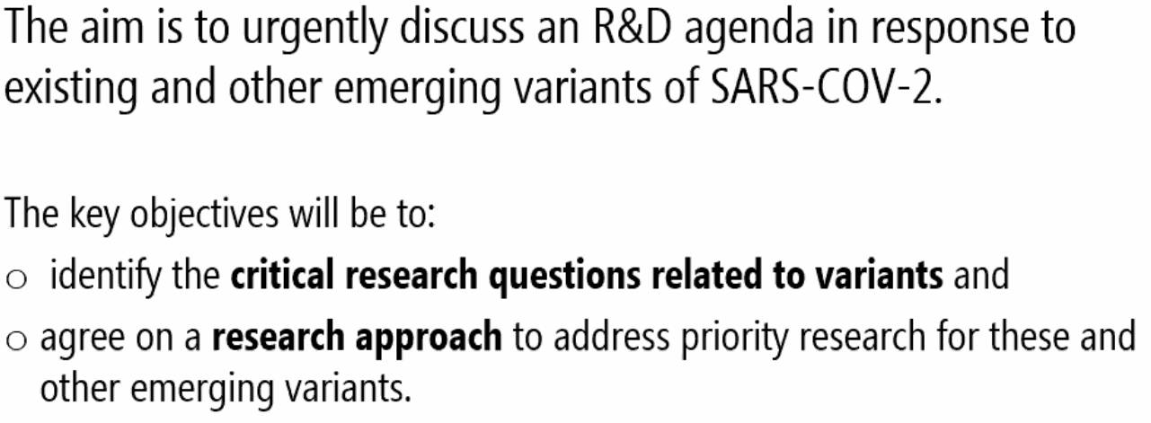
 | 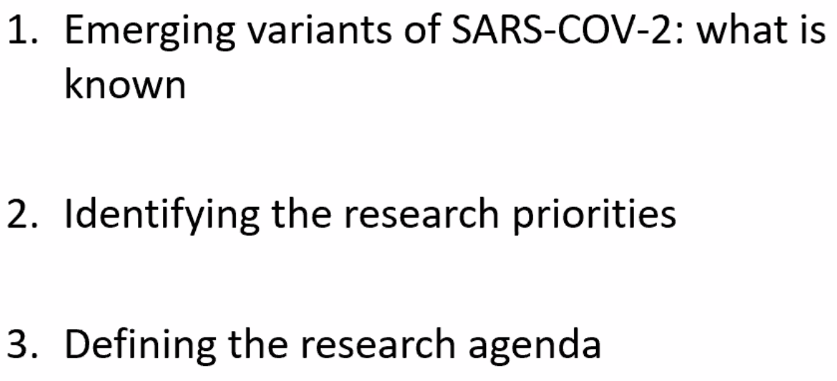
 | 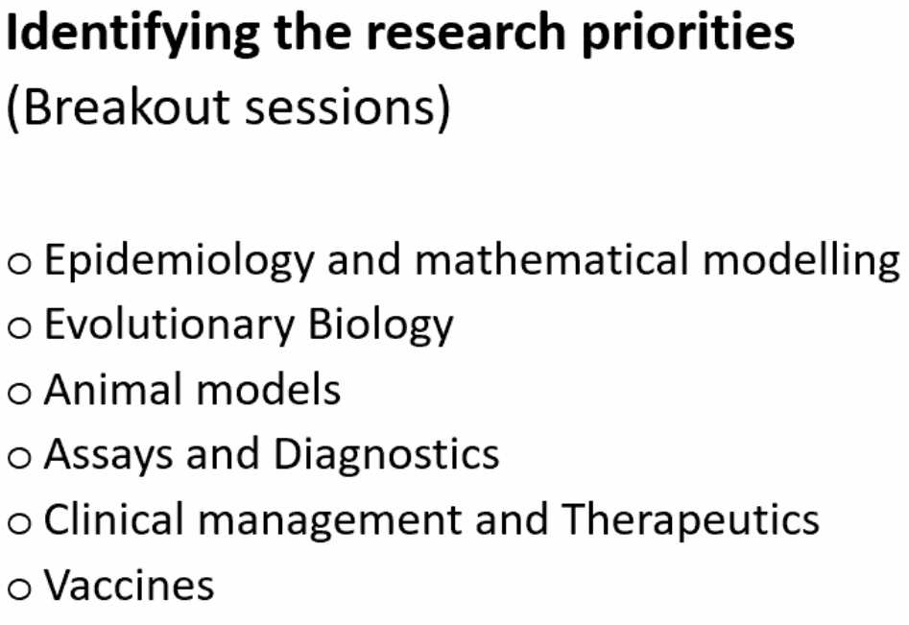
 | 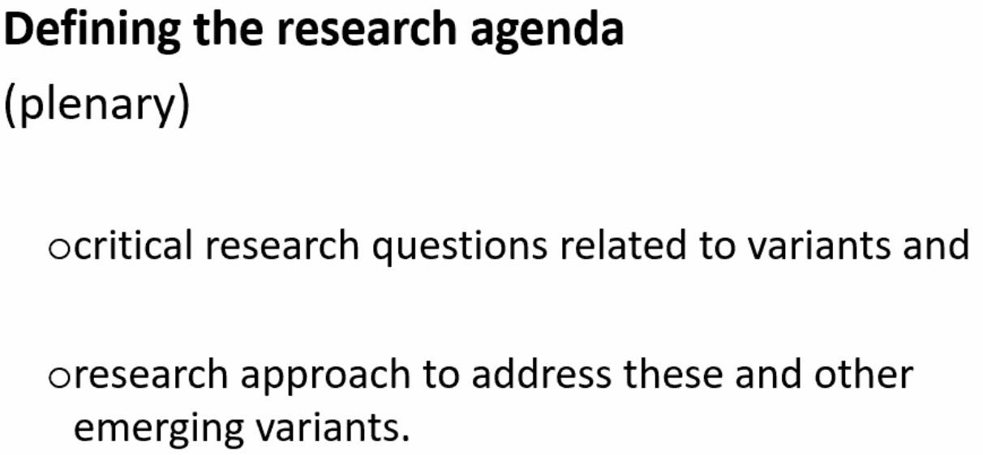
Oliver Morgan: Understanding the global spread of emerging SARS-CoV-2 | 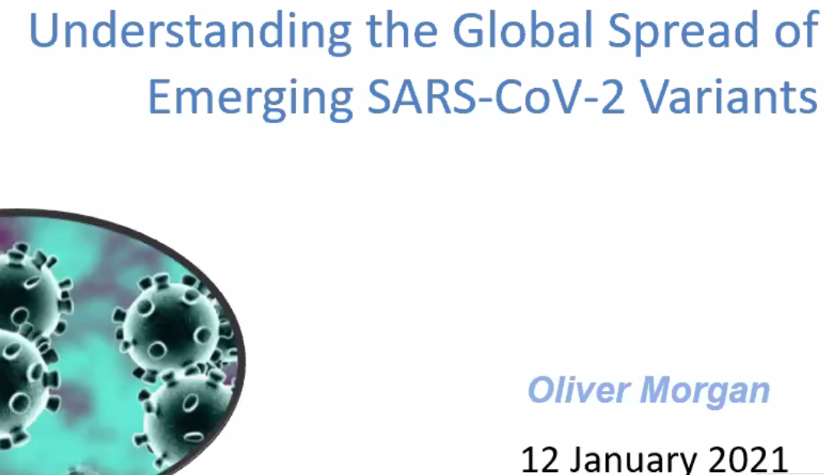
 | 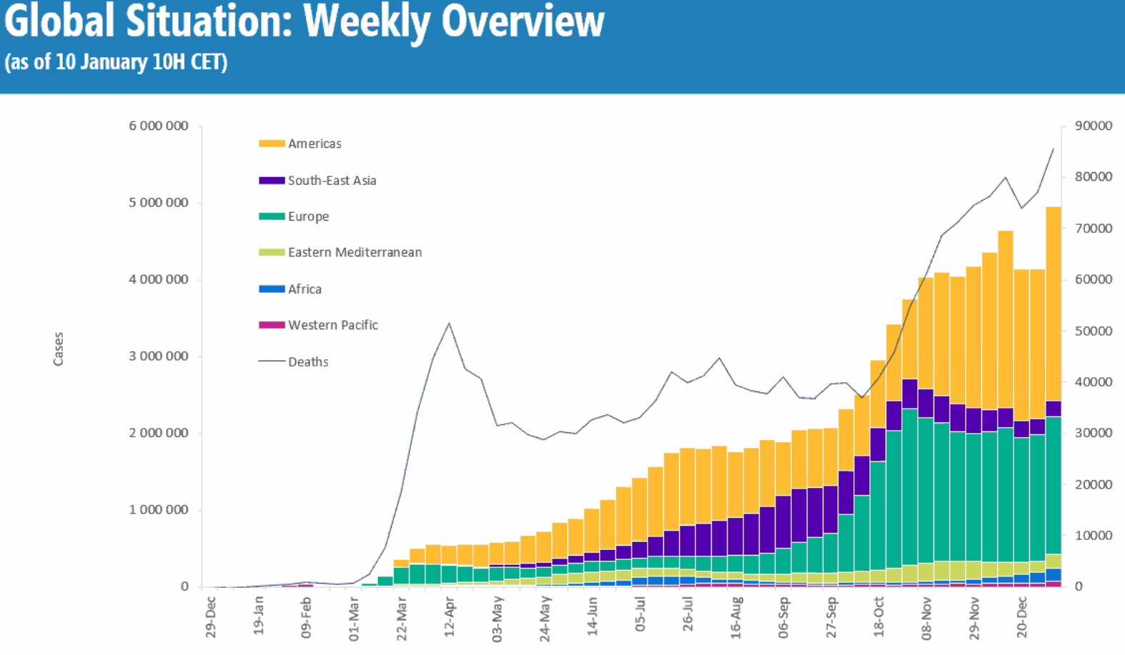
 | 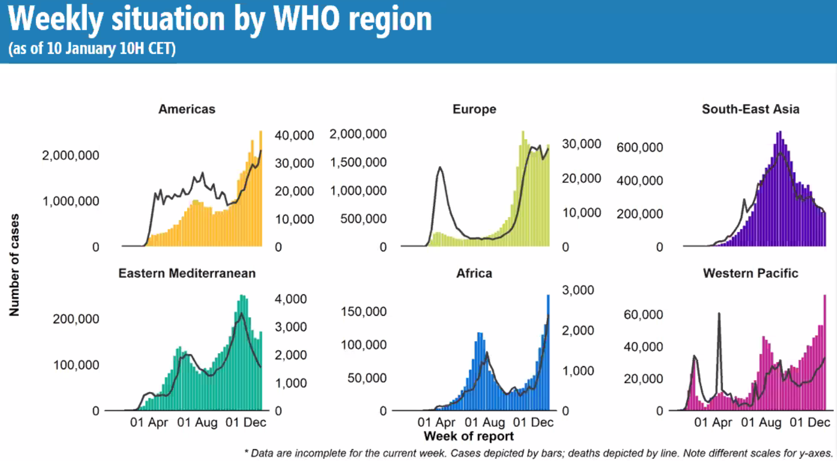
 | 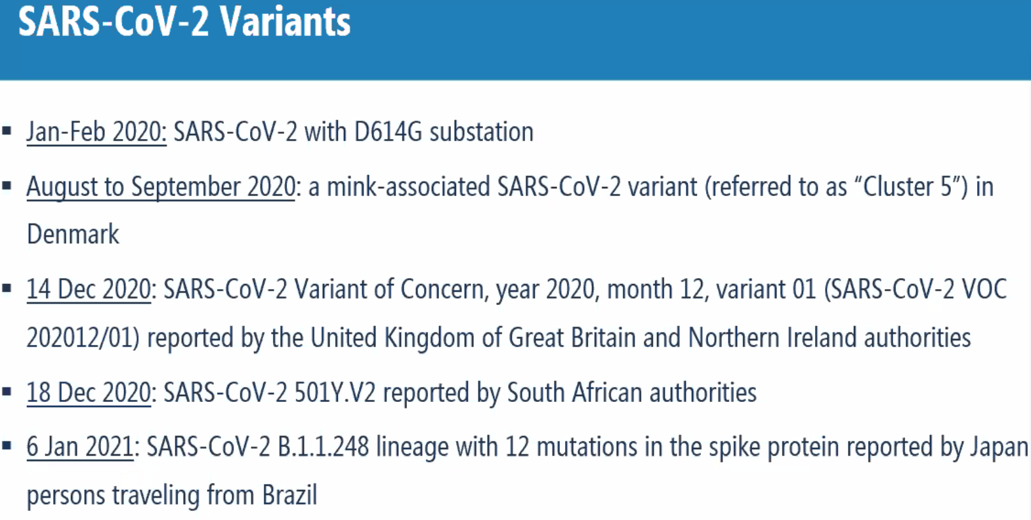
Over time: Predominance of G614 | 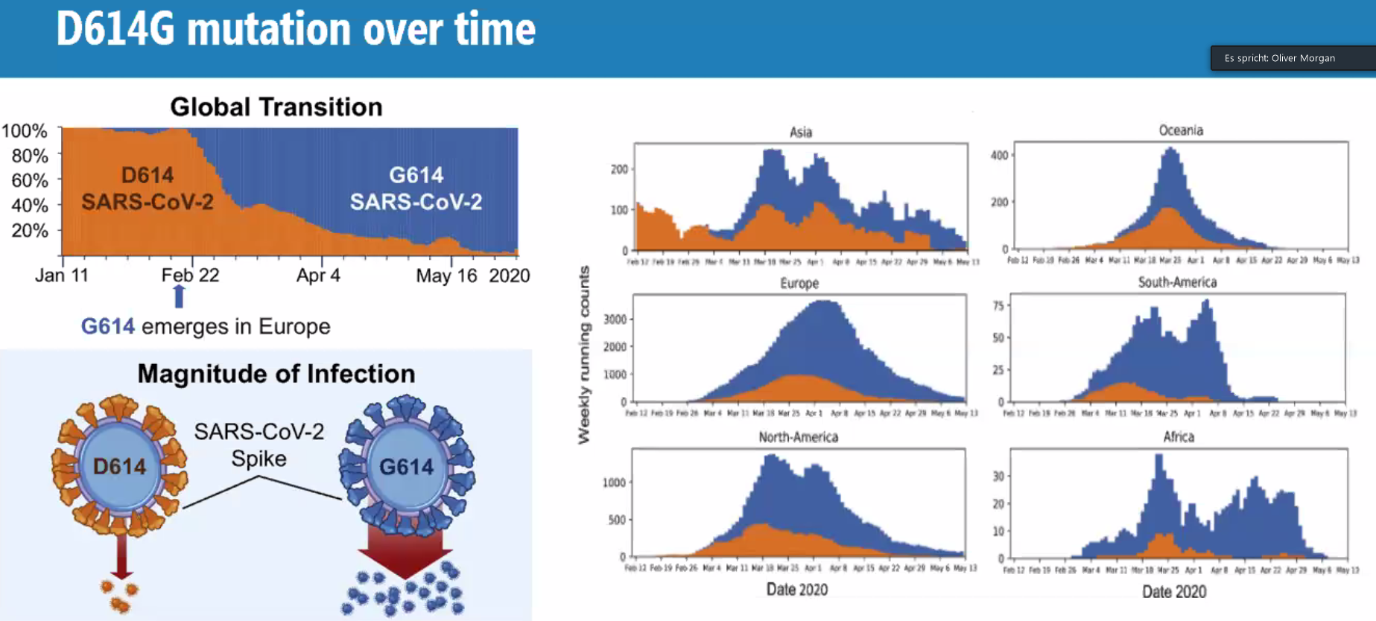
No additional cases, no spread despite good surveillance, has disappeared from human population in Denmark | 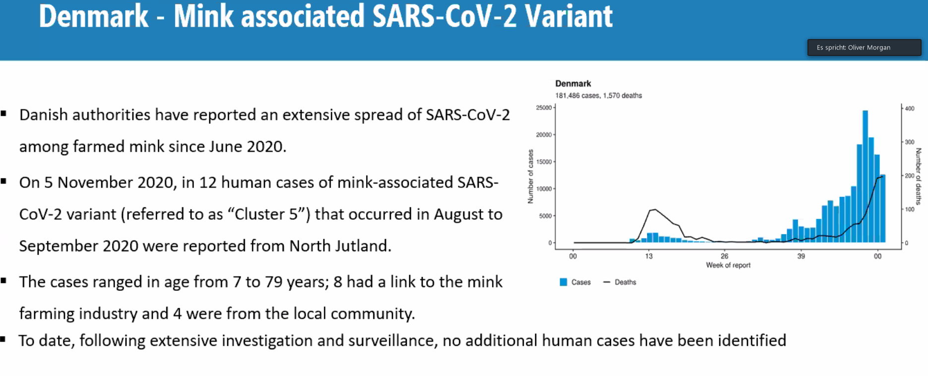
 | 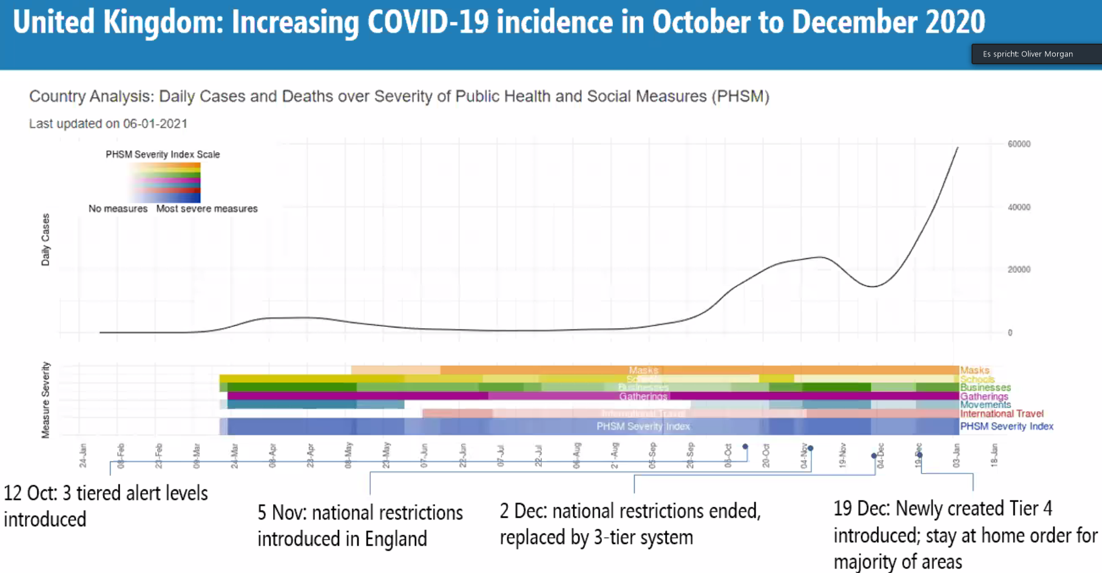
VOC 202012/01:  Coinciding new mutations and S-deletions (useful for diagnostics) | 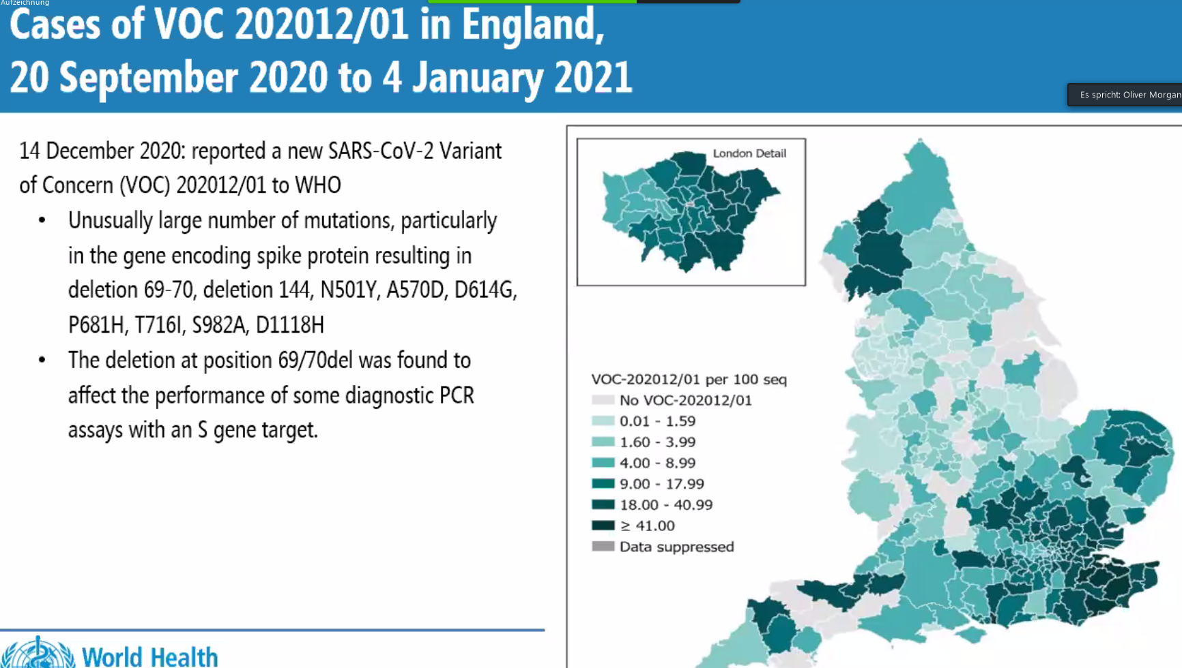
Continuous spread in UK | 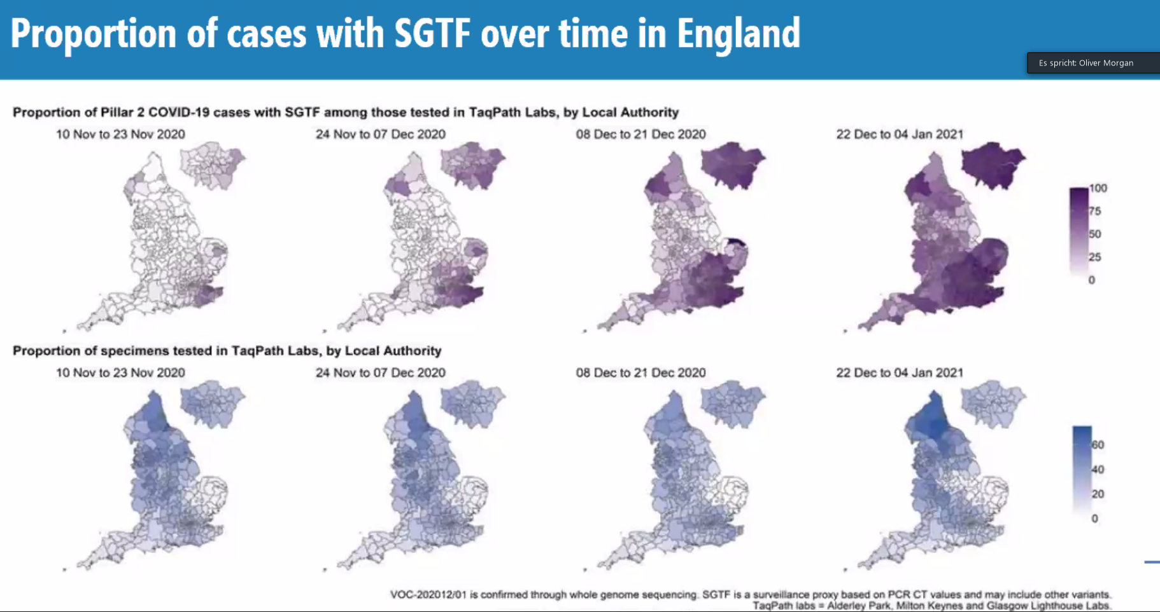
 | 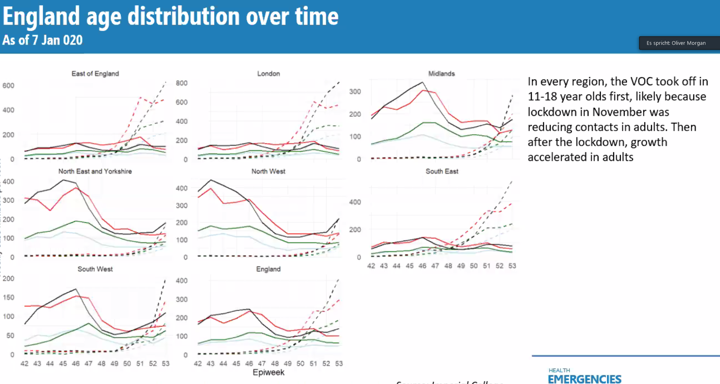
SAR in different counties: mostly elevated and in all age groups | 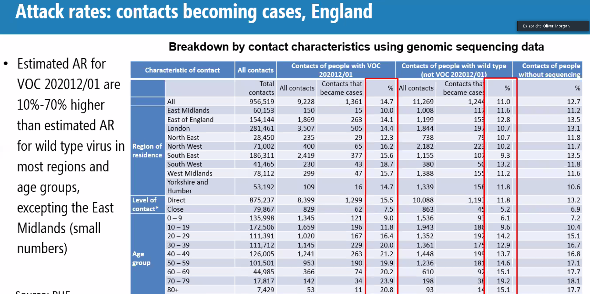
No difference in hosp admission or case fatality | 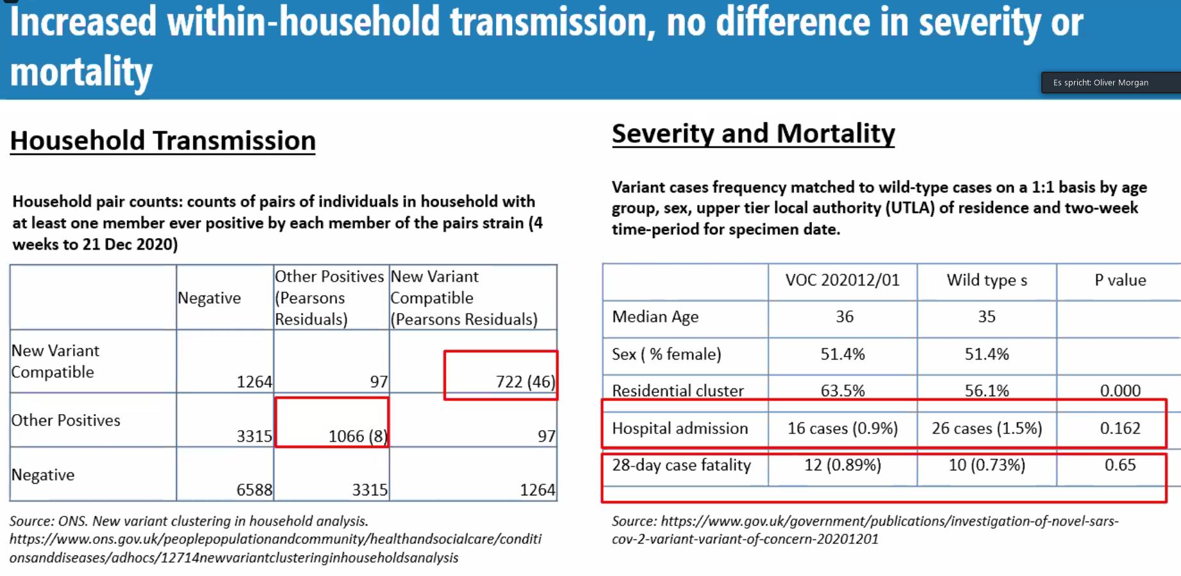
Reports from 46 countries by 11.01.2021 | 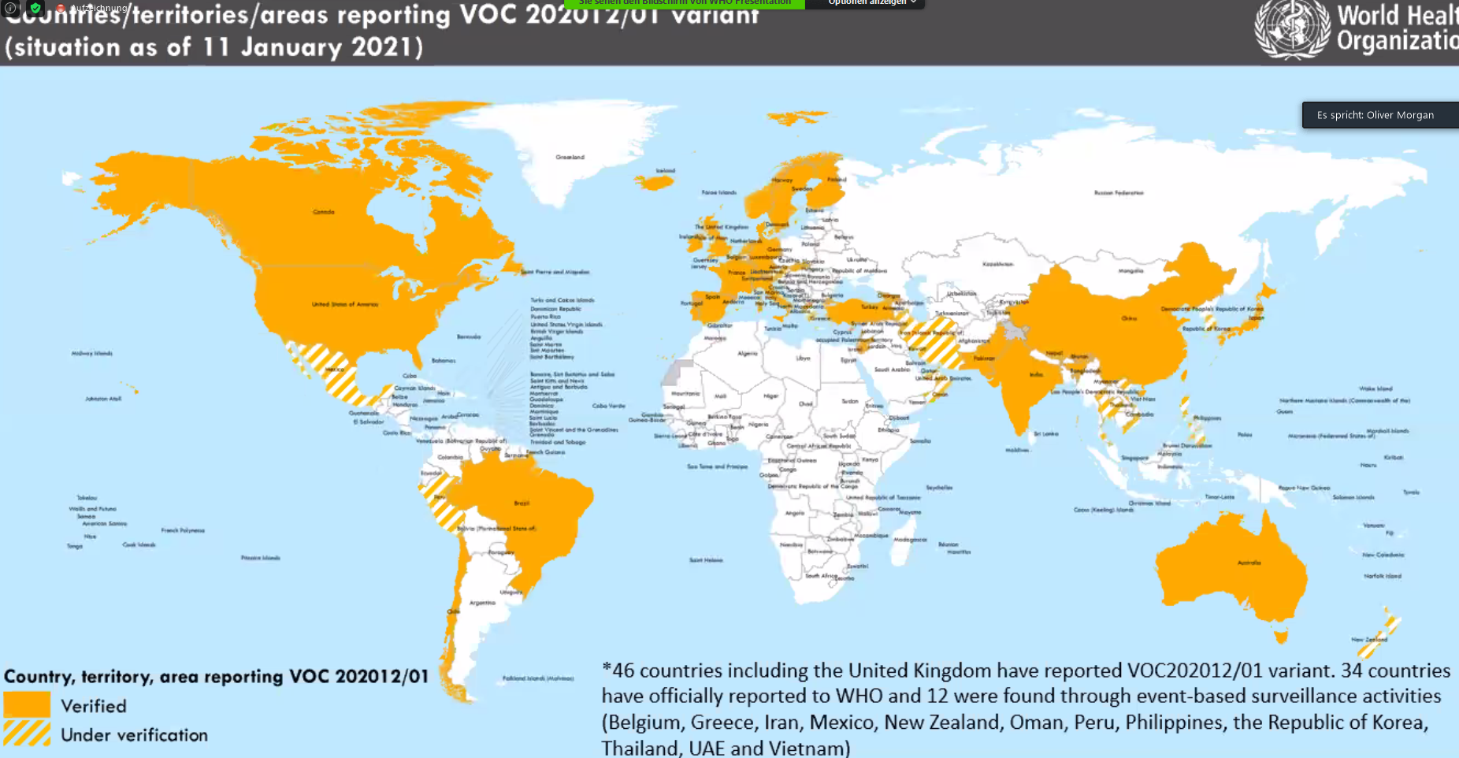
In Denmark:  B.1.1.7 has become dominant | 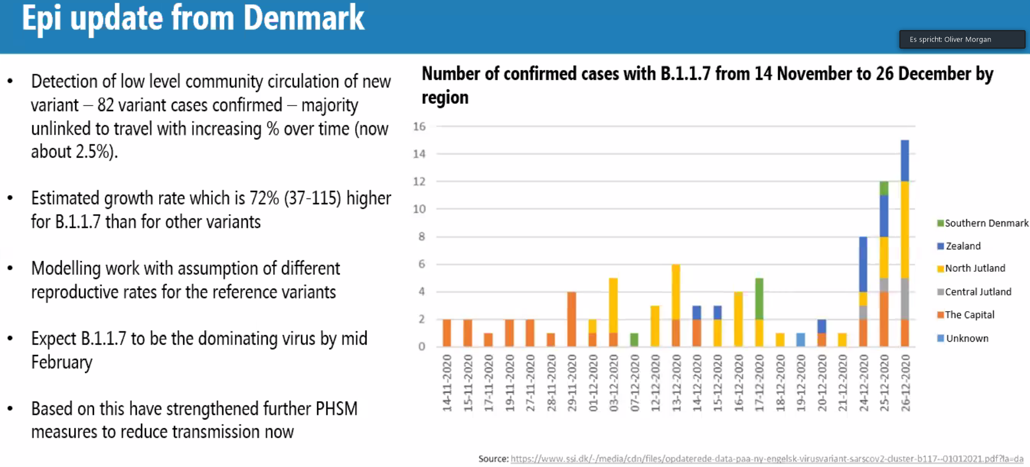
 | 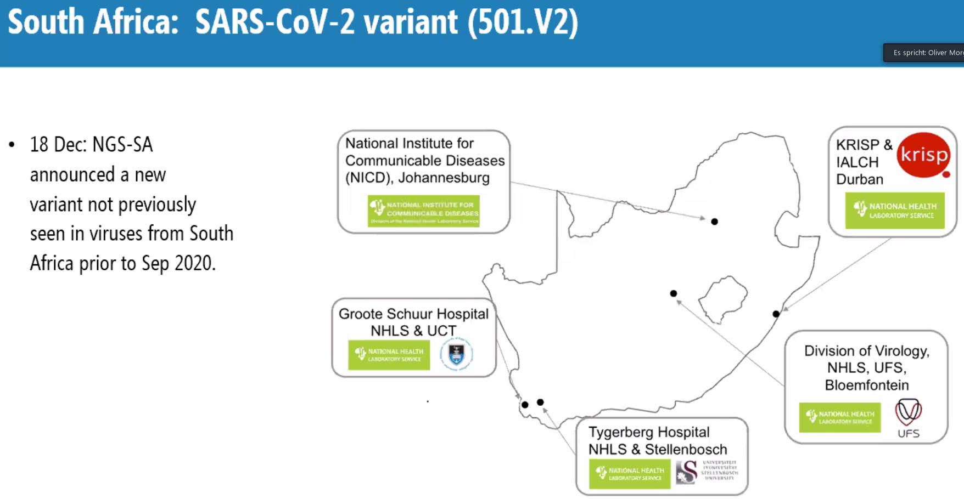
 | 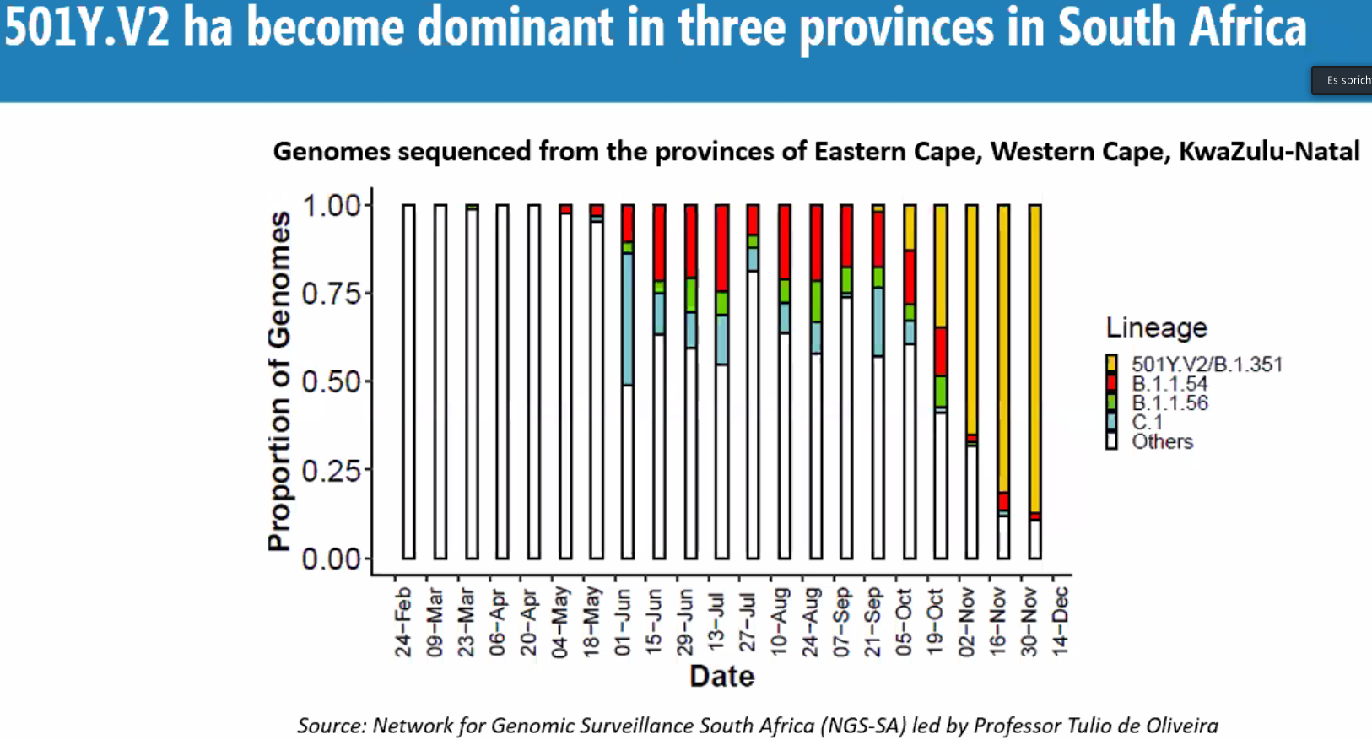
 | 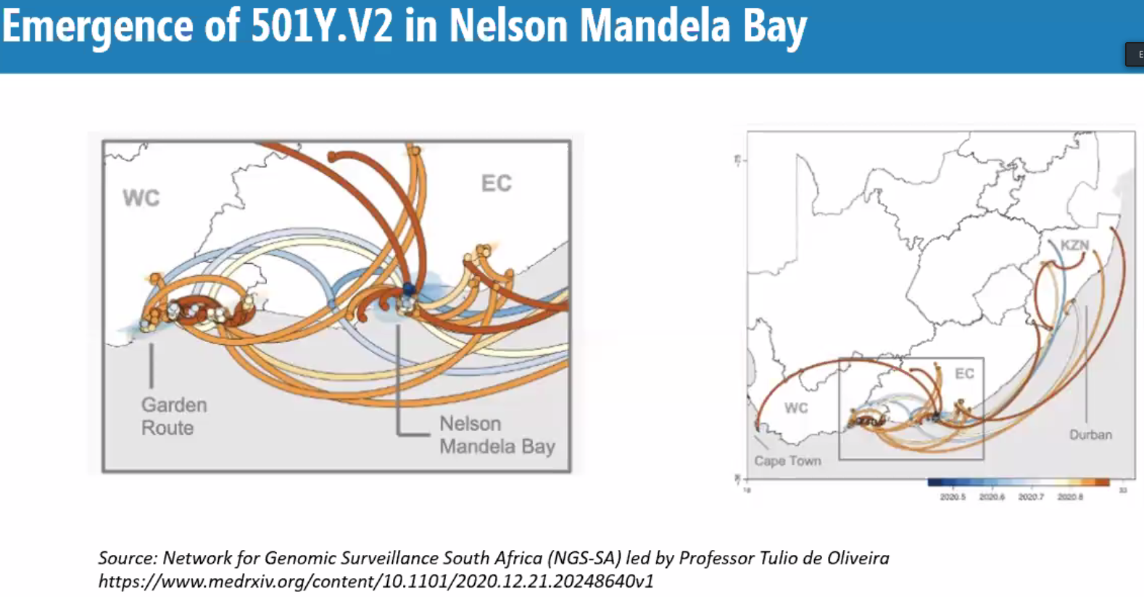
501Y.V2 1,5 times more transmissible, perhaps also due to immune evasion.  Severity issue not resolved yet. | 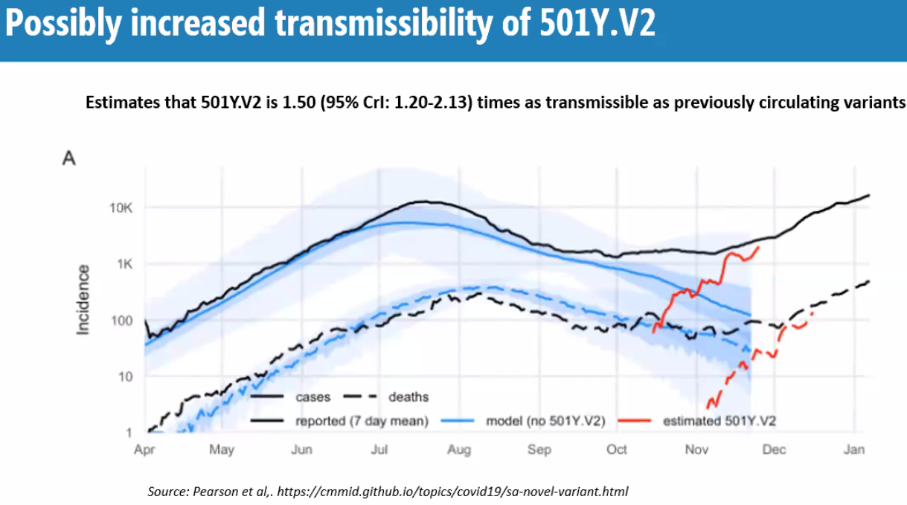
18 countries affected | 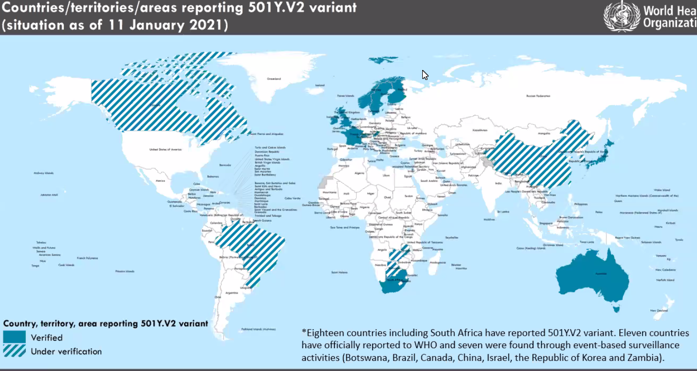
 | 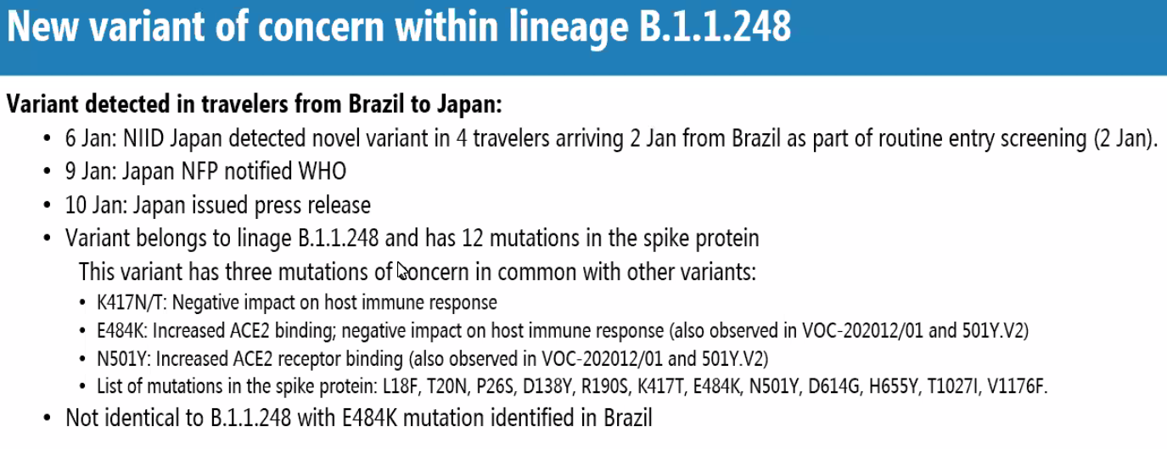
 | 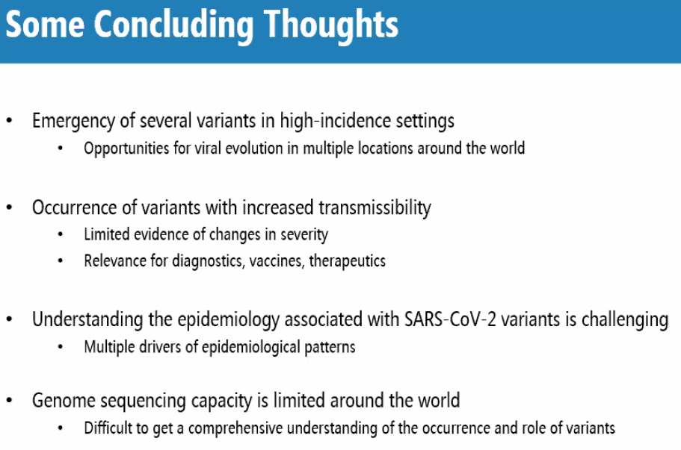
Mark Perkins:  SARS-CoV-2 and the pressures on the virus to evolve: what is known? | 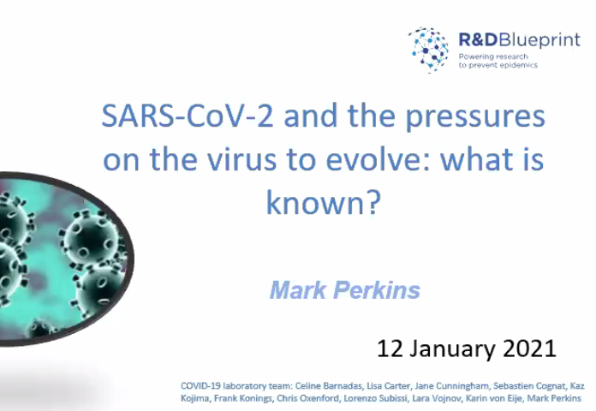
From February 2020: | 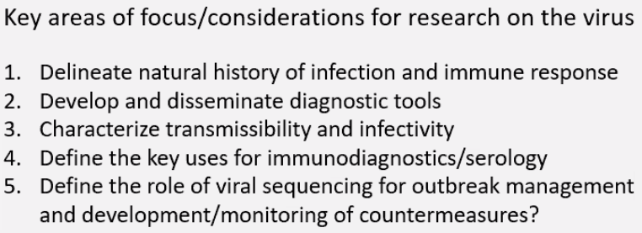
 | 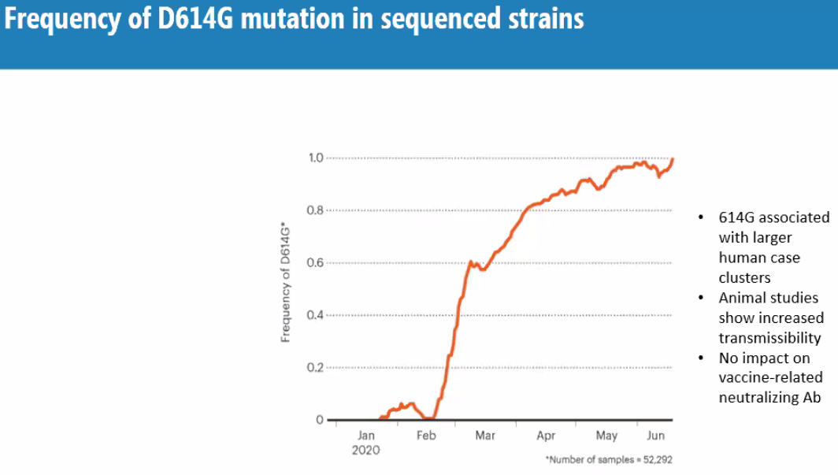
 | 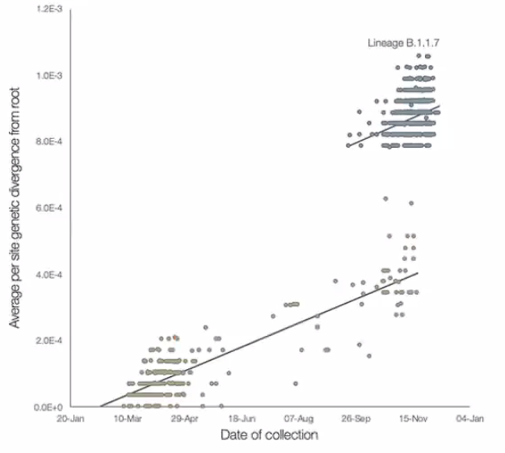
Perhaps from i-compromised pt or undetected population | 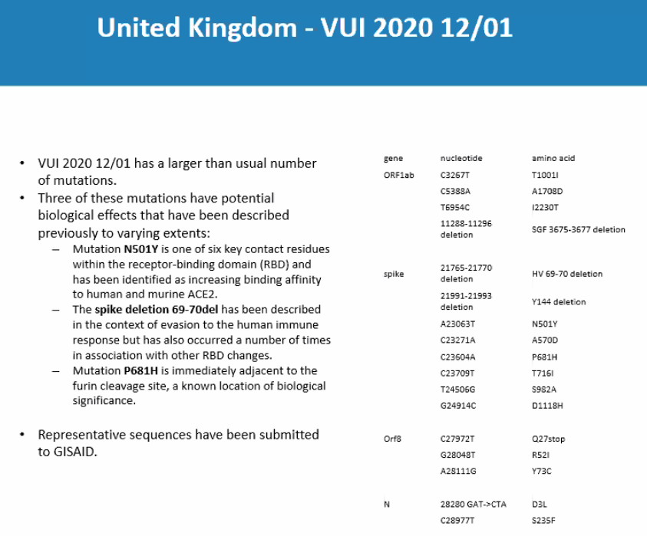
 | 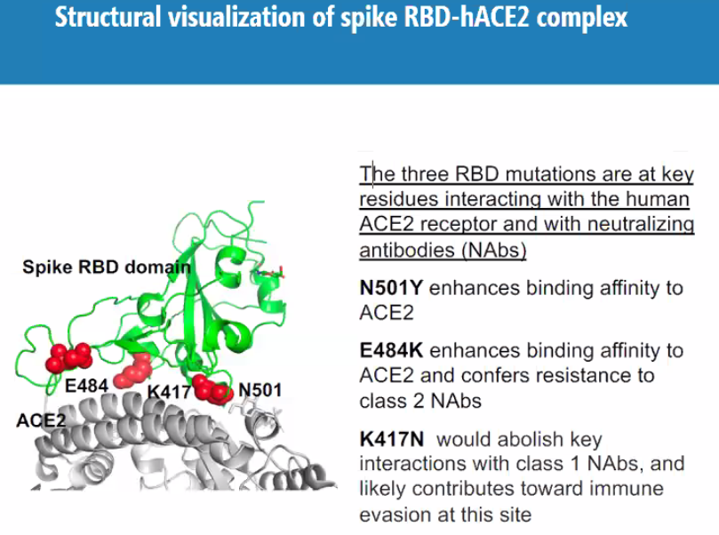
 | 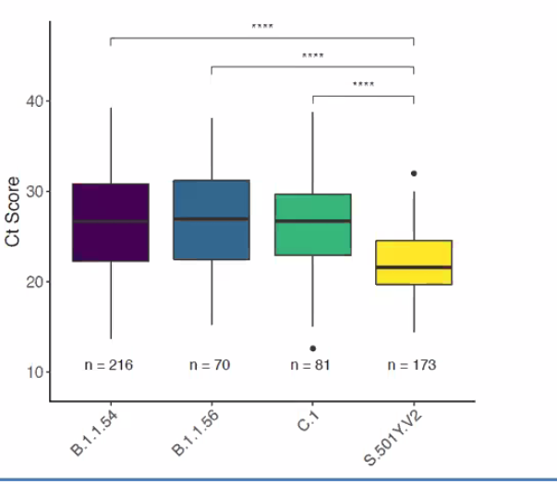
 | 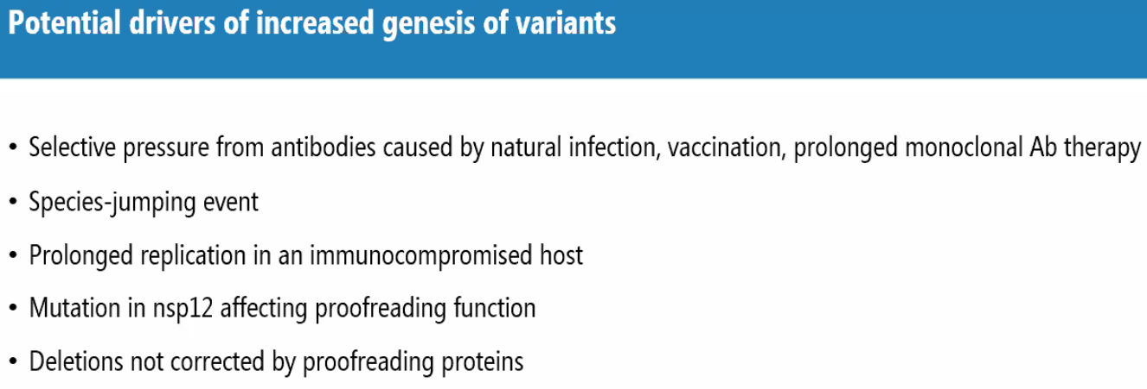
 | 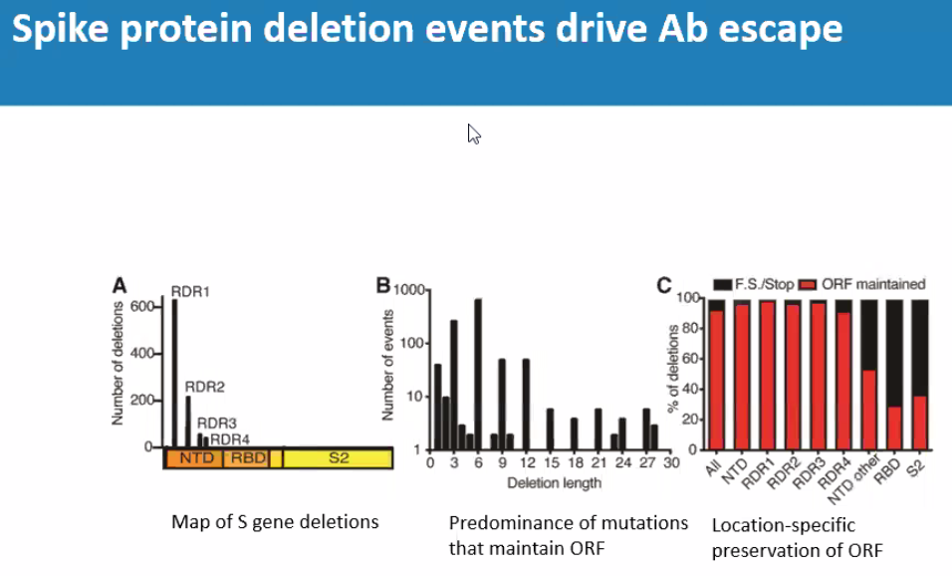
 | 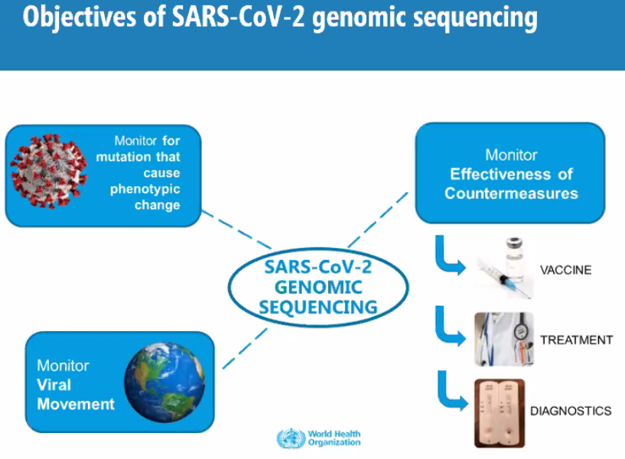
 | 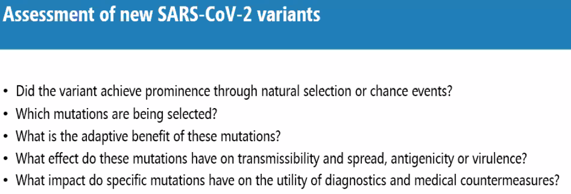
 | 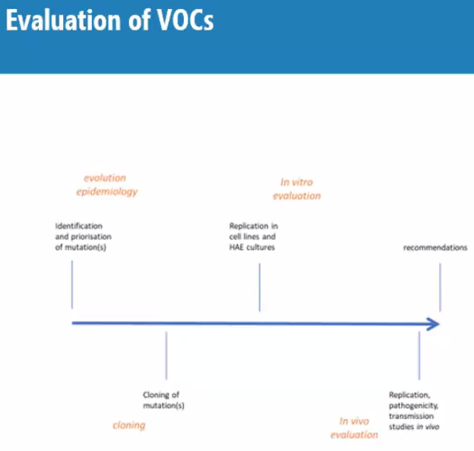
Maria von Kerkhove:  Ongoing strategies for the monitoring and control of spread of emerging variants of SARS-CoV-2 | 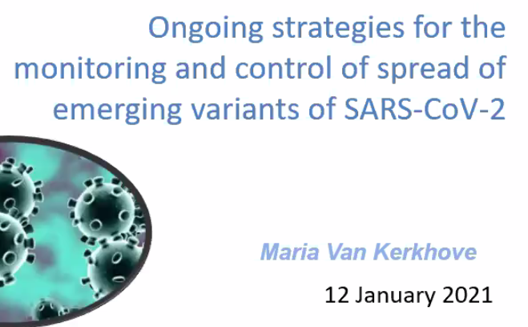
 | 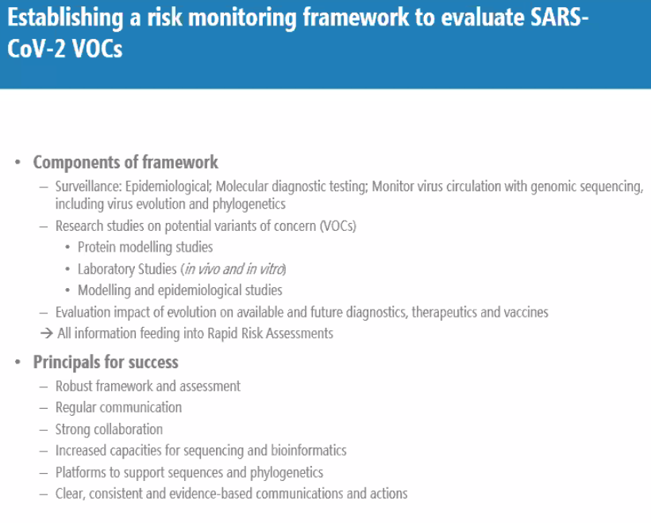
 | 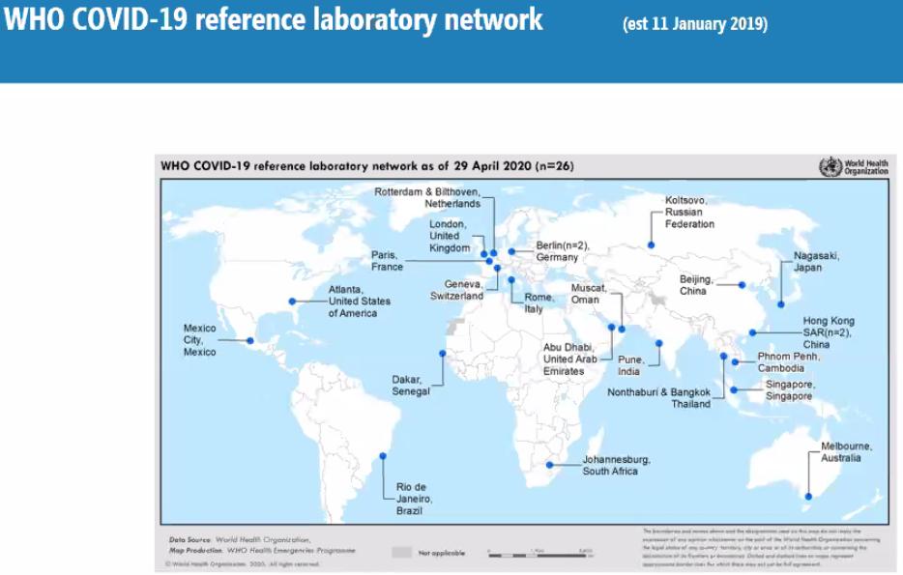
 | 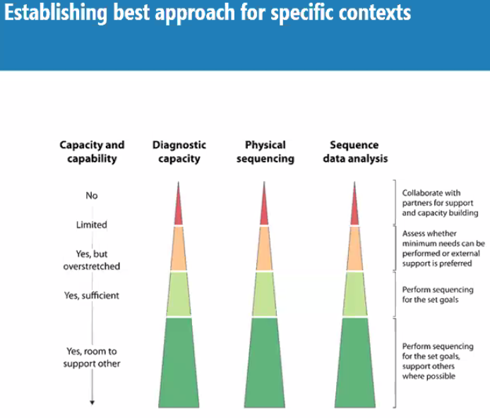
 | 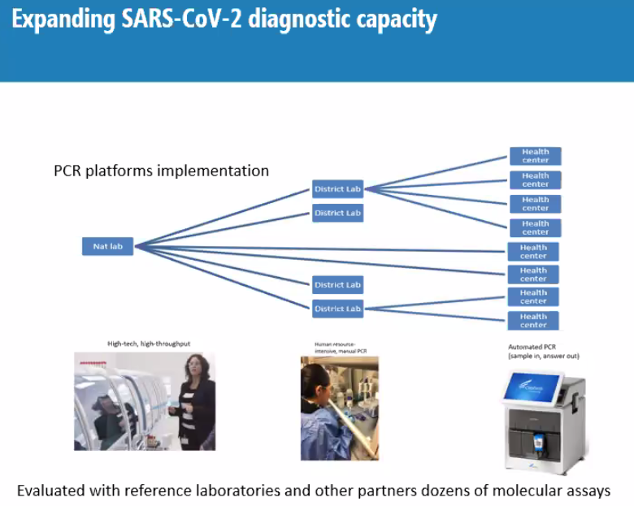
Example of roll-out in Africa | 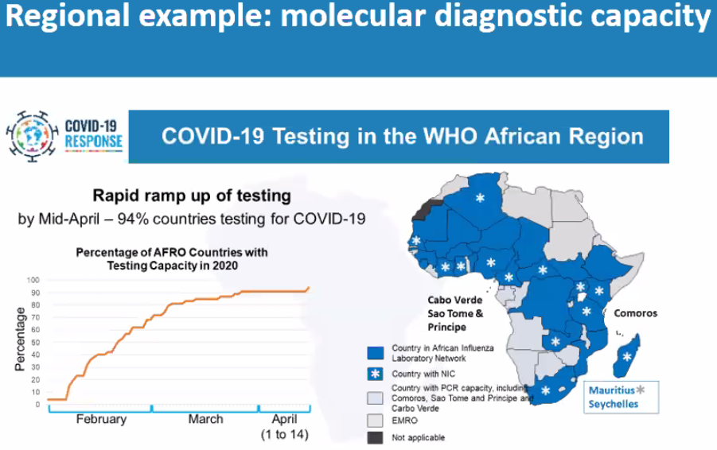
 | 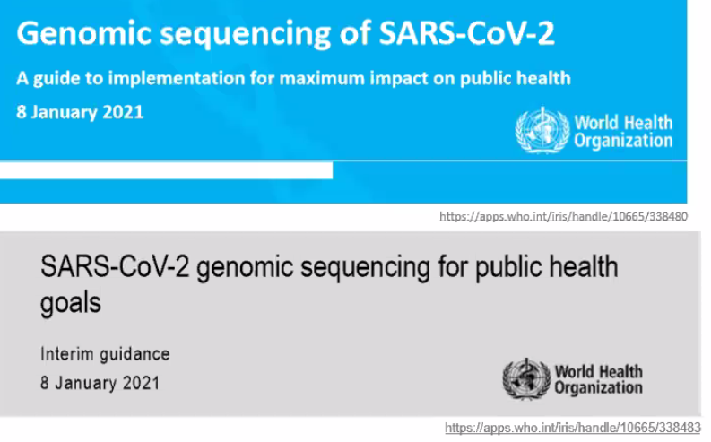
 | 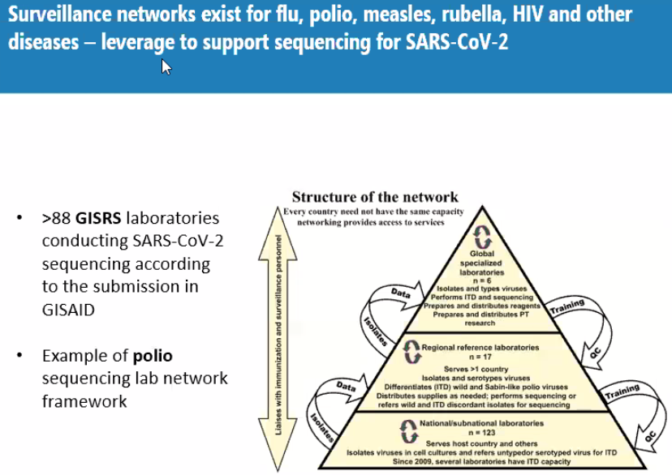
Recommendation for prioritization of sequencing | 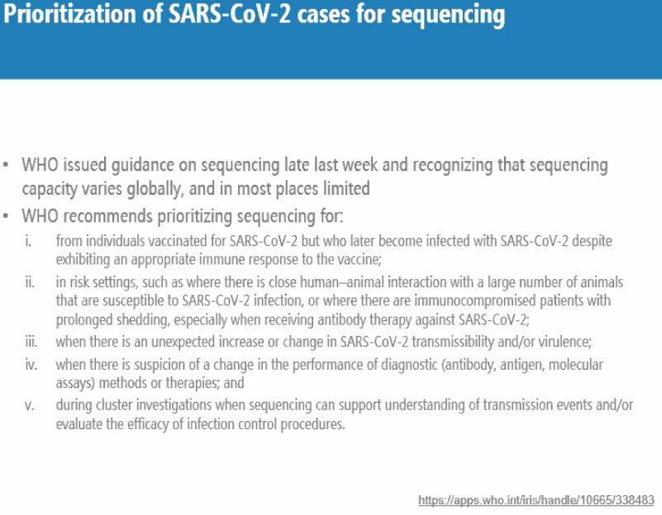
Platforms: nextrain, GISAID, pangolin | 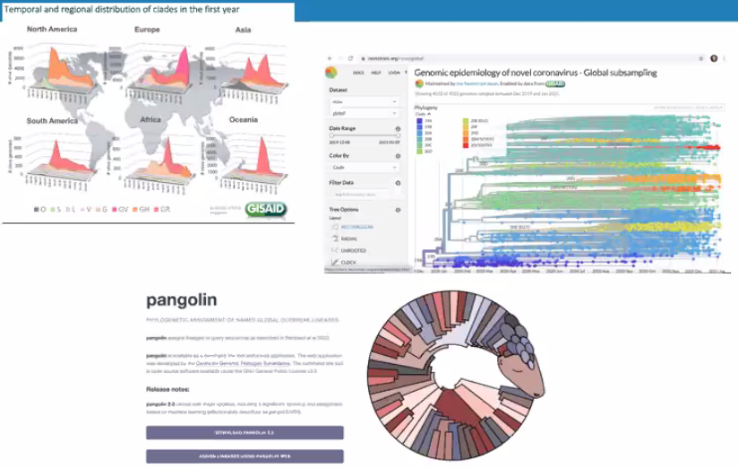
Standard nomenclature is needed and being worked on working group this p.m. | 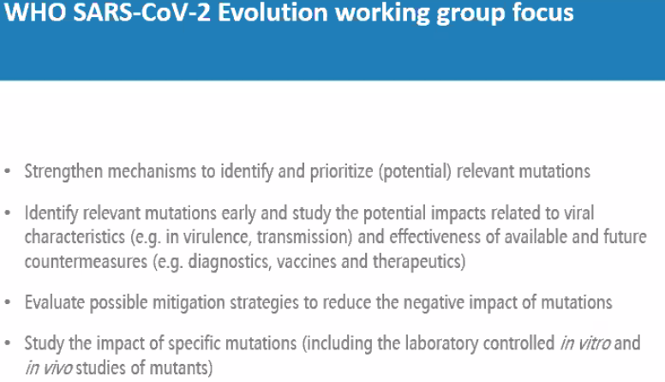
 | 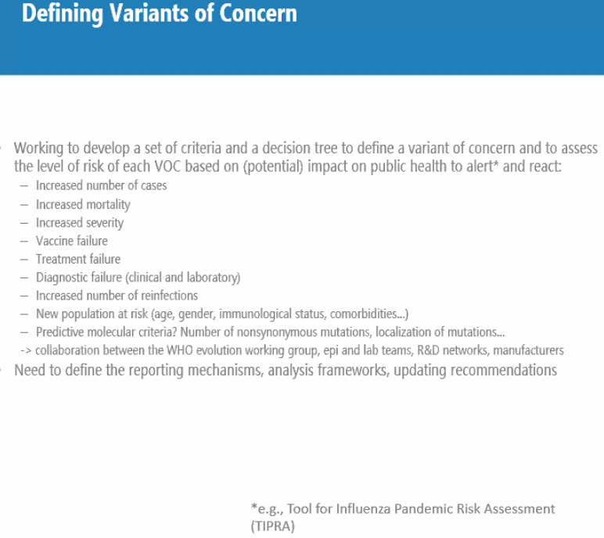
Working with R&D blueprint | 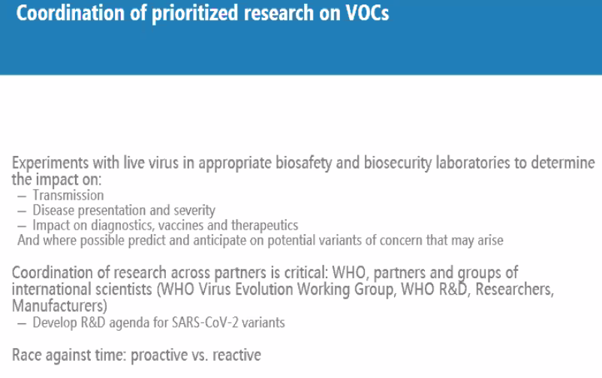
Adolfo Garcia-Sastre:  Animal models | 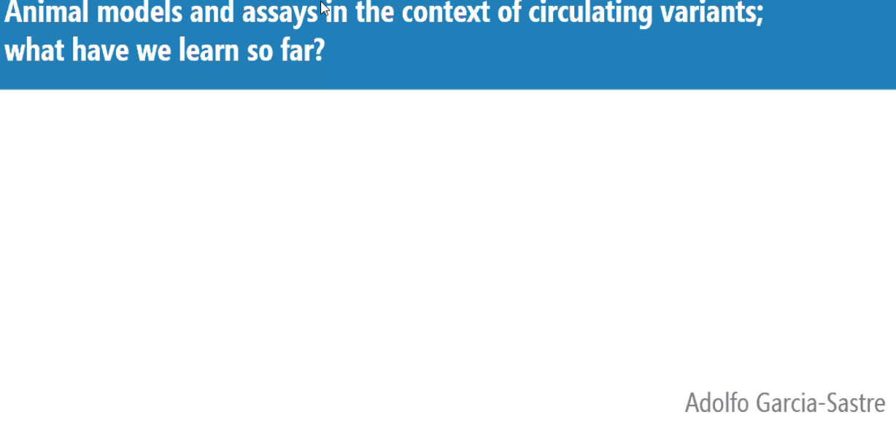
 | 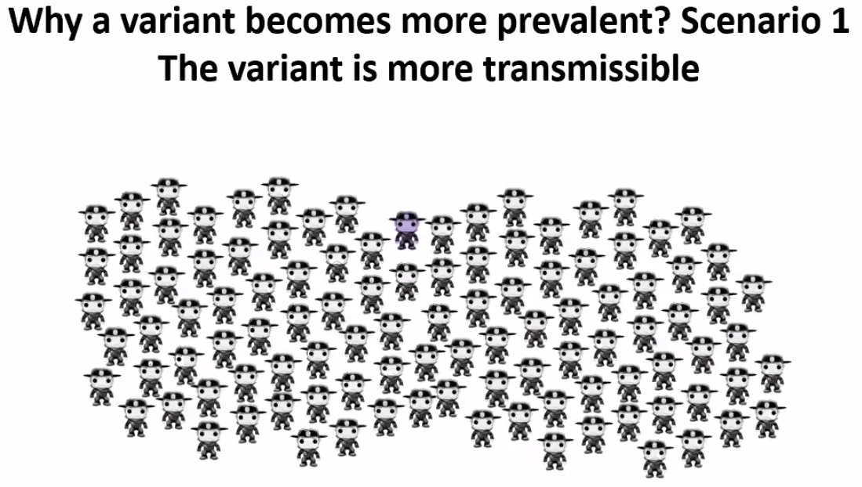
 | 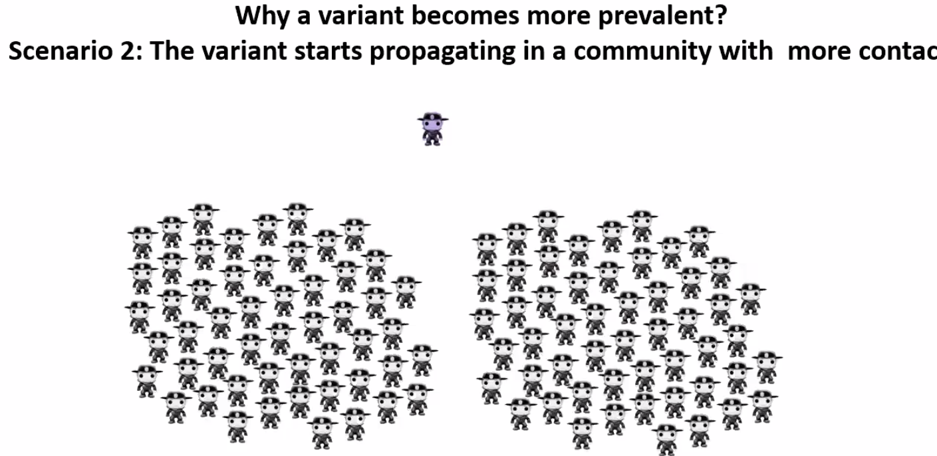
 | 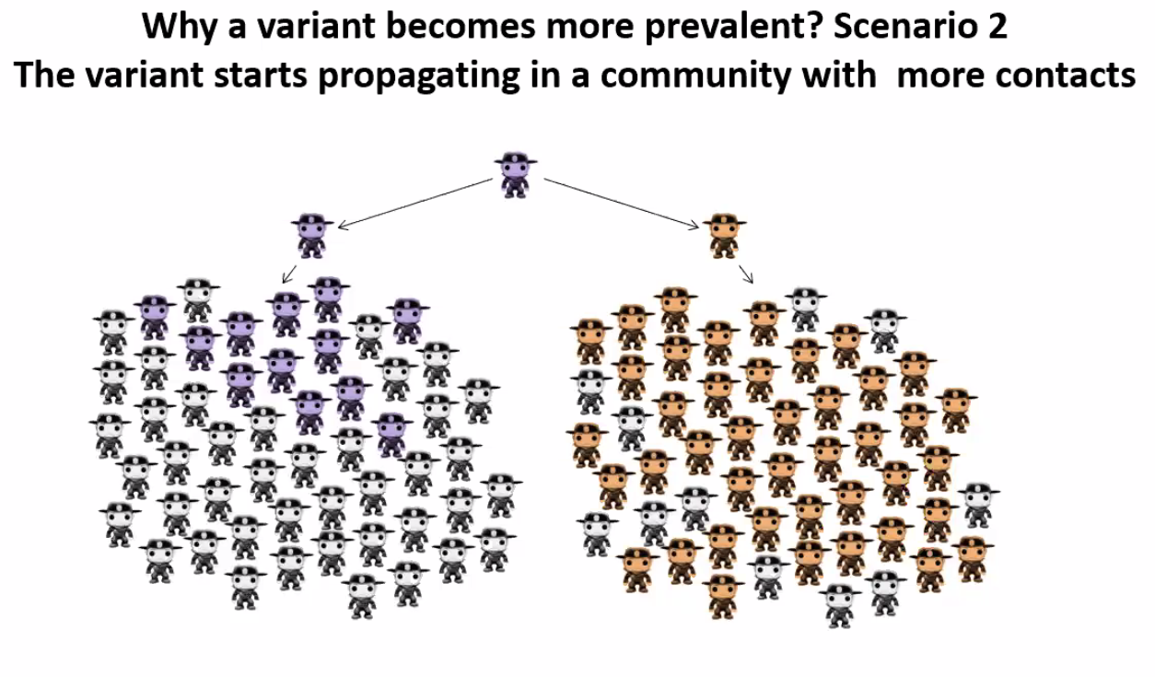
 | 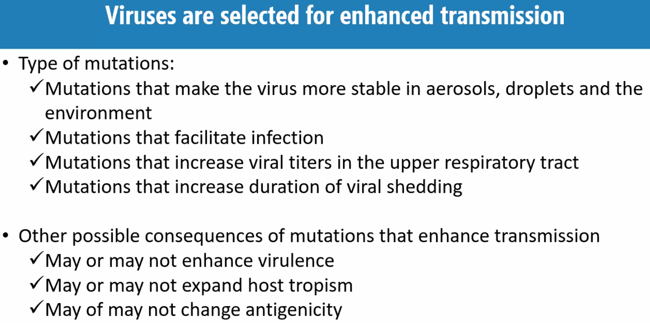
 | 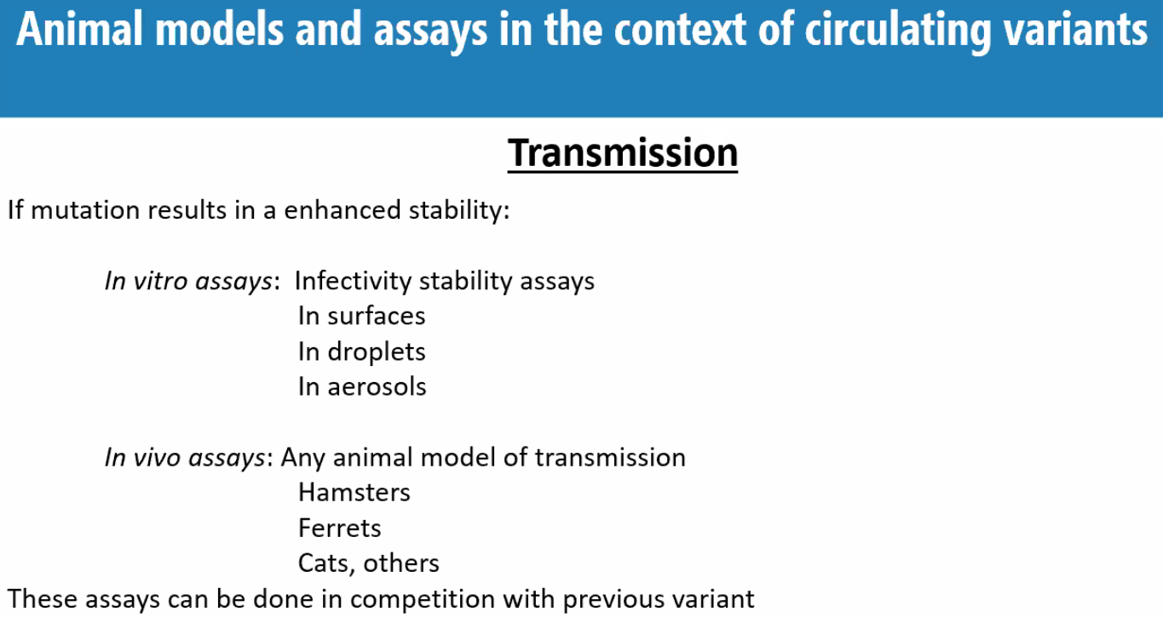
 | 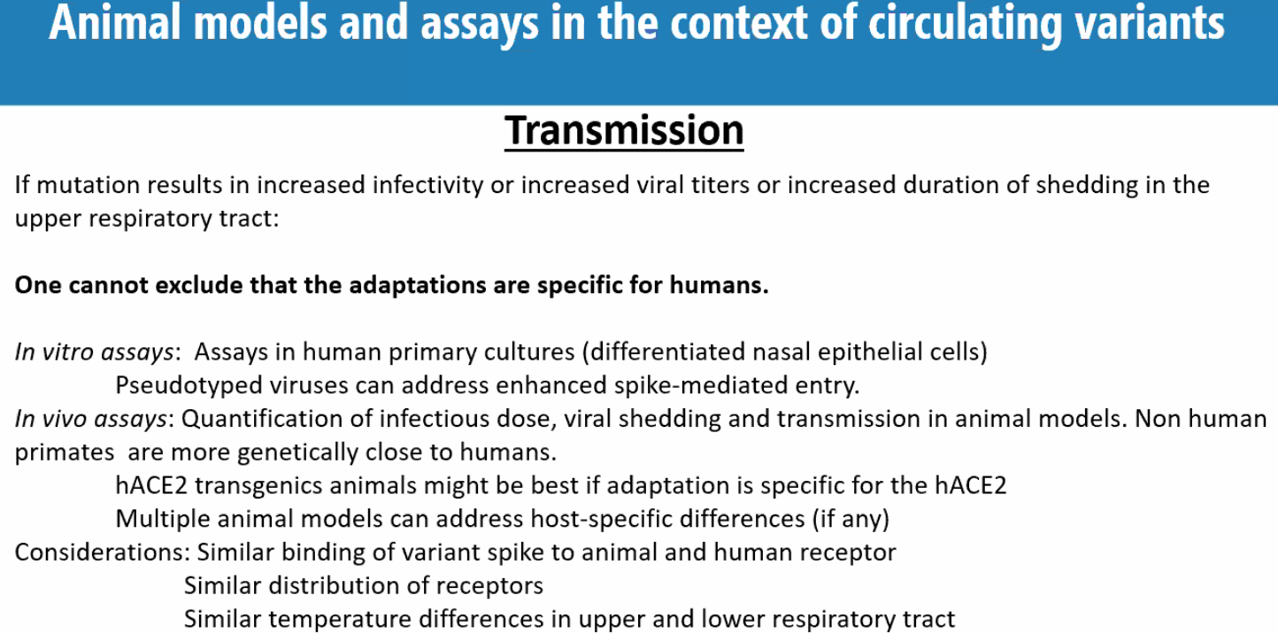
 | 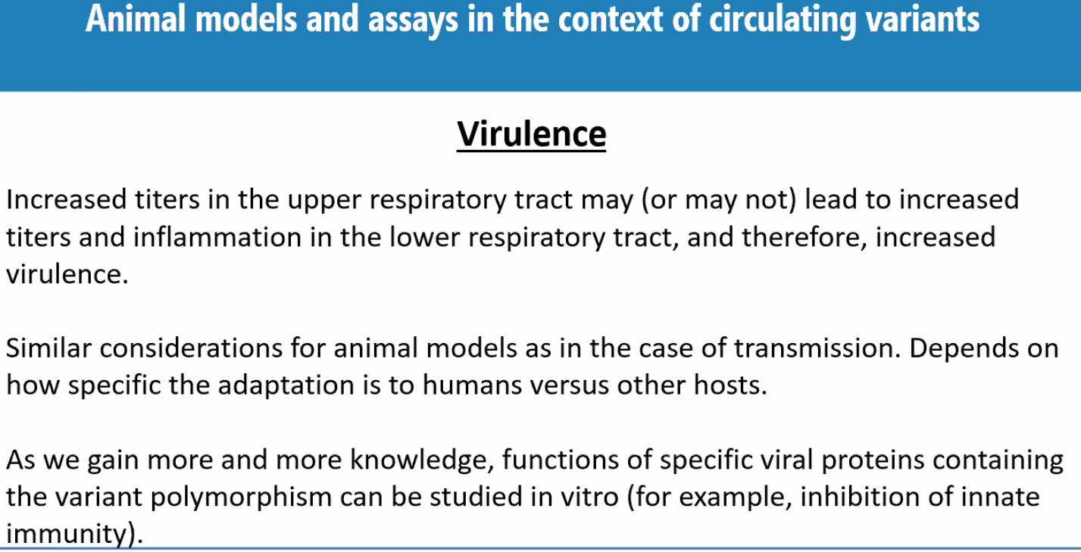
 | 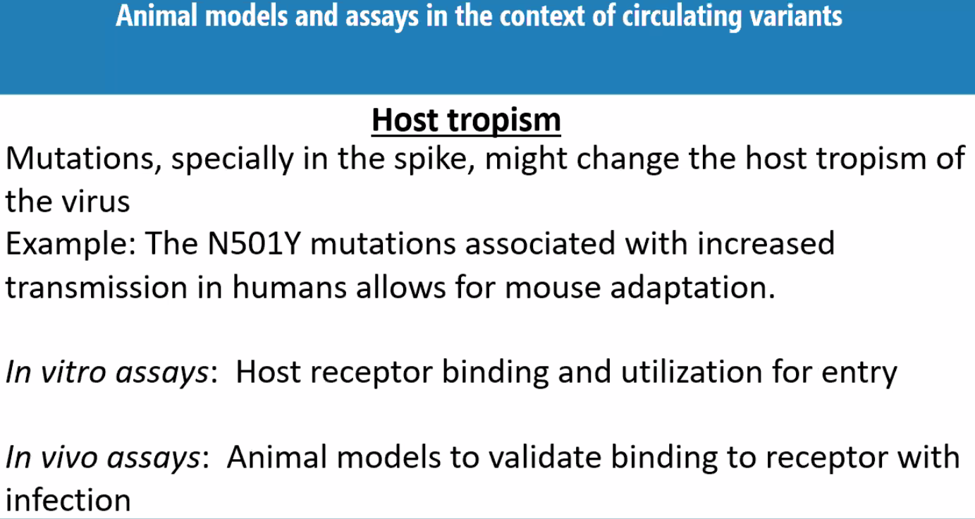
 | 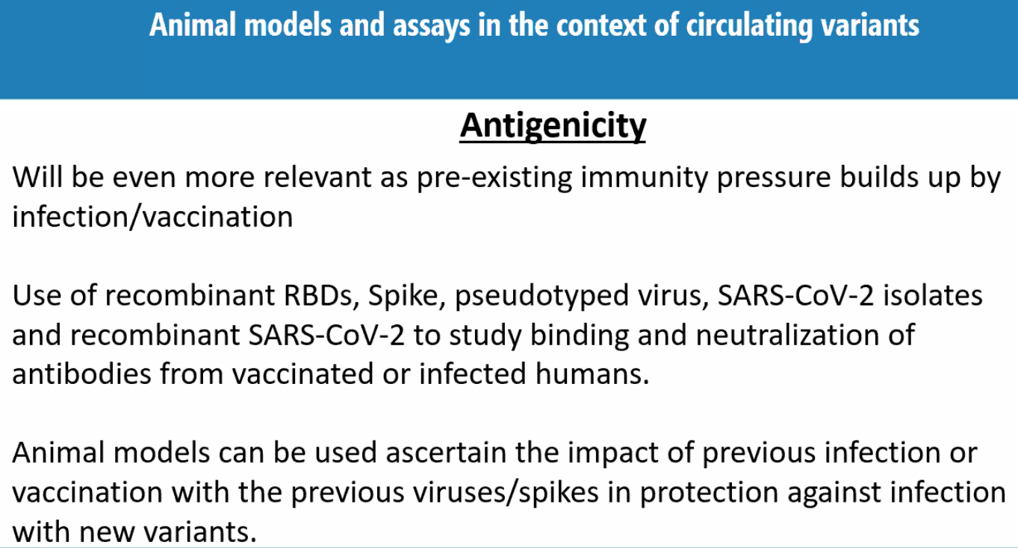
 | 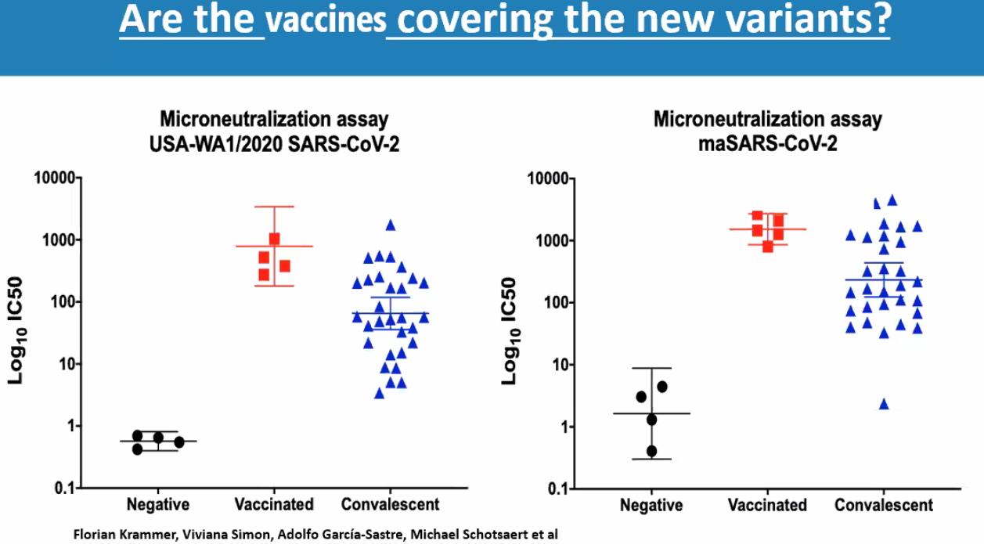
 | 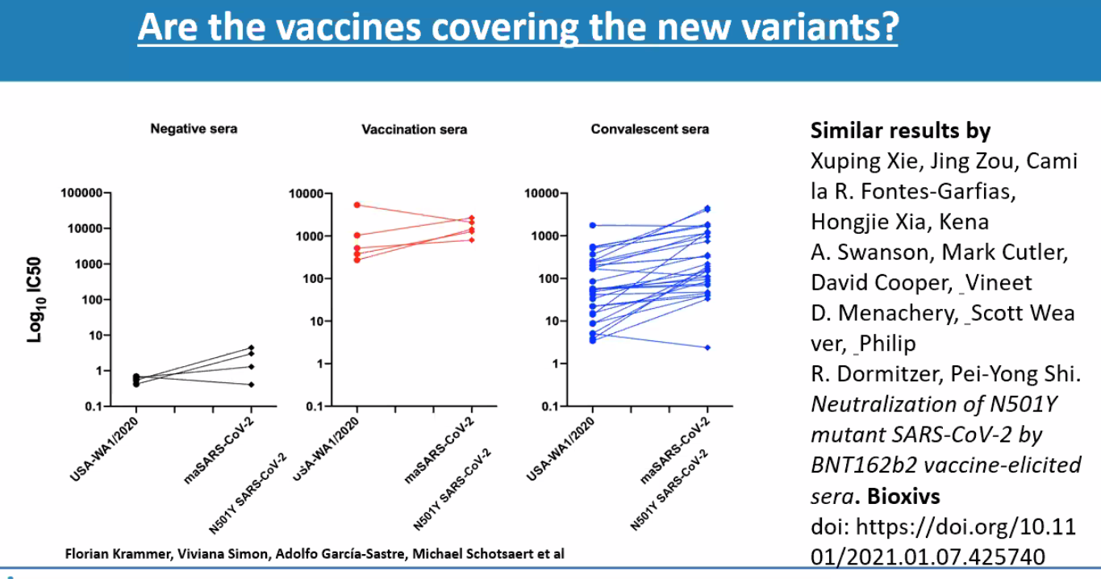
 | 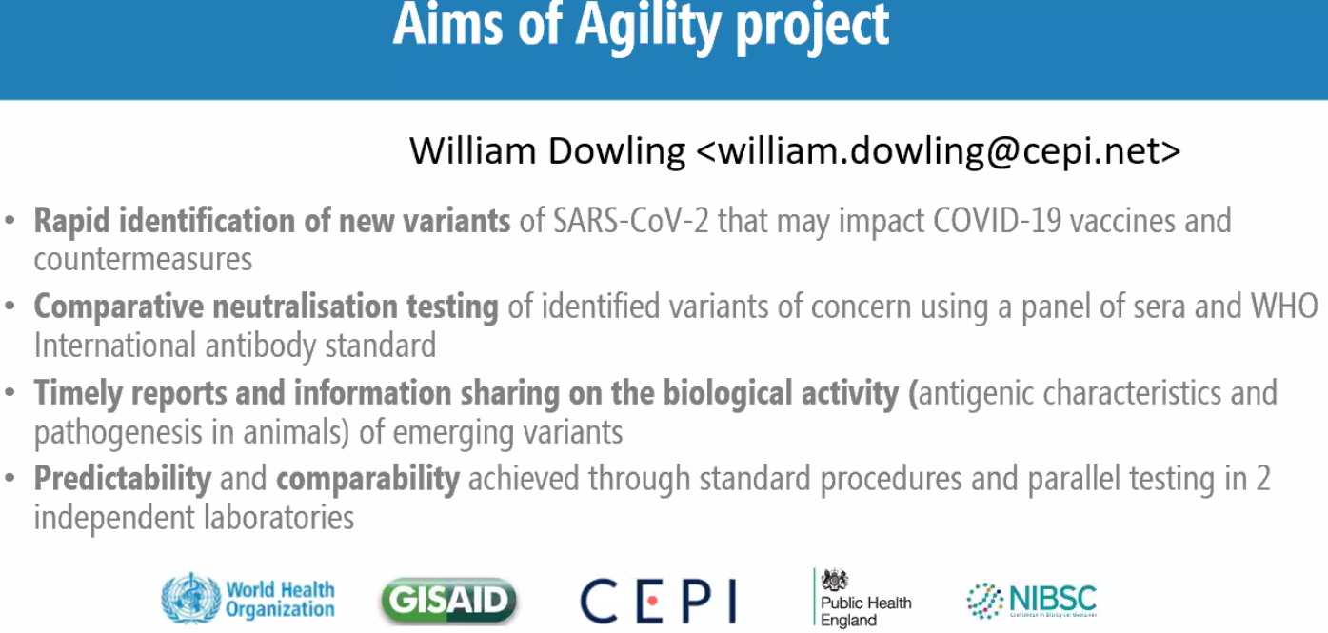
Jake Dunning:  Evidence on changes on disease severity and treatment approaches for pts infected with new variants | 
SGTF = S-Gene target failure | 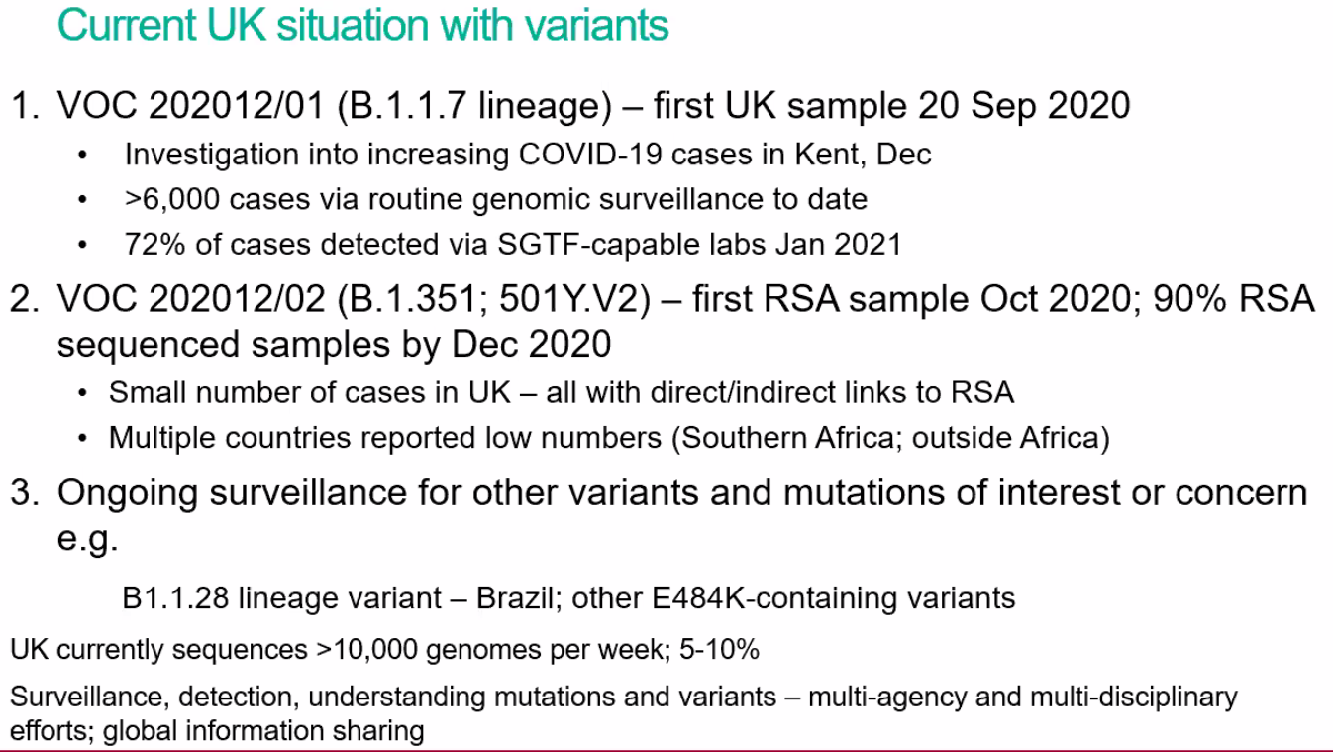
 | 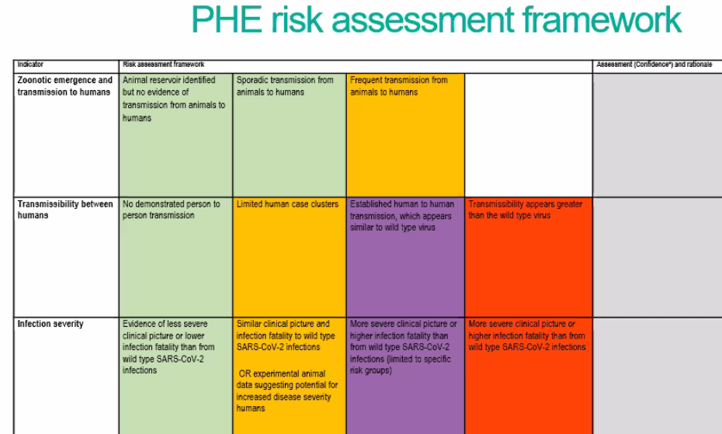
 | 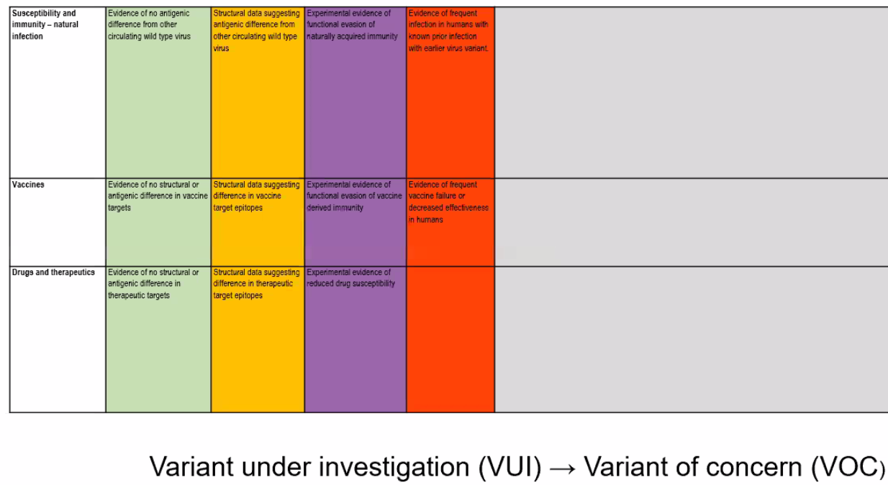
 | 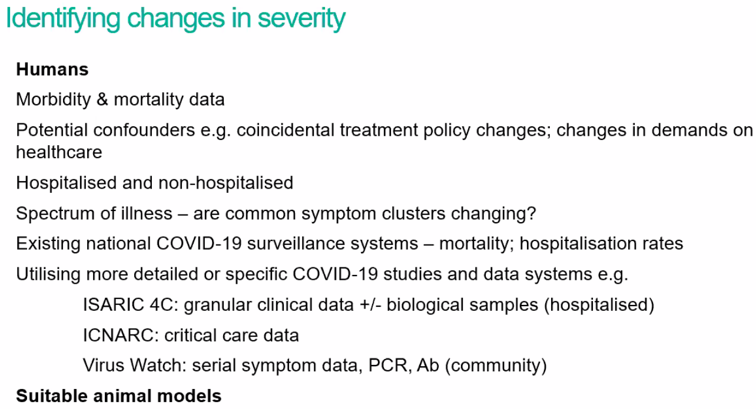
 | 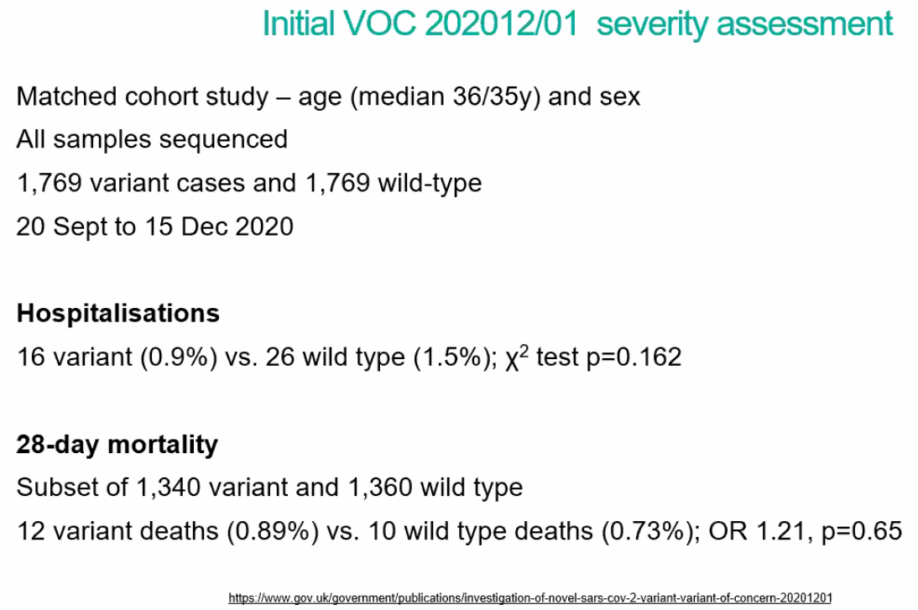
 | 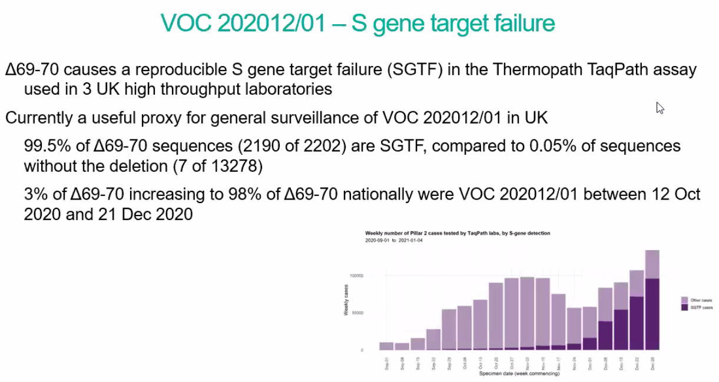
 | 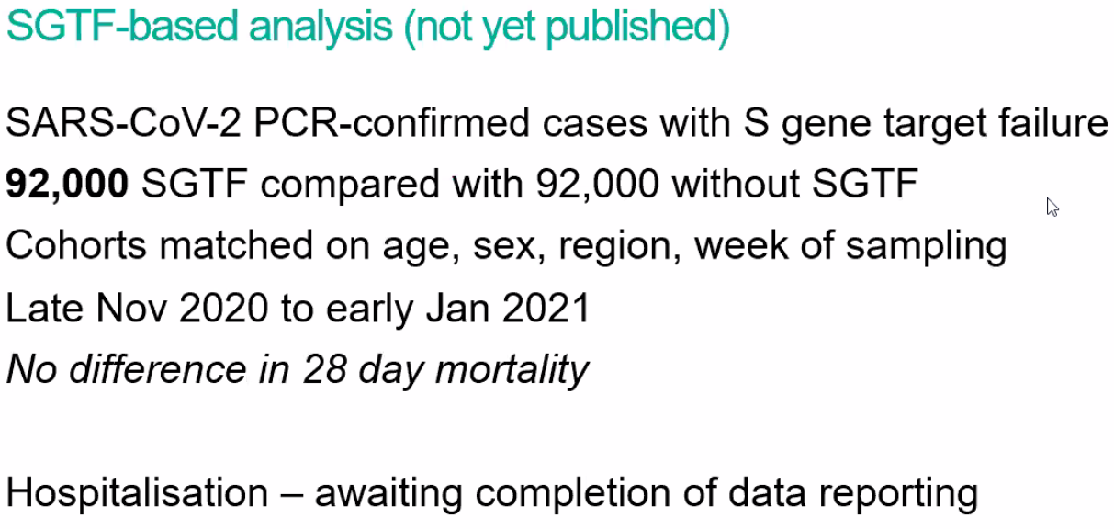
 | 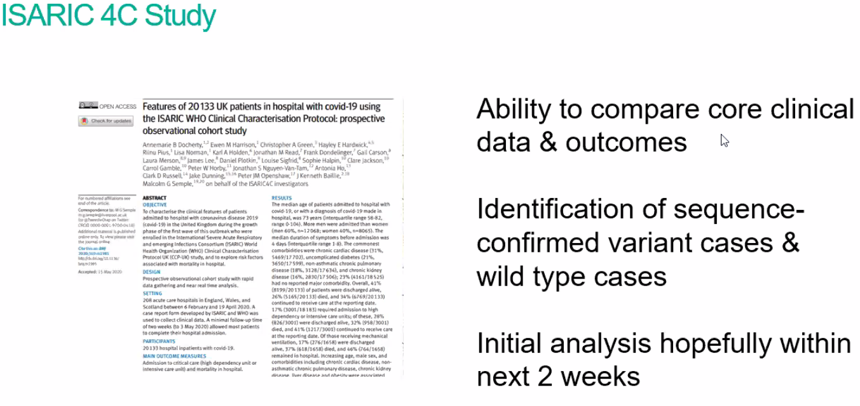
 | 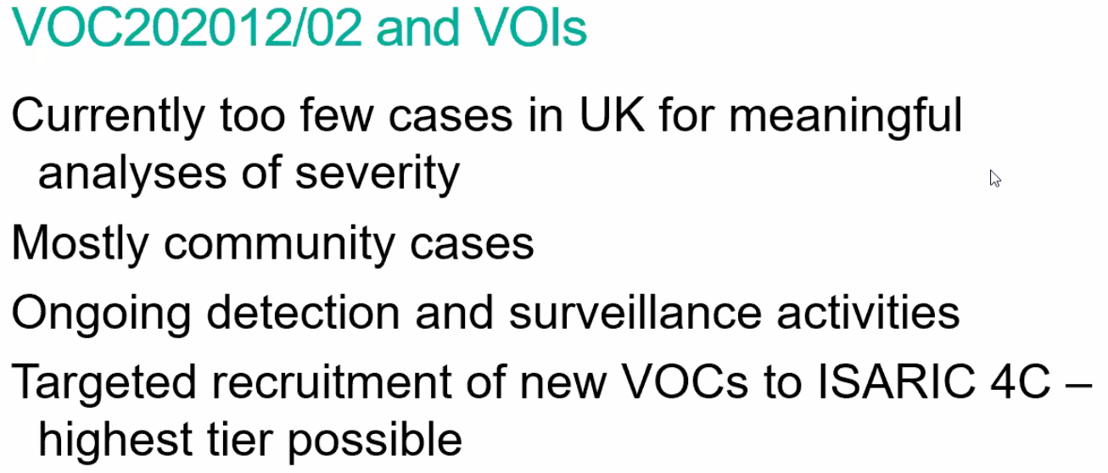
 | 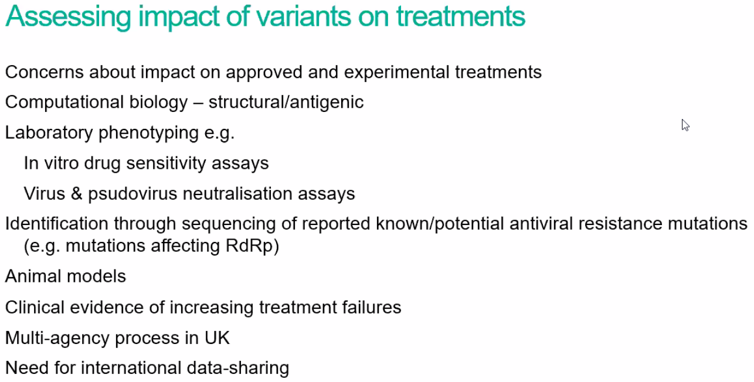
 | 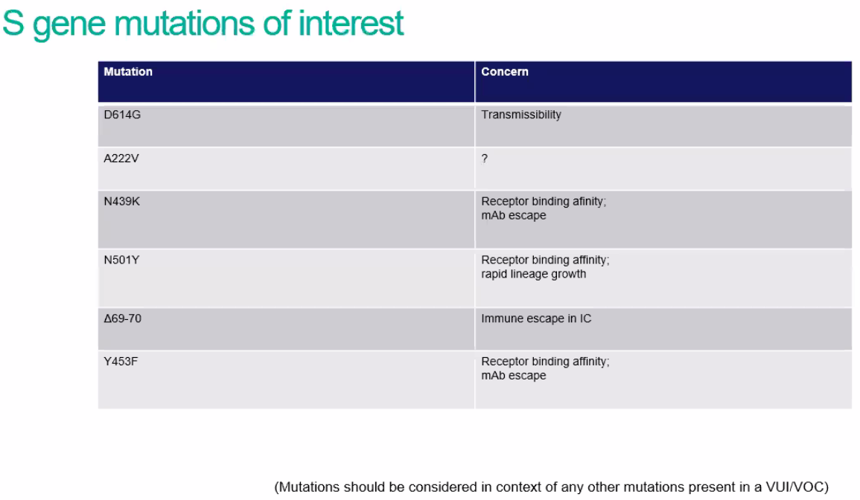
 | 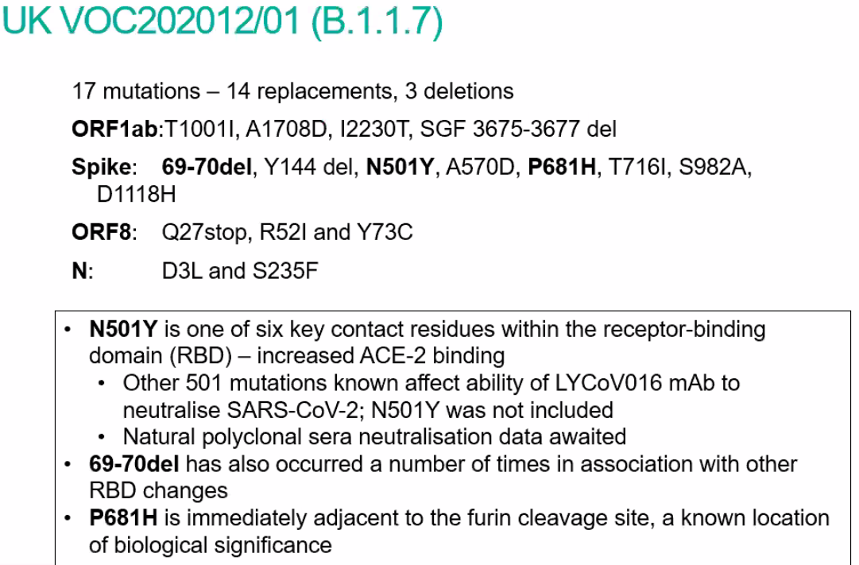
 | 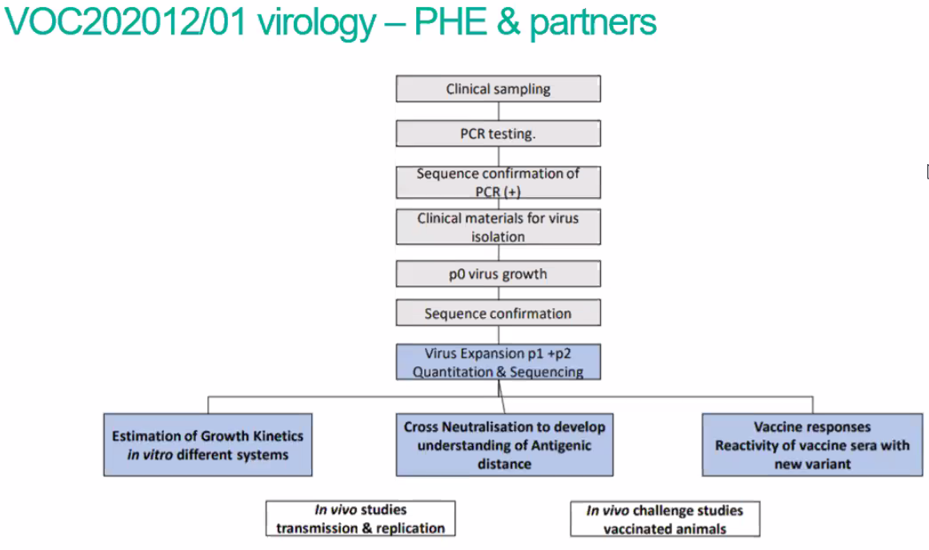
 | 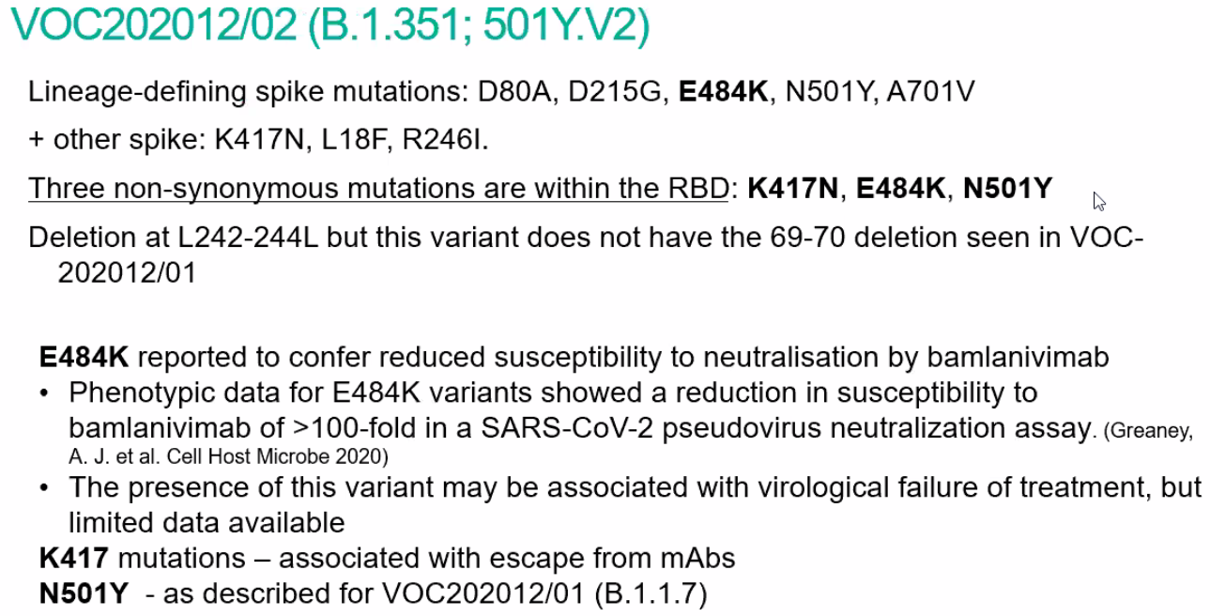
Brazil variant | 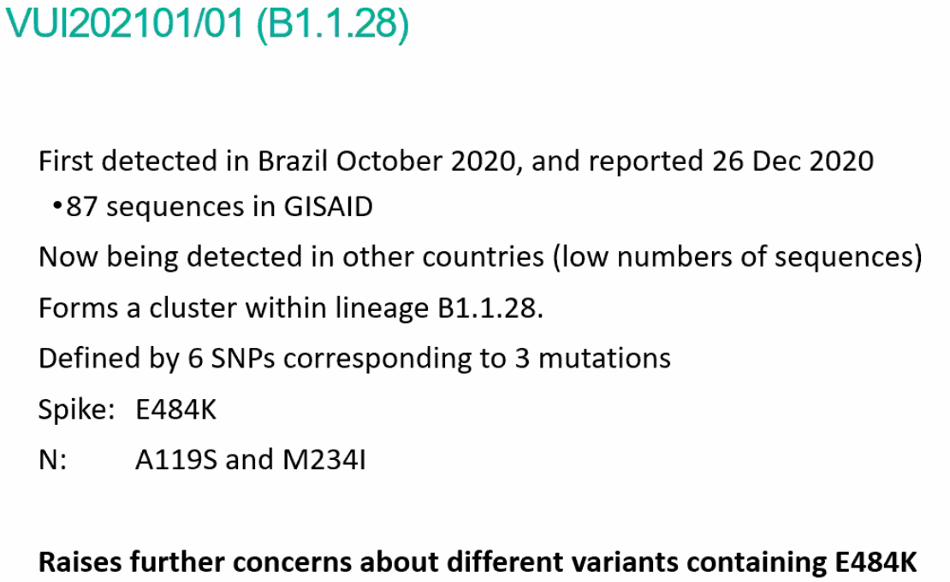
 | 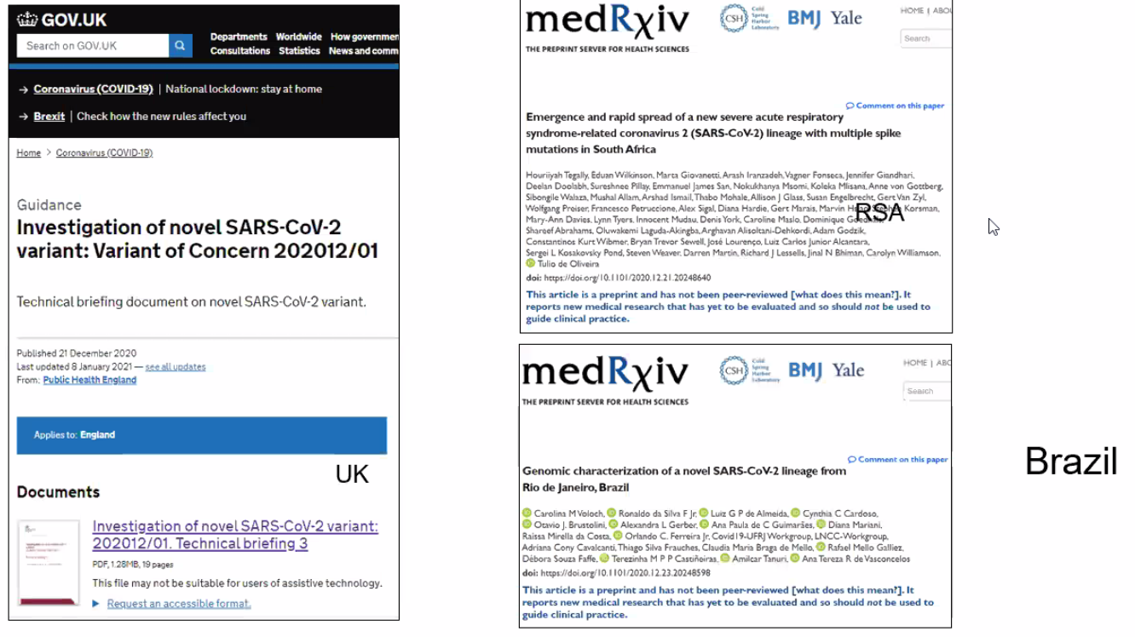
 | 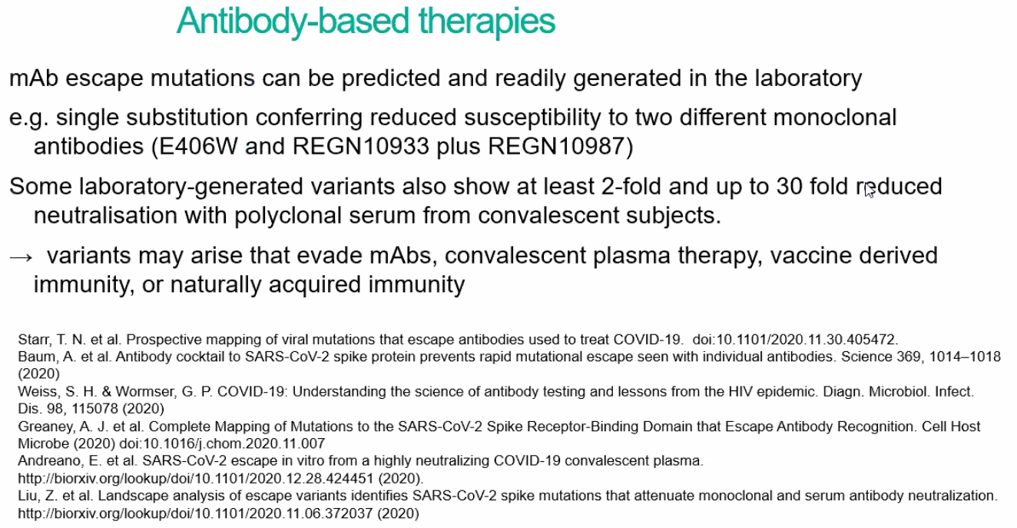
 | 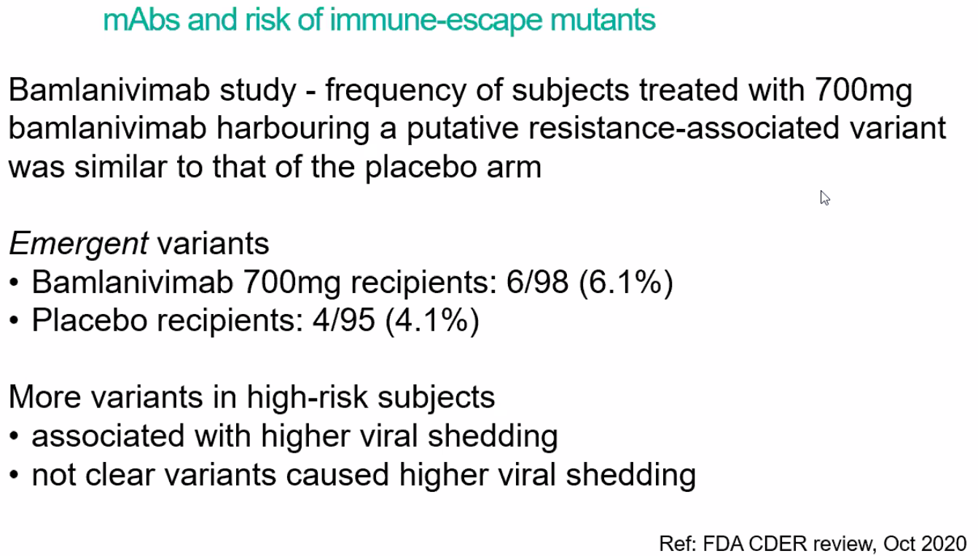
 | 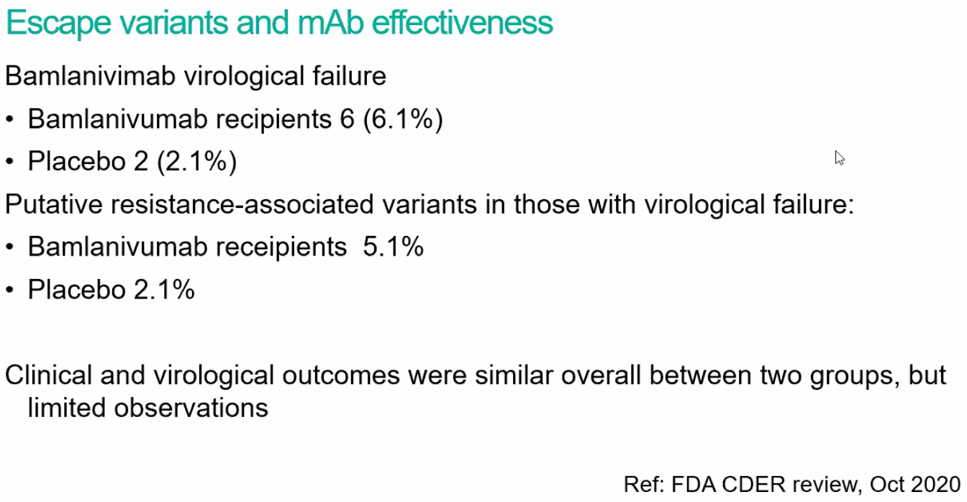
 | 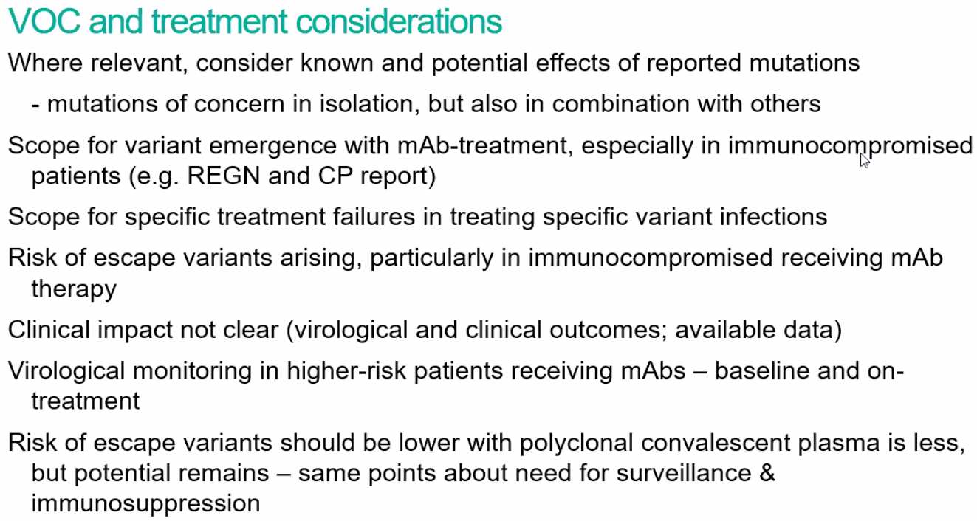
Phil Krause, WHO:  vaccines and variants | 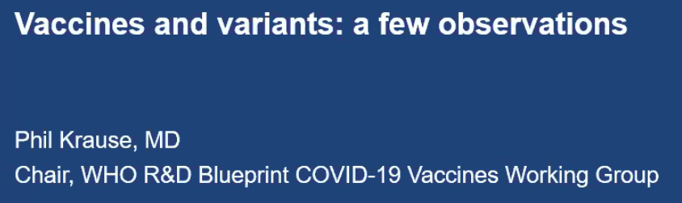
 | 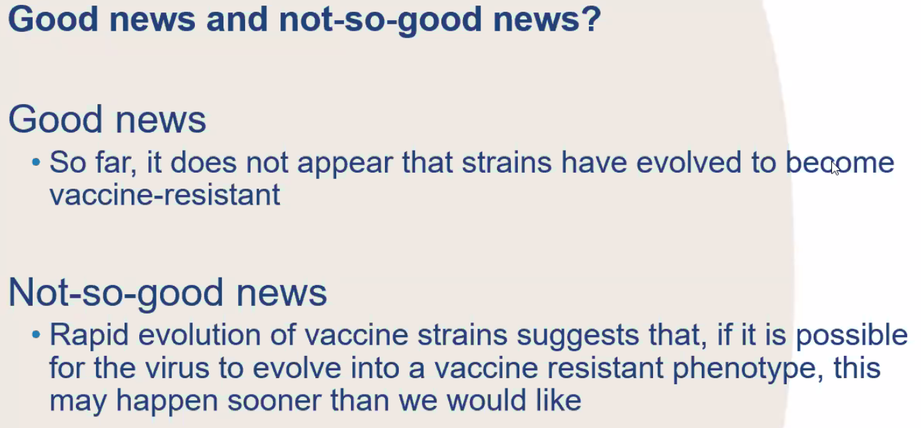
 | 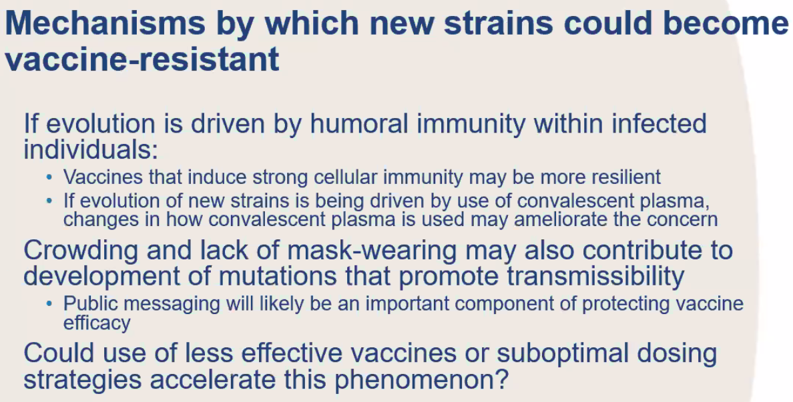
 | 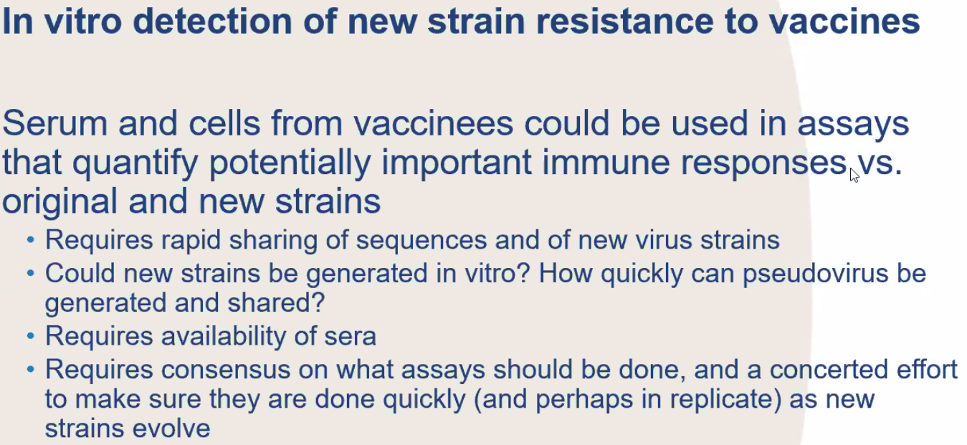
 | 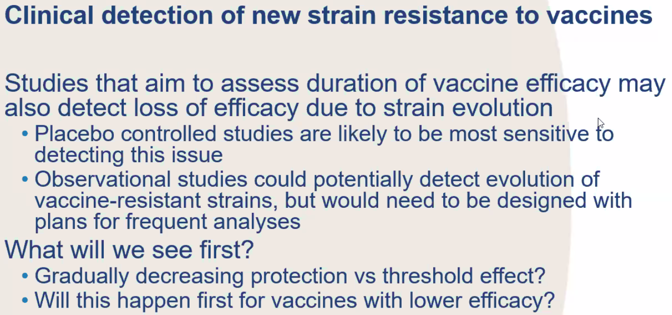
 | 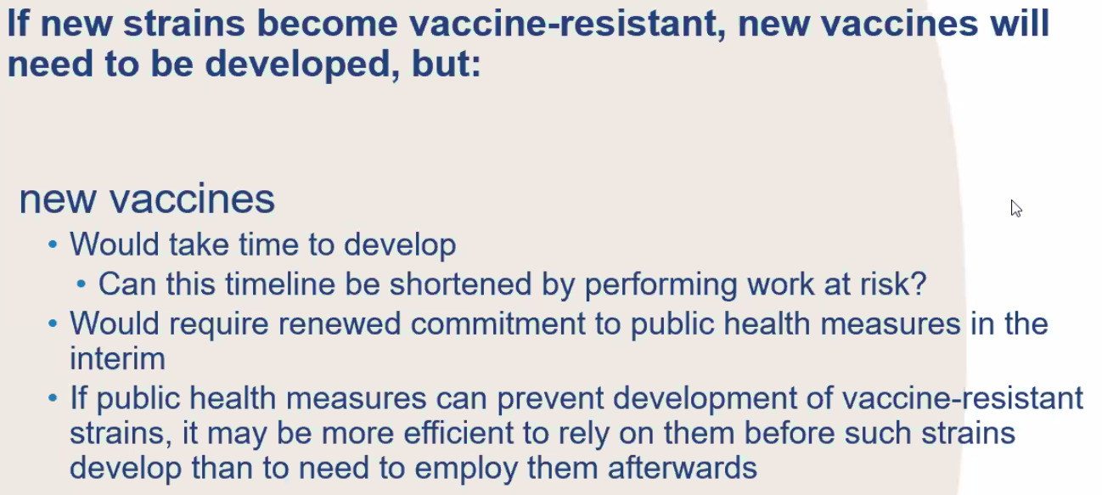
 | 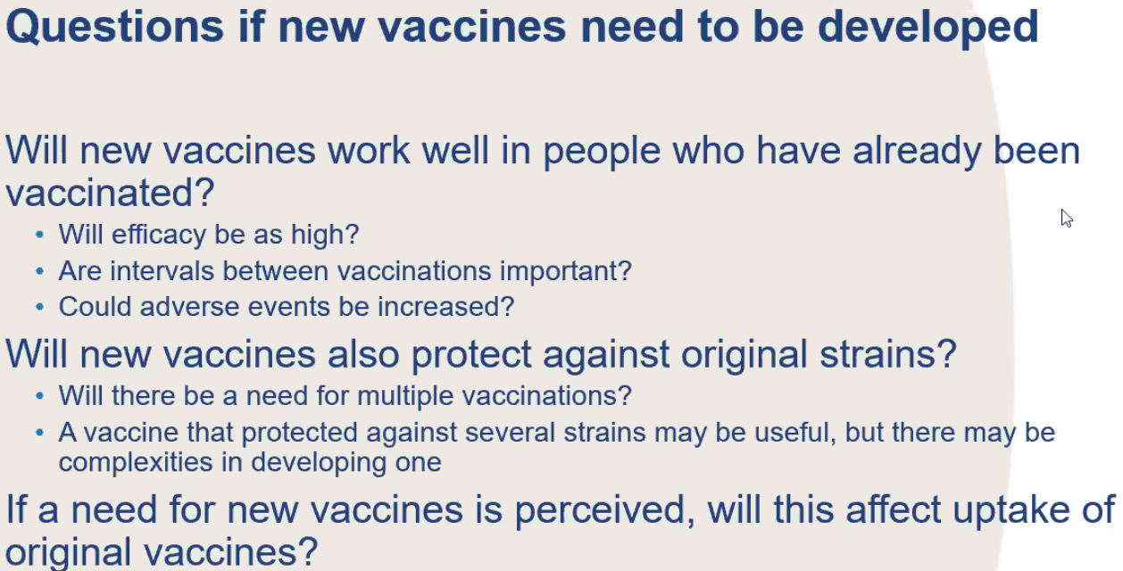
 | 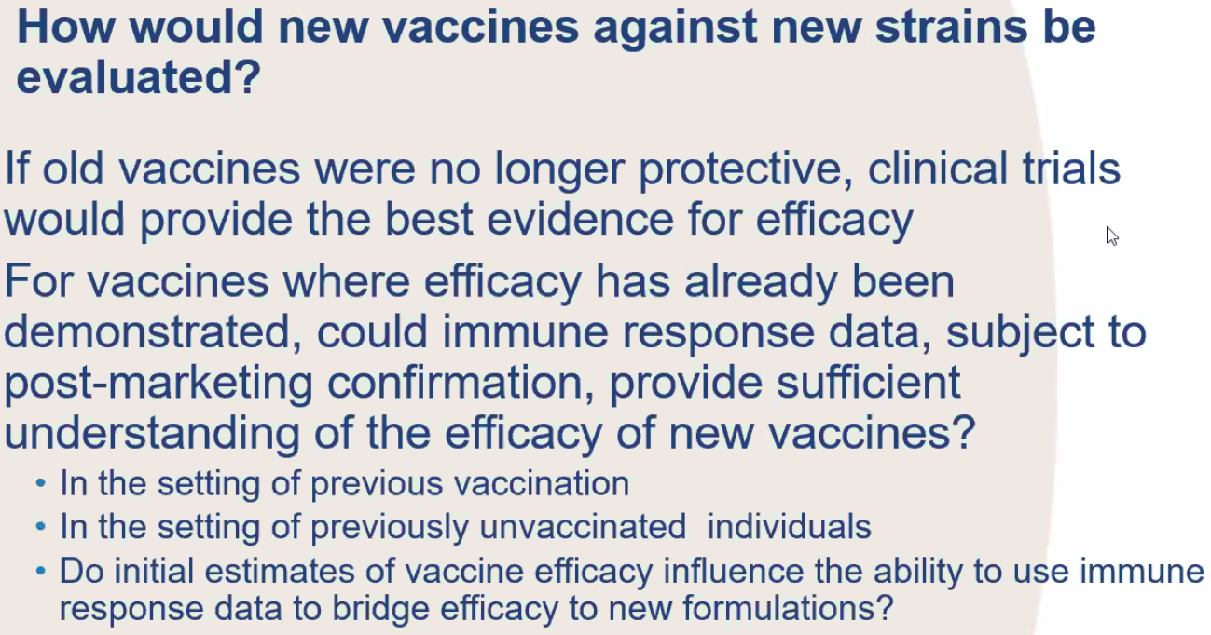
 | 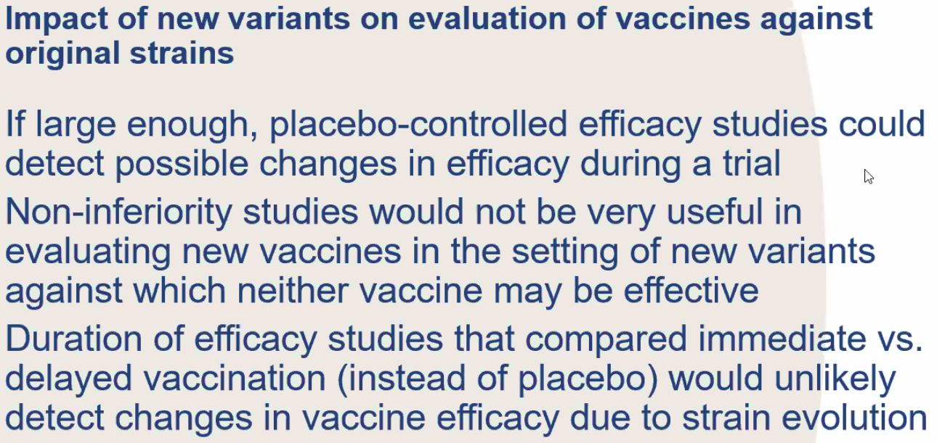
 | 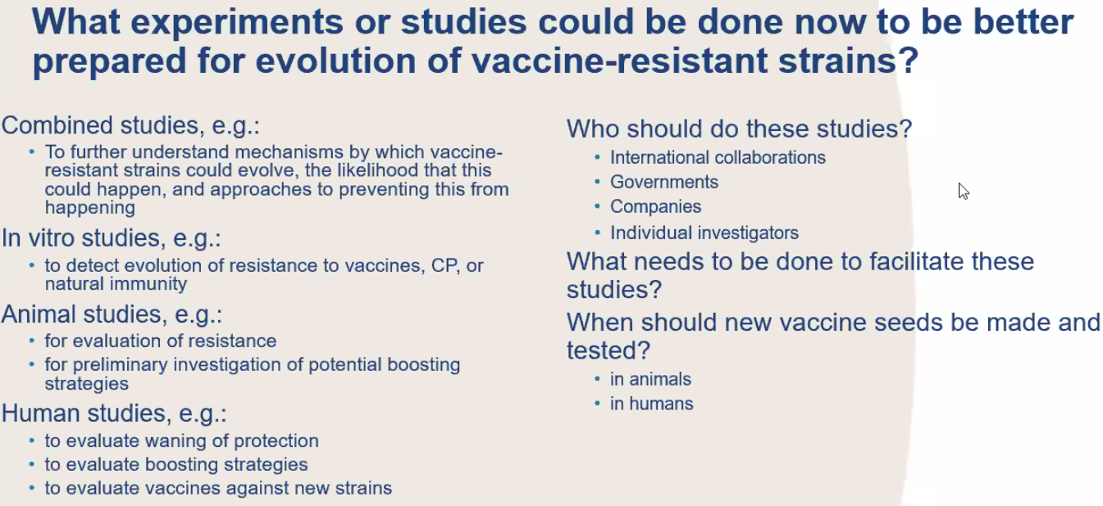
Breakout sessions | WORKING GROUPS
Group 1 | Epi & Modelling
John Amuasi (chair) | Neil Ferguson: “my greatest concern is the E484K – variant in Brazil. To be precise - B.1.1.28(K417N/E484K/N501Y)”  https://virological.org/t/spike-e484k-mutation-in-the-first-sars-cov-2-reinfection-case-confirmed-in-brazil-2020/584  Andrew Hayward: “it is important to try to make and make sure the samples that are sequenced are representative of different settings e.g.- community, hospital, nursing homes - rater than biased towards outbreaks”  Oliver Morgan: 2 entry points to detect a VOC: sequencing detects an increasing proportion of a variant what is the epi? --- OR: (as happened in the UK): unusual epi is there a VOC behind?  Maria Clara Padovec: “The understanding of drivers of mutation leading to VOC is a priority to identify potential for stopping it”
 | 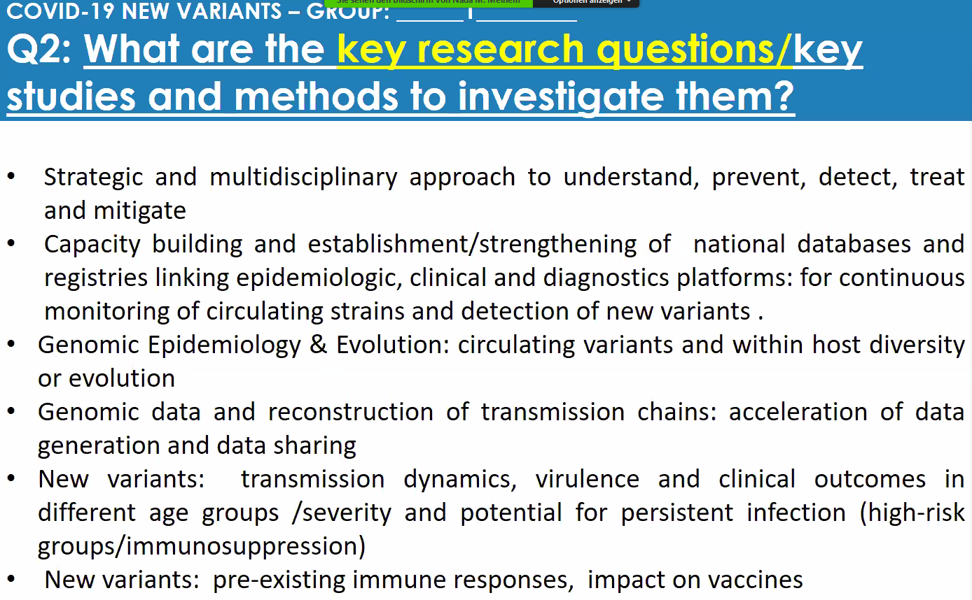
 | 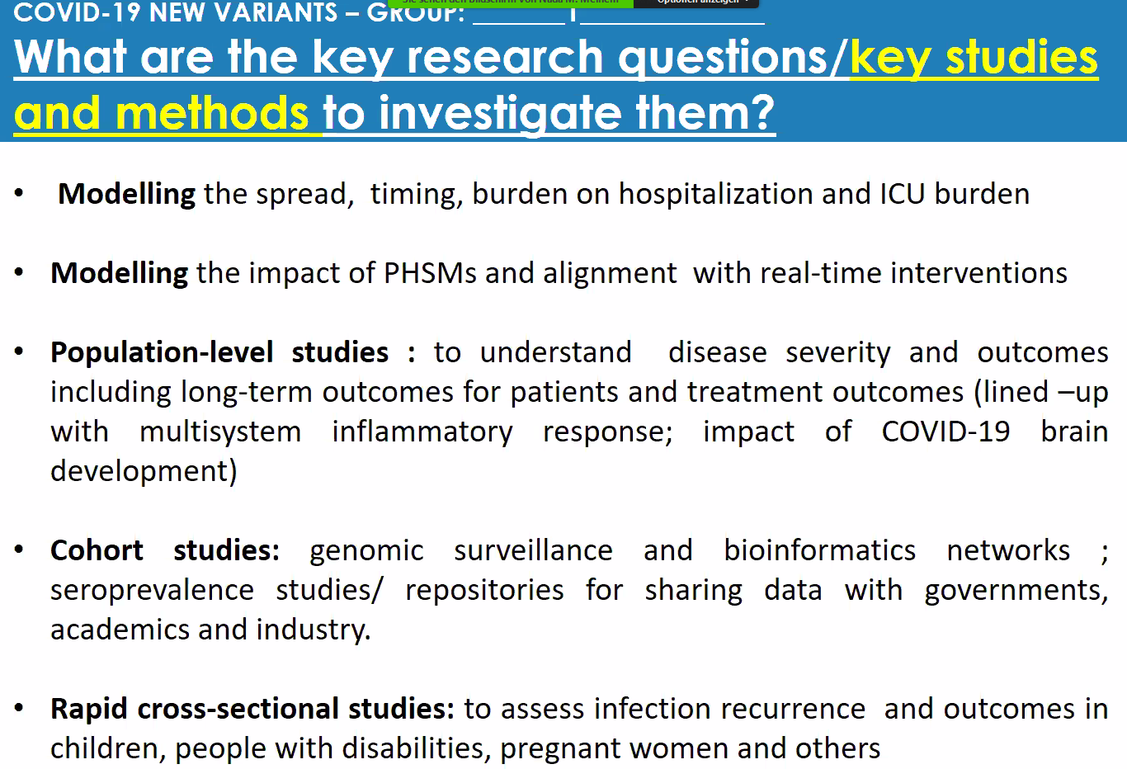
 | 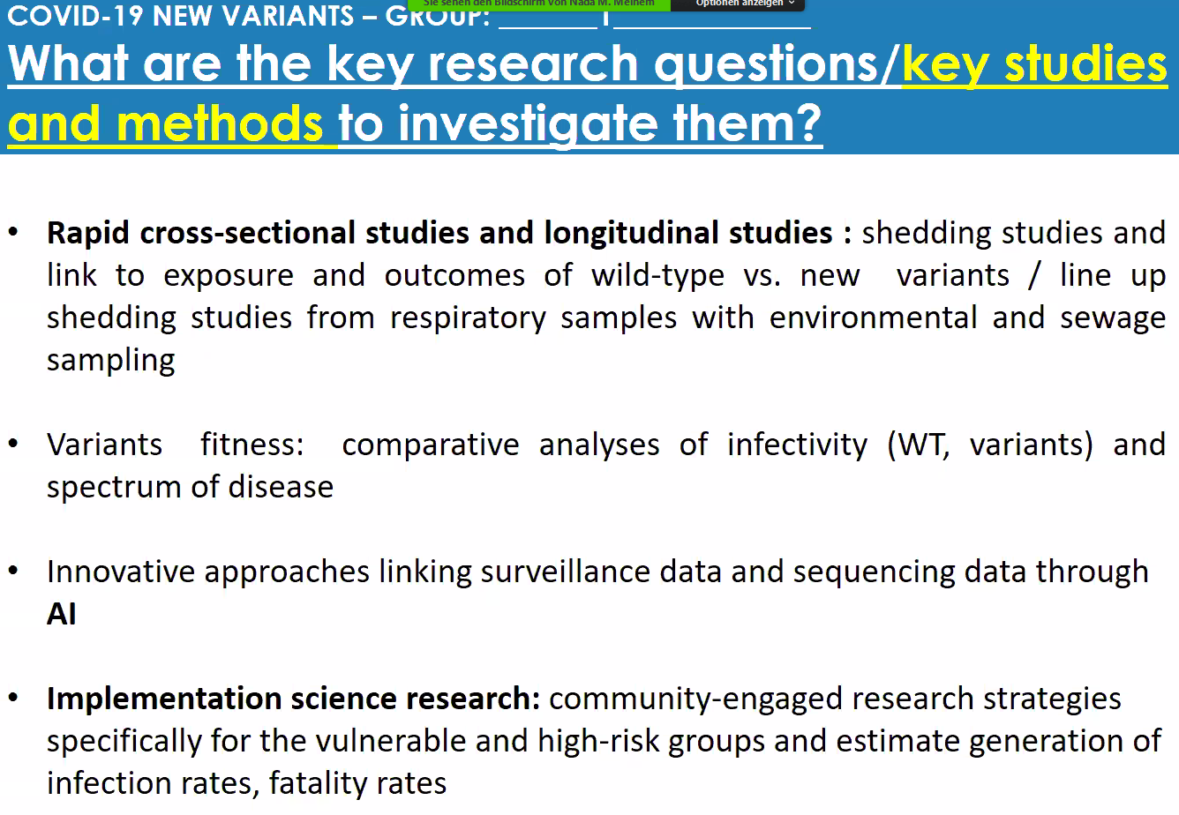
 | 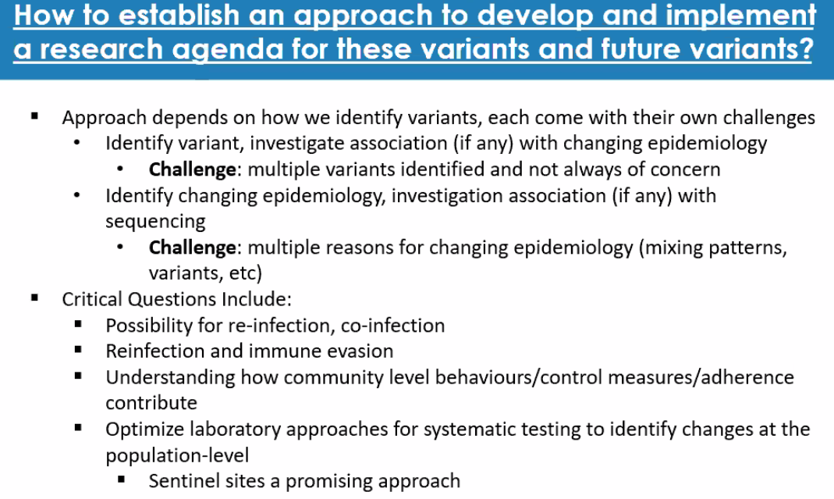
TOP priority: | National databases; longitudinal epi studies for cohorts (infected, never infected, …)
Group 2 | Clinical characterization and management and therapeutics
John Marshall,  Lydon Patrick | 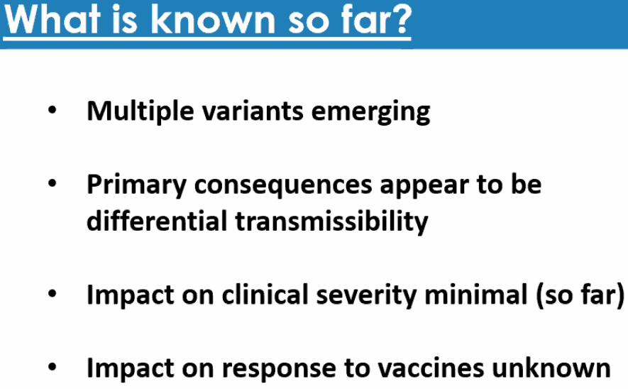
 | 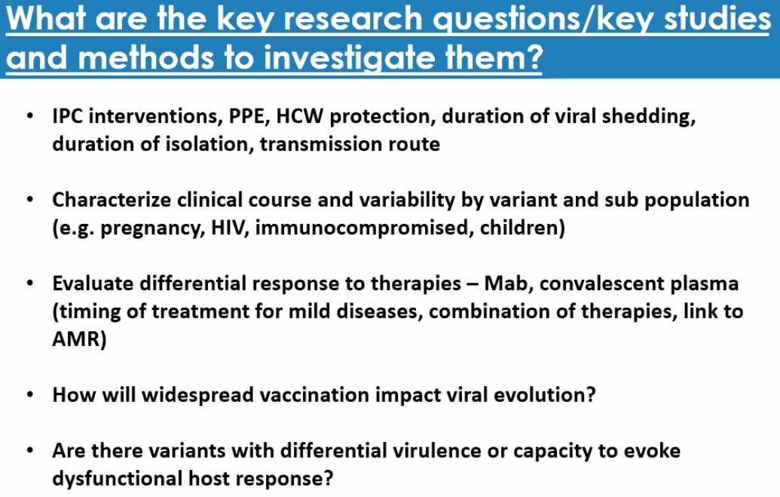
 | 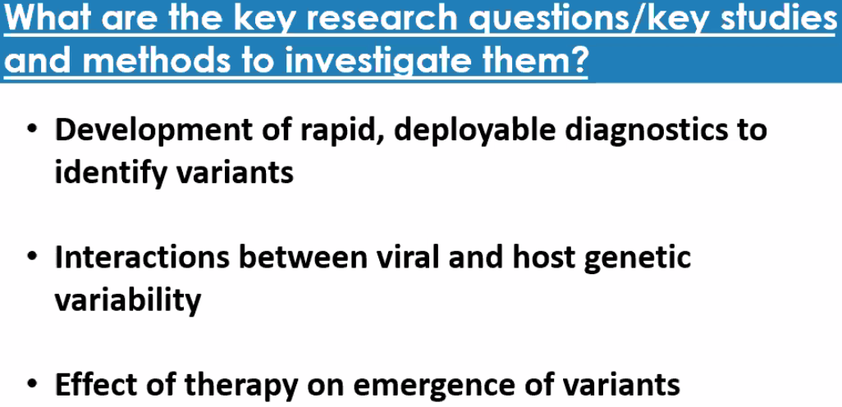
 | 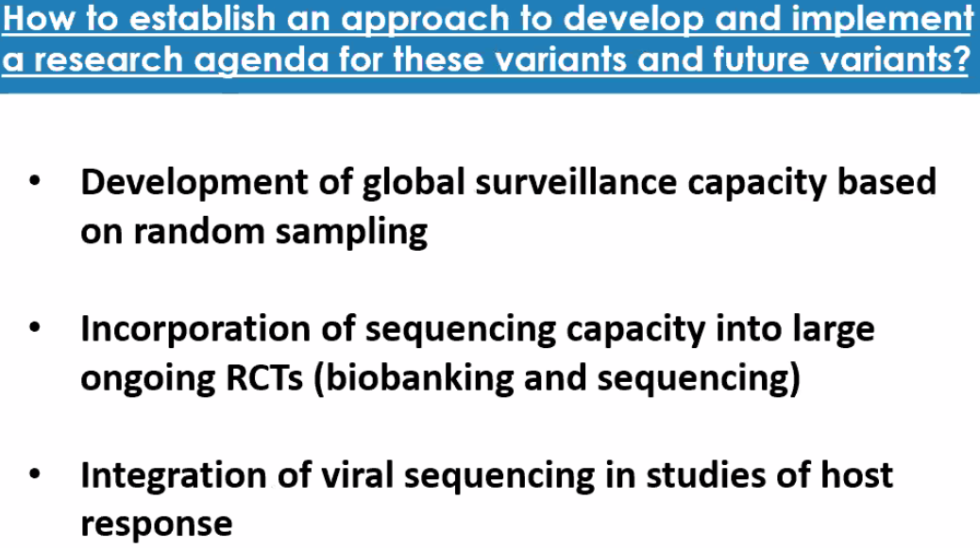
TOP priority: | Future clinical trials, specific therapies
Group 3 | Animal models
Dan Barouch | 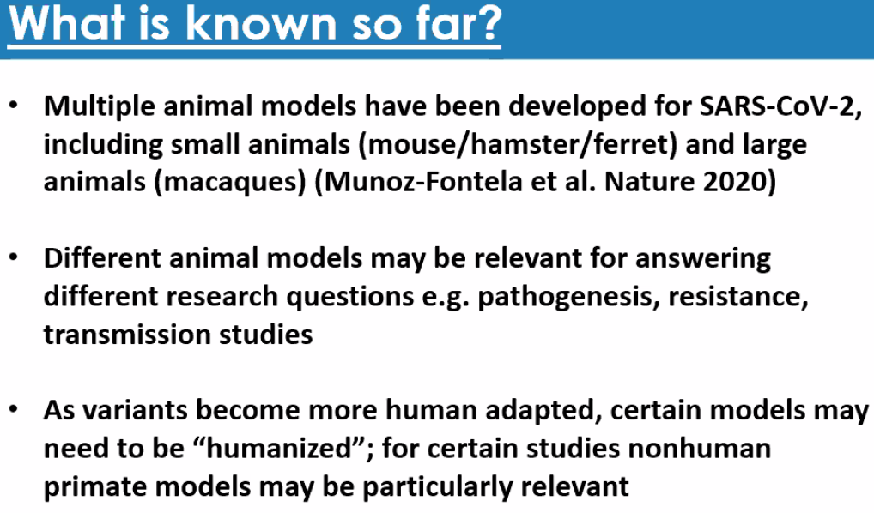
 | 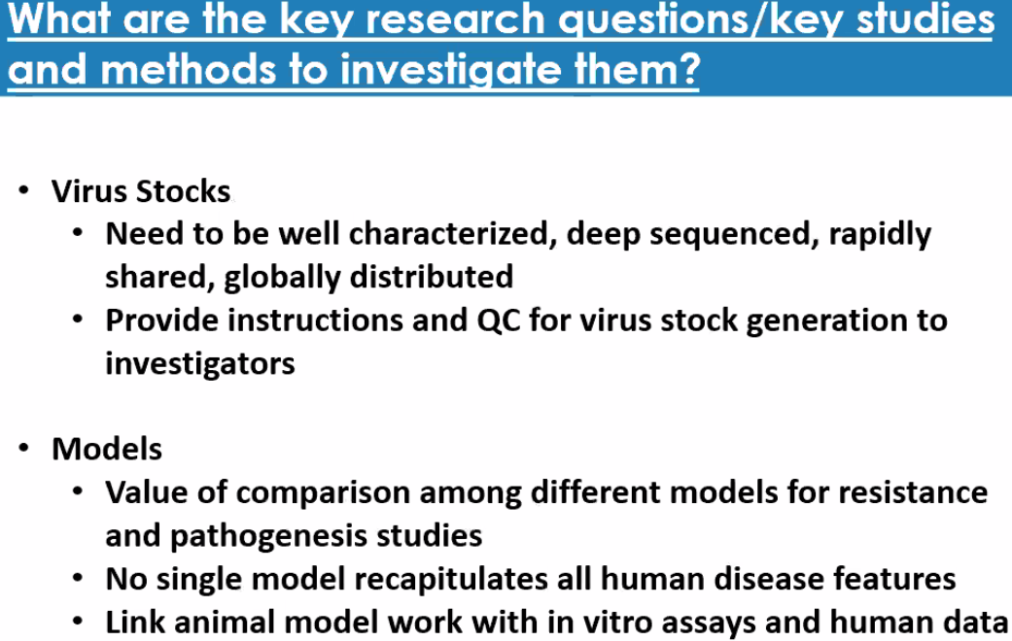
 | 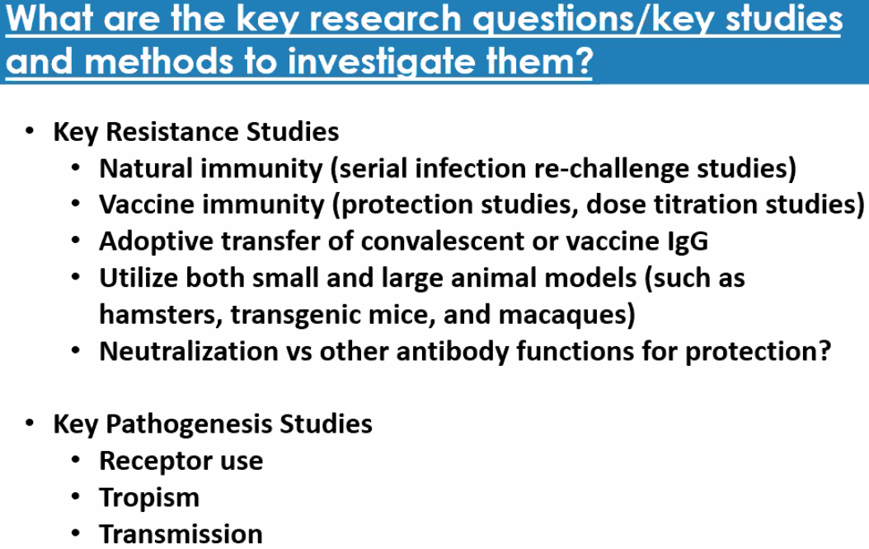
 | 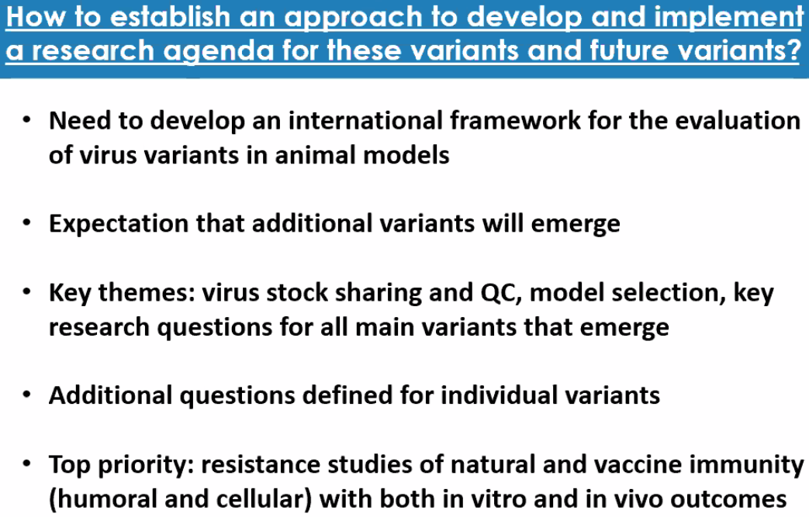
TOP priority: | Distribute viruses quickly around the world; resistance studies
Group 4 | Assays and Diagnostics
Florian Krammer | 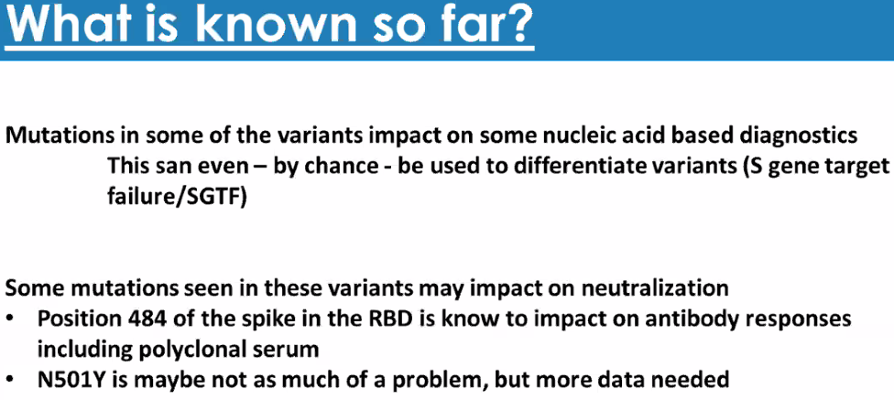
 | 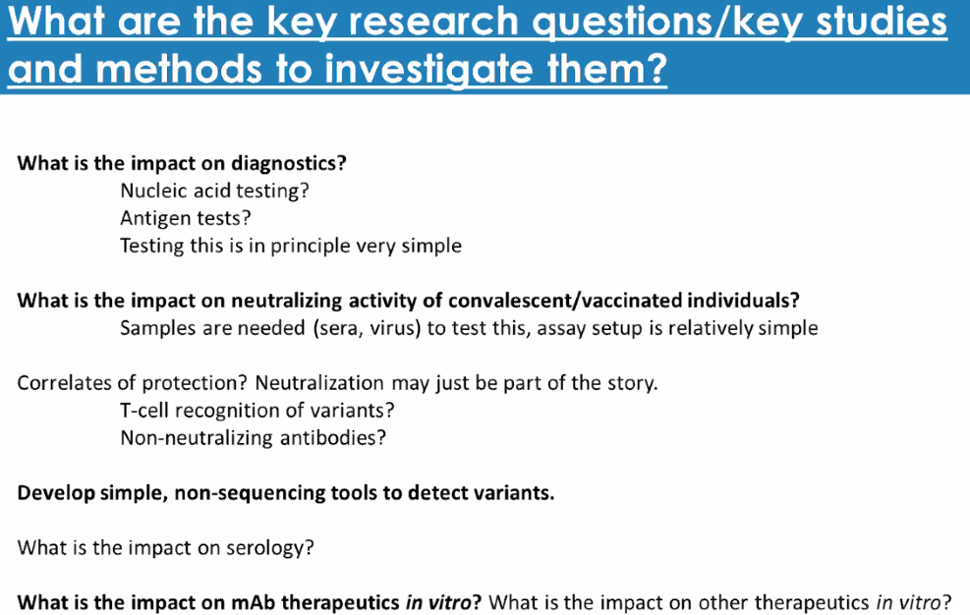
 | 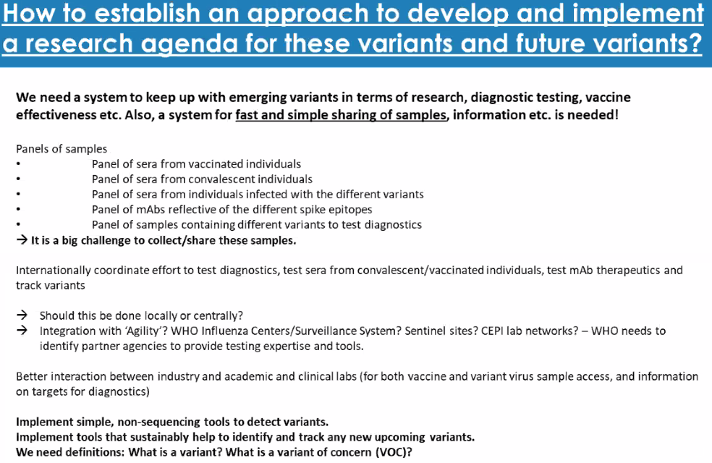
TOP priority: | To get serum samples very rapidly
Group 5 | Evolutionary biology
Malik Peiris  In short order evolution of several new variants of relevance | 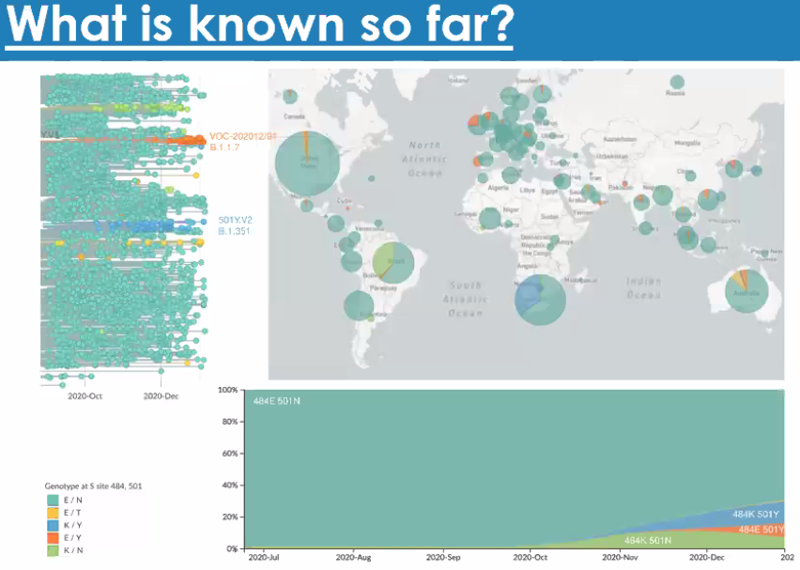
Long branch length of some variants, e.g. UK variant, could suggest evolution under unusual condition.  First signal is mostly: epi or routine sequencing. How to standardize sampling? How putting together epi and sequence data?  Risk assessment: e.g. TIPRA (WHO), or IRAT (CDC).  Nomenclature: should not have a country’s name, but should be easy to capture for the public. | 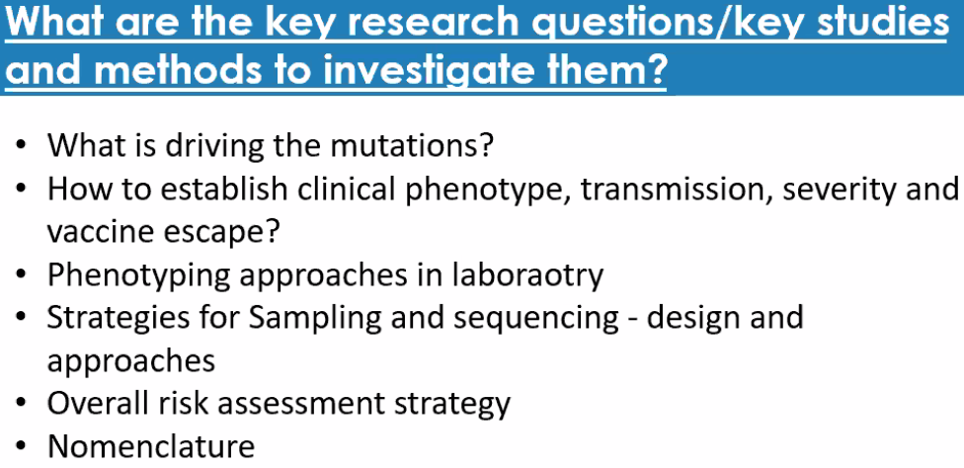
Sampling: might need something similar as the Global Influenza Surveillance Network. | 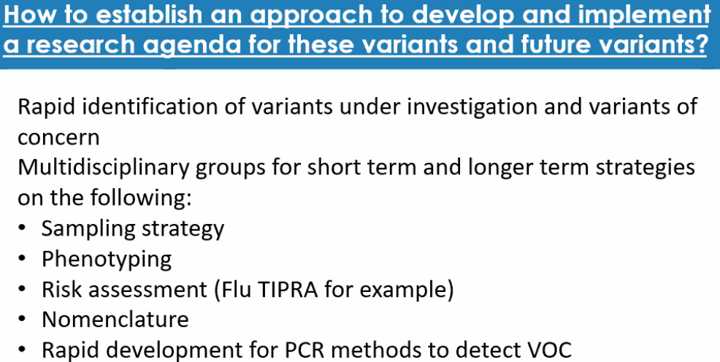
TOP priority: | (1)establish GLOBAL surveillance system to monitor variants (use Influenza as model)  (2)nomenclature
Group 6 | Vaccines
Phil Krause  Many epitopes of vaccines might prevent drop of efficacy | 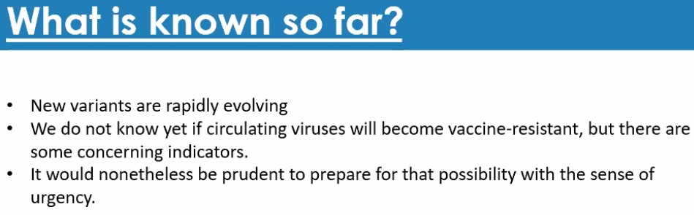
Ecological studies: e.g. sewage.  Effectiveness might decrease gradually. | 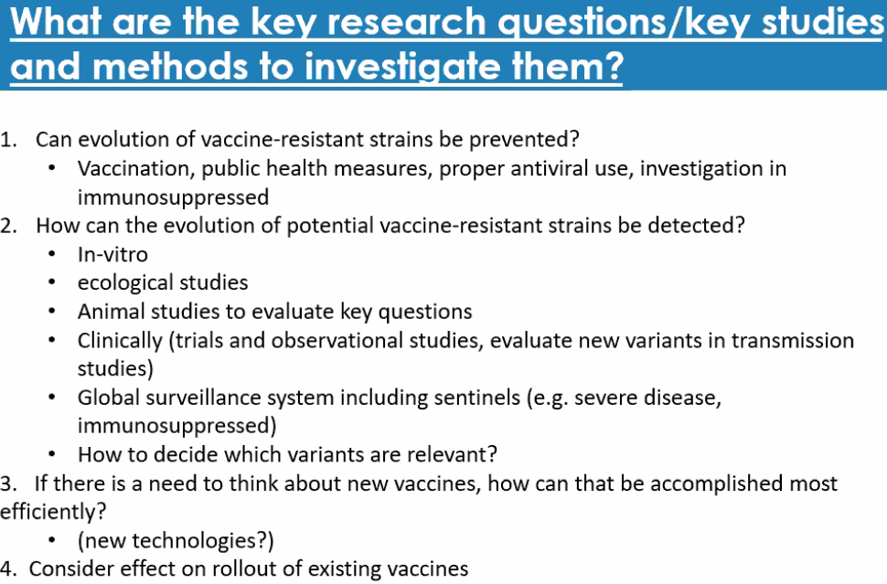
Global surveillance of high importance | 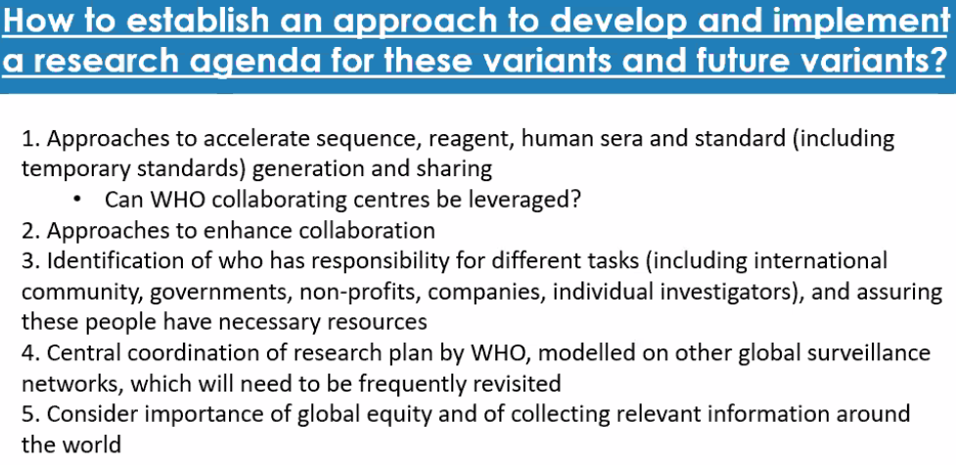
TOP priority: | Global research agenda

Last

