**Update on the development of SARS-CoV-2 variants of concern (VOC) in Denmark**

The VOC concept comprises SARS-CoV-2 variants that are either more infectious or have been shown to have a reduced susceptibility to antibodies following infection.

Update on B.1.351  
Since the publication of the previous update, two new cases of B.1.351 have been detected. This variant may both be more infectious and have a reduced susceptibility to antibodies. As per 9 February 2021, a total of seven cases of B.1.351 have been detected in Denmark, all of which are associated with foreign travel.

Update on B.1.1.7  
So far, B.1.1.7 has been detected in 1,690 persons in Denmark in the period from 14 November to 2 February. This includes 13 cases who were household contacts to known infection cases. In 64 of the cases, information about travel history from a total of 22 countries has been available. It remains unknown if these cases have become infected abroad or in Denmark.  
Overall, from week 46 2020 through 3 February (in week 5) 2021, a total of 41,662 samples have been sequenced. Among these, 32,988 samples yielded sufficient genetic material for determination of the virus variant. This means that B.1.1.7 has been found in 5.1% of these samples.

**Table 1. Number of confirmed cases, number of samples sequenced and B.1.1.7 cases detected from random samples, from week 46 2020 through week 5 2021**



*Including 13 cases who were household contacts to infected persons.   
**Including persons of no known address.  
***Data for week 5 are incomplete and may be expected to change as sequencing data are collected.

**Figure 2. Share of sequenced samples with B.1.1.7 with 95% confidence intervals, from week 46 2020 to week 5 2021**

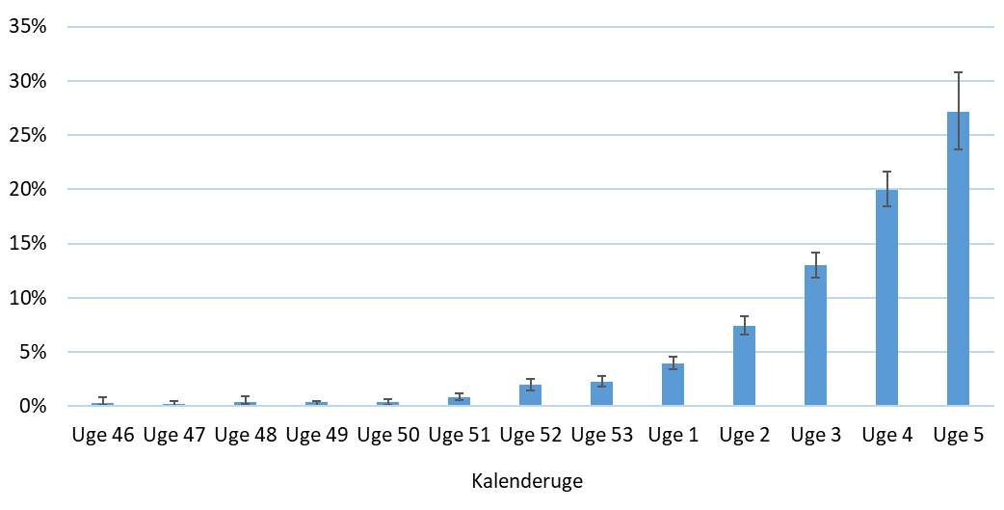

**Table 2. Number of confirmed cases with B.1.1.7 and share of sequenced samples by region, for week 4 and week 5 2021**



**Figure 3. Number of cases with B.1.1.7 from 14 November to 2020 to 3 January 2021, by region and sampling date.**

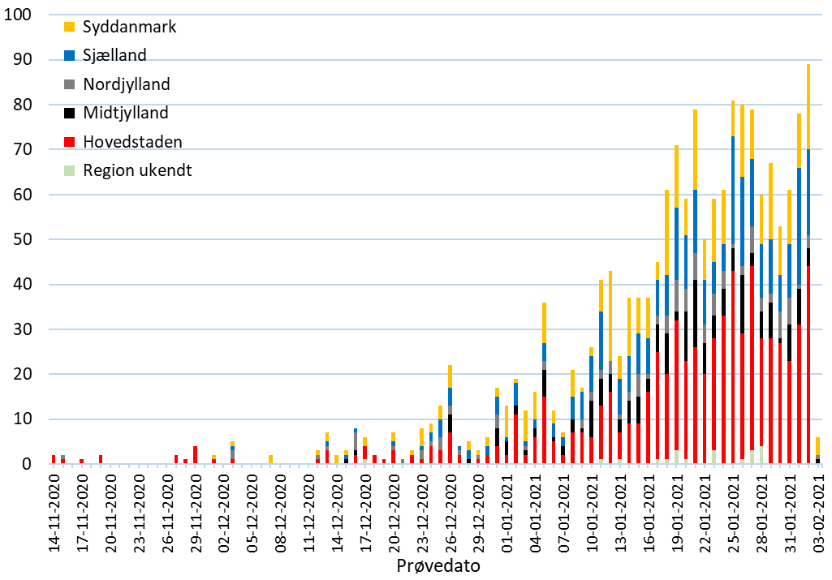

**Figure 4. Age distribution by functional age groups for confirmed B.1.1.7 cases and age distribution for all cases of COVID-19 from 14 November 2020 to 3 February 2021**

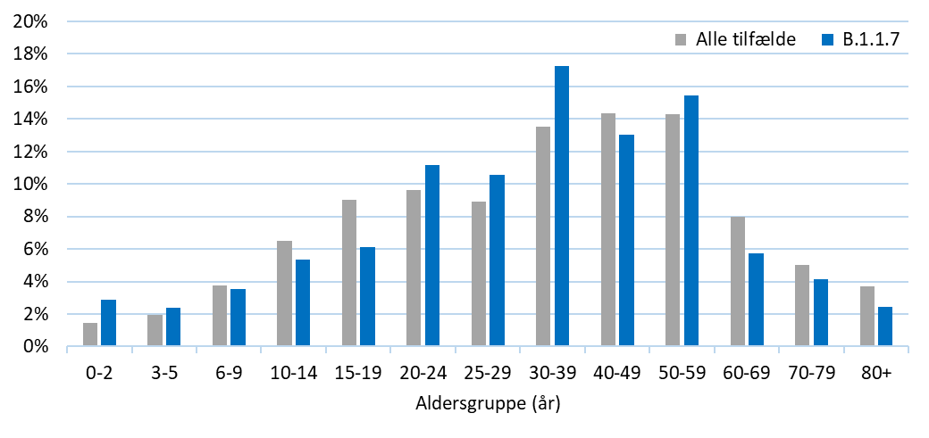

**Figure 5. Age distribution by 10-year age groups for confirmed B.1.1.7 cases and age distribution for all cases of COVID-19 from 14 November 2020 February 3 2021**

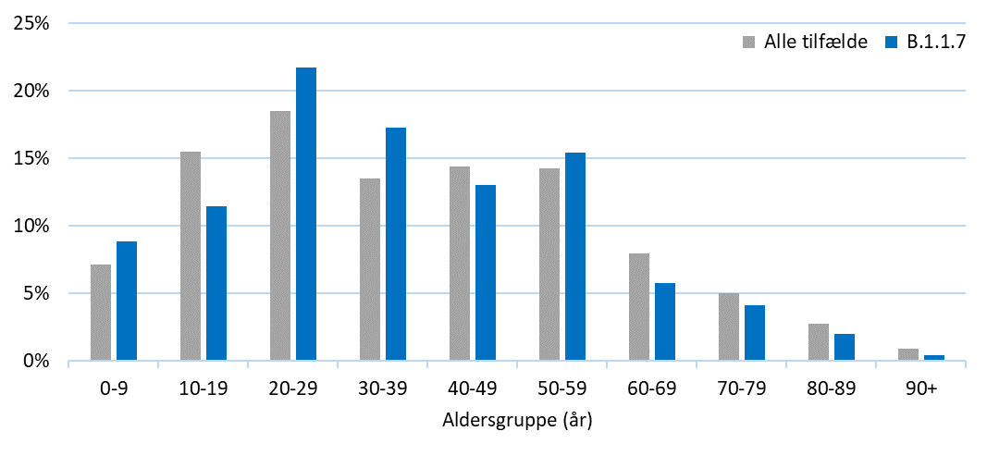

**Update on the E484K mutation**  
The E484K mutation is monitored closely due to concern that it may cause a reduced susceptibility to antibodies. This mutation is found in several of the VOC that are also monitored closely, such as B.1.351 and P1. The E484K mutation is a substitution of Glutamate (E) for Lysine (K) in position 484 of the receptor-binding domain of the spike protein.

Data on detection of the E484K mutation will continuously be updated in this report as more data and knowledge about the mutation become available. Thus, this section of the report may change over time.

So far, the E484K mutation has been detected in 50 cases in addition to the seven variant B.1.351 cases. The geographical distribution of the cases is as follows: 22 in the Capital Region of Denmark, 15 in Region of Southern Denmark, 11 in the North Denmark Region, one in Region Zealand and one case had no known address. Samples were made in the period from 29 December to 3 February. Ten of these cases have a travel history.

**Figure 1. Number of cases with the E484K mutation from 29 December 2020 to 3 January 2021, by region and sampling date.**

